Year 4 School Closure Work Booklet

Name:
English
There are a range of different activities in this booklet based on things we have already been learning about.
There are 3 writing tasks – one fiction, one non-fiction and a slow writing (where you are told what you have to include in each sentence). There are also some spelling and grammar activities for you to try with prompts on this page to help you.
You should be practising your spellings every day, like your times tables. When you’re confident with the spelling pattern listed on the sheet you should continue to work on the Year 3/4 spelling list.
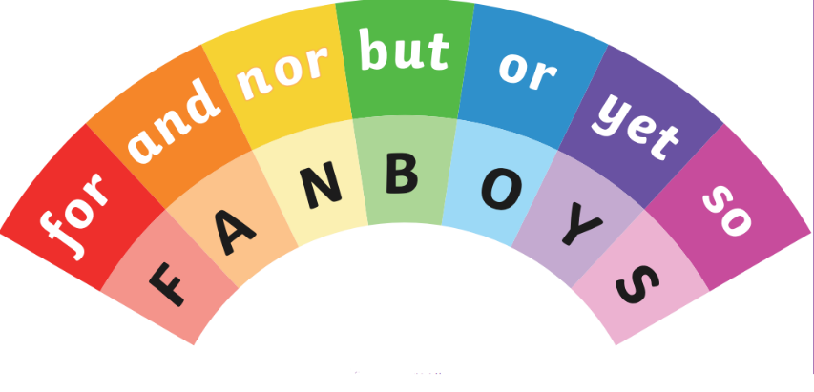
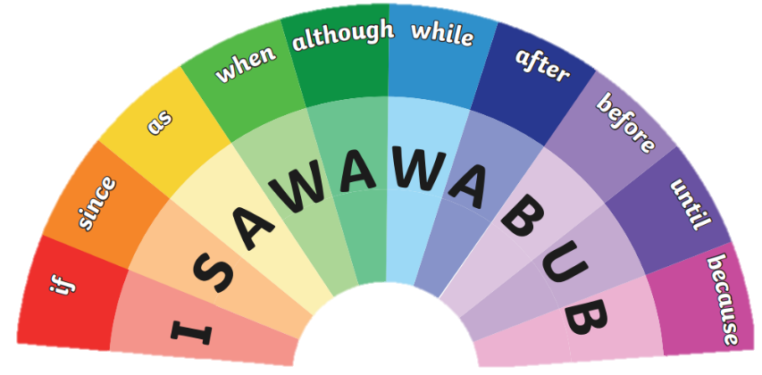
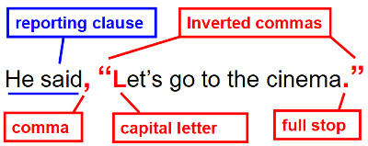
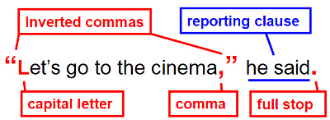
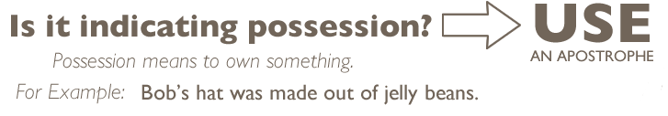
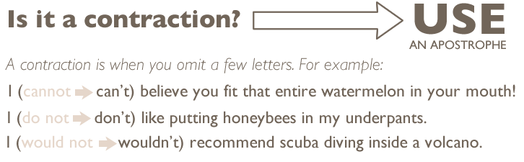
Co-ordinating and Subordinating Conjunctions
Using inverted commas and other punctuation in direct speech
Apostrophes for contraction and possession
Fiction Writing: The Three Pigs
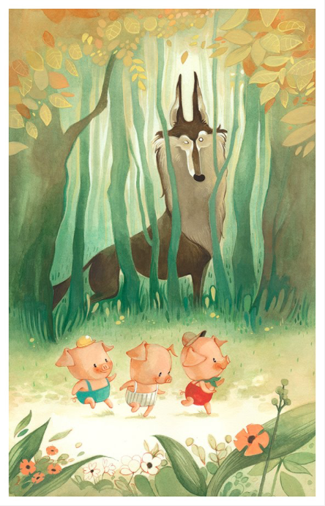
Choose three words or phrases that best describe the pigs
_____________________________________ _____________________________________ _____________________________________

Choose three words or phrases that best describe the wolf
_____________________________________ _____________________________________ _____________________________________

Do the pigs and wolf have anything in common?
_____________________________________ _____________________________________ _____________________________________
Write a new story with the characters of the three pigs and the wolf. Maybe think about what happened after the traditional tale we know. Or write the story from the wolf’s perspective – maybe he only approached the pigs because he wanted a friend?

Toolkit
- Paragraphs
- Basic punctuation
- Present or past tense
- First or third person
- Dialogue with inverted commas
- Expanded noun phrases
- Fronted adverbials
- Apostrophes for contraction and possession
- Adverbs and prepositions to show time or cause

Non-Fiction Writing: The Rather Interesting Octopus
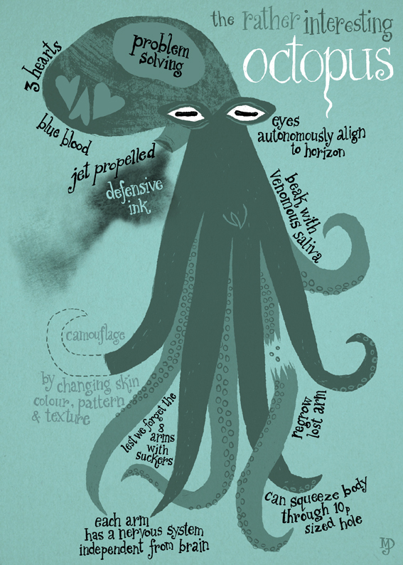
What do you think is interesting about the octopus?
____________________________ ____________________________ ____________________________ ____________________________ ____________________________

Why do you think camouflage has been written in this way?
____________________________ ____________________________ ____________________________ ____________________________ ____________________________
Write a non-chronological report about the octopus. Think about its appearance, habitat and diet. Maybe try to do some extra research to help you understand more about octopuses.

Toolkit
- Heading
- Sub-headings
- Basic punctuation
- Introduction paragraph
- Present tense
- Third person
- Formal tone (no contractions or chatty language!)
- Co-ordinating and subordinating conjunctions
- Apostrophes for possession

Slow Writing: Unknown Specimen
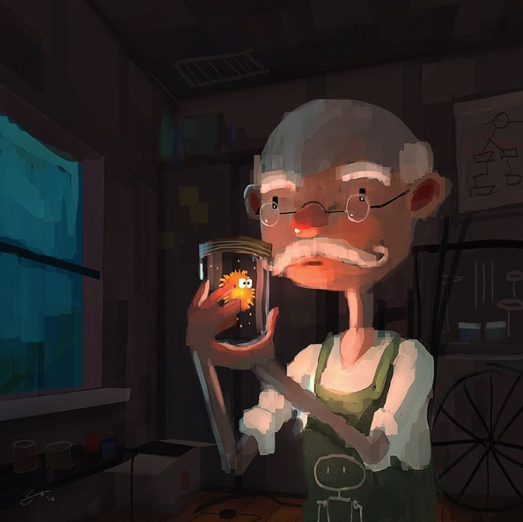
Use the following instructions to write two paragraphs about the picture. If you would like to, you could finish a story about the man with the unknown specimen.

Sentence 1: this sentence must start with a fronted adverbial
Sentence 2: this sentence must include a preposition
Sentence 3: this sentence must include a co-ordinating conjunction
Sentence 4: this sentence must be no longer than 6 words
Sentence 5: this sentence must include the word different
Sentence 6: this sentence must include a subordinate clause

Sentence 1: this sentence must include an apostrophe for possession
Sentence 2: this sentence must include the word natural
Sentence 3: this sentence must include an expanded noun phrase
Sentence 4: this sentence must include an adverb ending in -ly
Sentence 5: this sentence must be longer than 8 words
Sentence 6: this sentence must start with what or how and end with an exclamation mark

Direct Speech
Tricky

Trickier

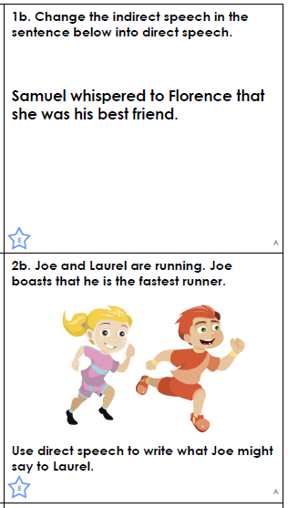
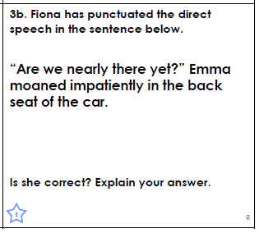
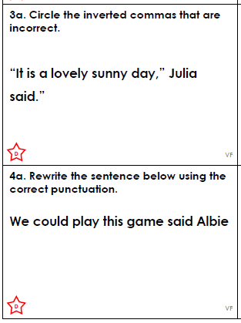
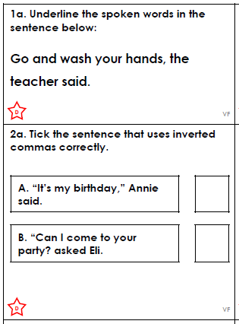

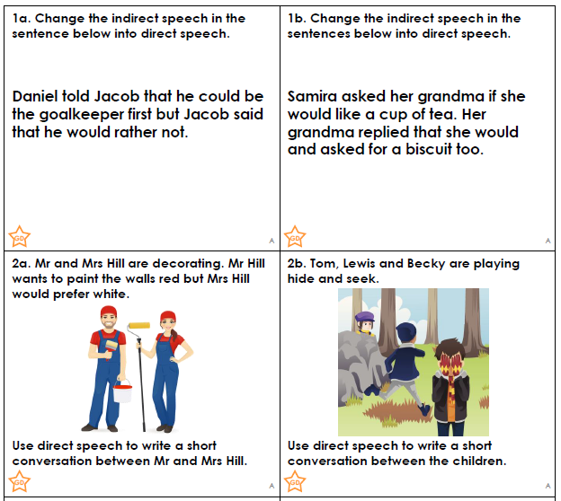
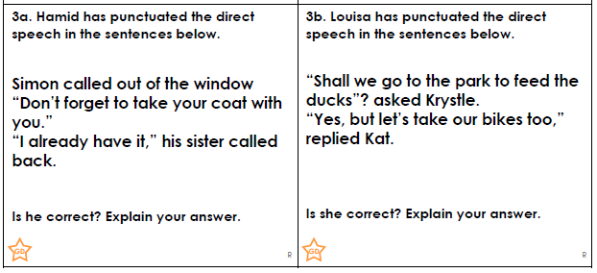
Trickiest

Fronted Adverbials
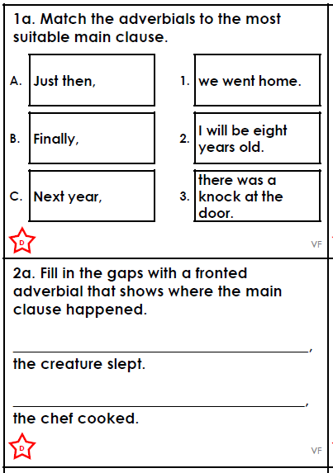
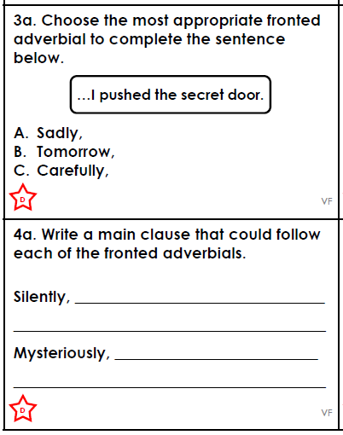
Tricky

Trickier

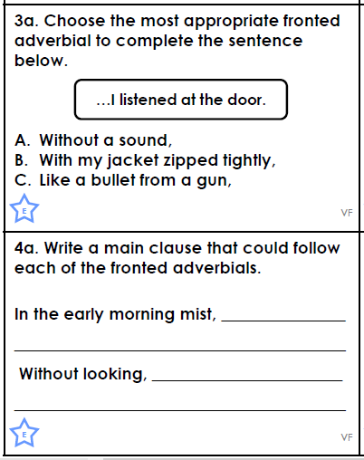
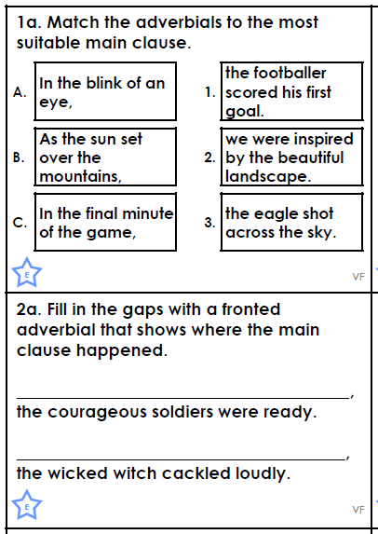
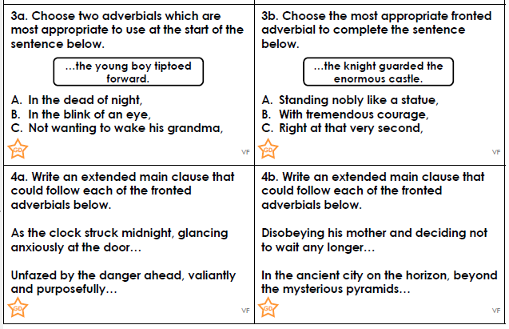
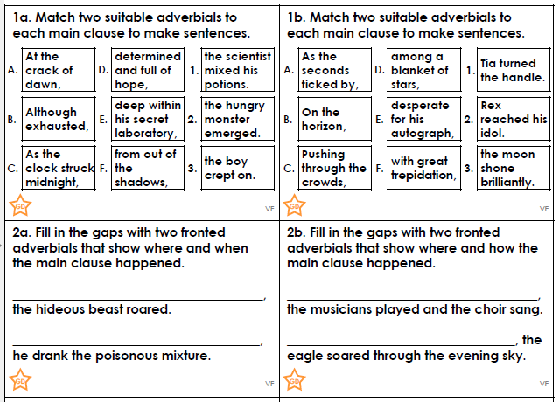
Trickiest

Spelling
Using some of the different strategies included on the next page, practise spelling the words from the following lists:
Words ending -cian, -sion, -tion and -ssion
- -tion is the most common ending. It is used if the root words end in ‘t’ or ‘te’
- -cian is commonly used in occupations. It is used if the root words end in ‘c’ or ‘cs’
- -sion is used if the root word ends in ‘d/de’ or ‘s/se’
- -ssion is used if the root word ends in ‘ss’ or ‘mit’
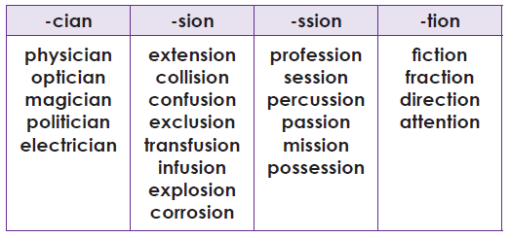
You can also practise the words on the Year 3/4 spelling list which are included in this pack. In addition to the strategies included on the following page, you can also use the look, say, cover, write, check technique explained below. Just use your ideas book and remember to tick them off in your reading records when you have mastered them.
Look  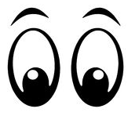 | Look at the word. How many parts are there?  What are the tricky bits?  Can you find any spelling patterns?
Say | Say the word to yourself.  Break the work up into syllables.  How many parts are there?  What sounds can you hear?
Cover  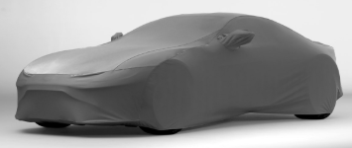 | Cover up the word so you can’t see it.  Picture the word in your mind.
Write | Write down the word, remembering how it sounds and what it looks like.
Check | Check to see if it’s correct.  Tick the letters you got correct.  Write the word correctly if you made a mistake.
You can also play some spelling games here: https://spellingframe.co.uk/
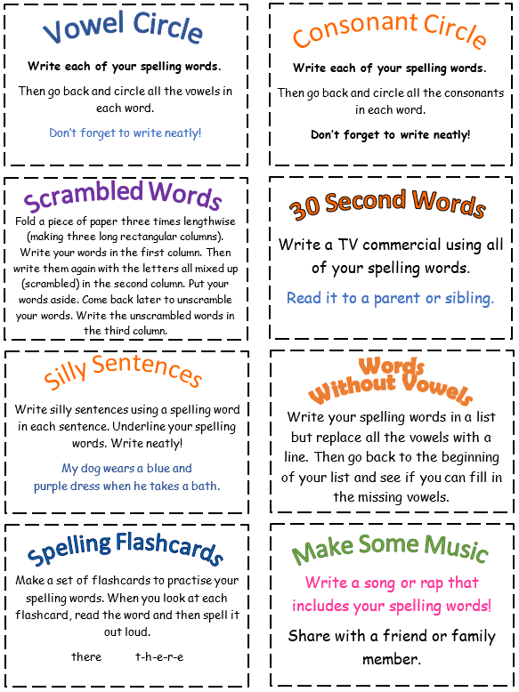
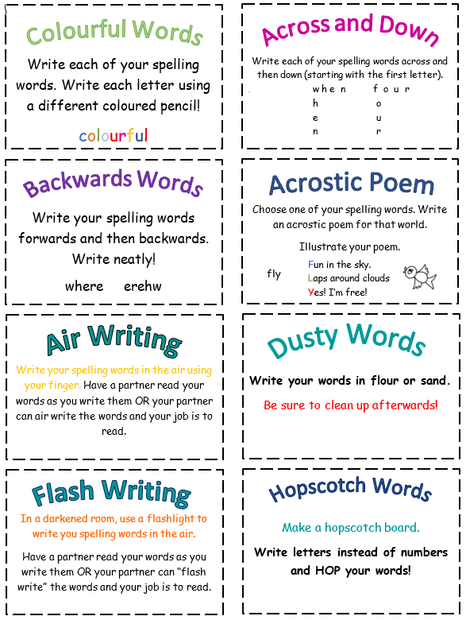
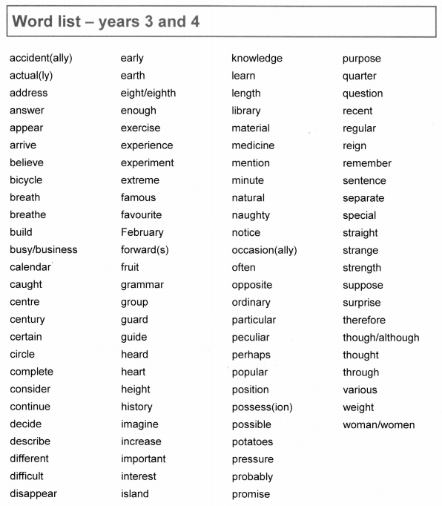

Reading
Just like your normal homework, you are expected to read for at least 20 minutes 4 times per week. You can read to a parent, carer, sibling or friend. Remember, it doesn’t just have to be a book, it can be a magazine, leaflet, online article or poem too.

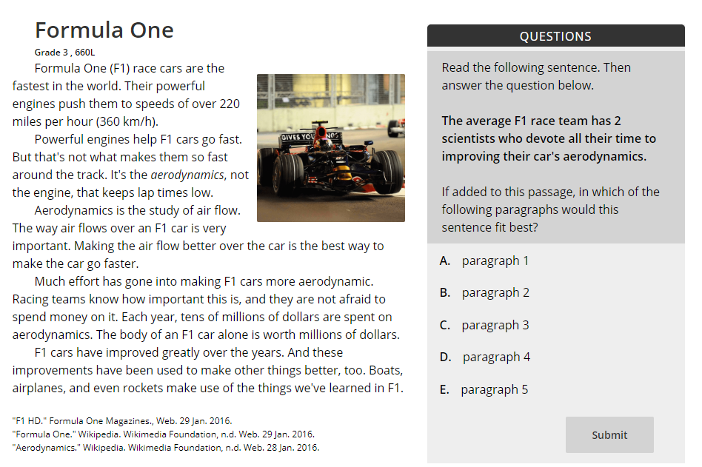
You can also log onto readtheory.org using the username and password your teacher has given you.

When you log into read theory you will have a short text and questions related to it. The website will give you harder or easier texts depending on how you answer the questions.

You earn individual and class points by getting questions correct and earn badges when you reach different levels.
Maths
There are lots of different maths activities in this booklet for you to have a go at. They are split up into Tricky, Trickier and Trickiest but remember you don’t just have to do one challenge, you could work through them.
Throughout the maths pages there are different prompts or examples to help refresh your memory and support you if you get stuck.
There are also activity pages about your times tables. Try to practise your times tables every day either on a website or on paper using the activity cards.

Rounding

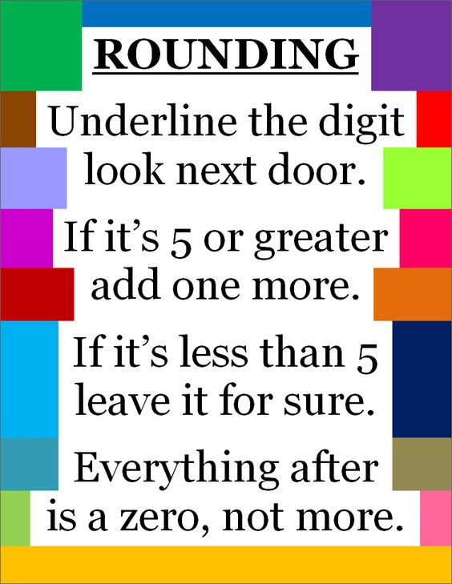

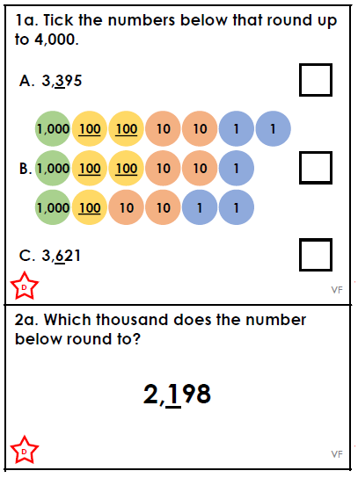
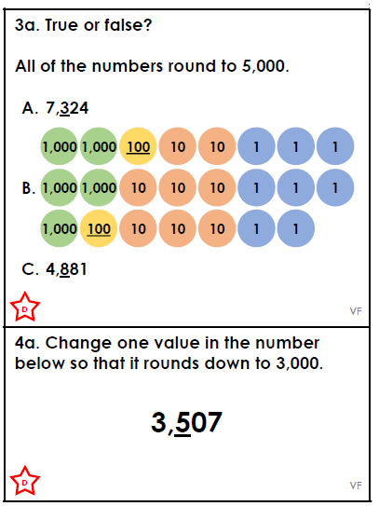
Tricky

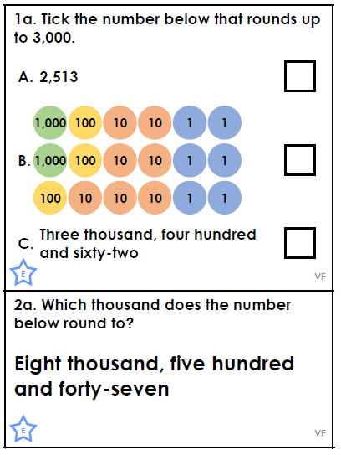
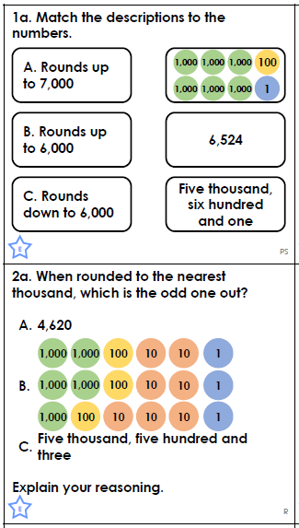
Trickier

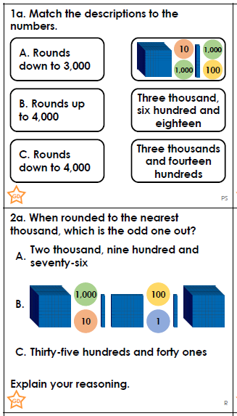
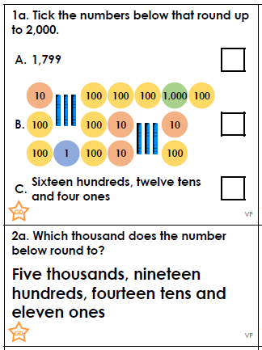
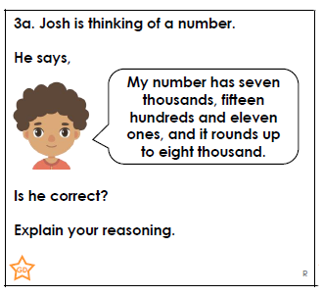
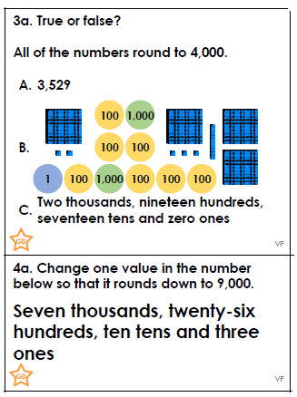
Trickiest

Addition – Tricky & Trickier

Use a formal written method like the one below to answer these questions.

H T O
3 4 7
2 7 5 +
If you are confident, you can use the compact method without these steps.

--------------
1 2 O
1 1 0 T
5 0 0 H
--------------
6 2 2

- 281 + 116
- 344 + 235
- 643 + 327
- 823 + 129
- 1,920 + 271
- 2,356 + 2,543
- 6352 + 2, 326
- 8,126 + 1722

Subtraction – Tricky & Trickier
Use a formal written method like the one below to answer these questions.

H T O
6 8 3
2 5 1 -
If you are confident, you can use the compact method without these steps.

--------------
2 O
3 0 T
4 0 0 H
--------------
4 3 2

- 543 – 211
- 768 – 556
- 328 – 327
- 643 – 272
- 6,457 – 3,322
- 4,317 – 2,104
- 5,339 – 1, 612
- 6,284 – 2,526
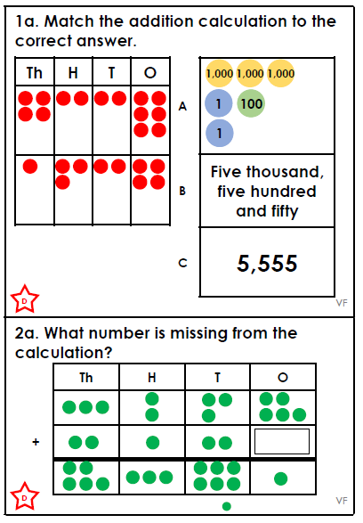
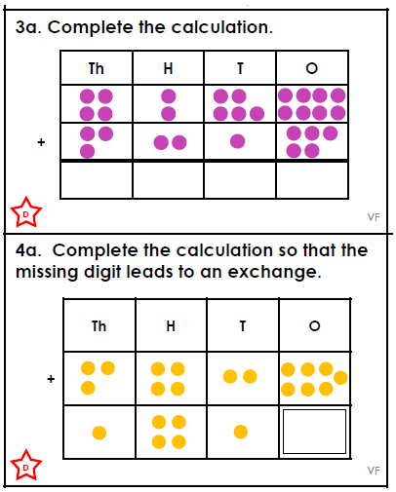
Tricky

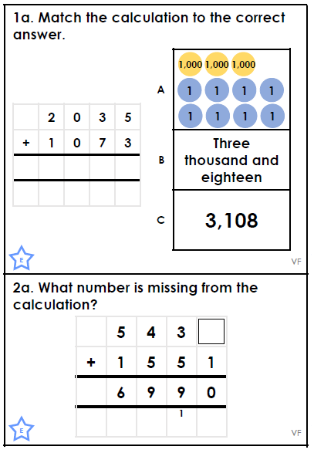
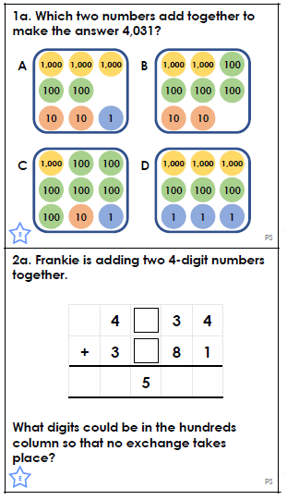

Trickier

Addition and Subtraction - Trickiest
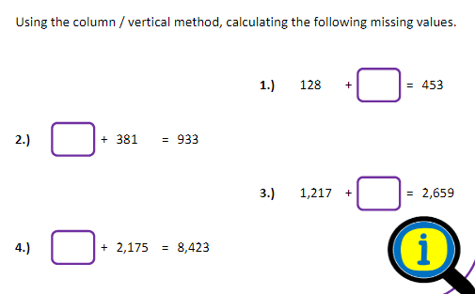
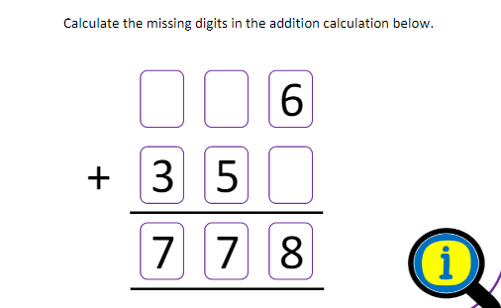
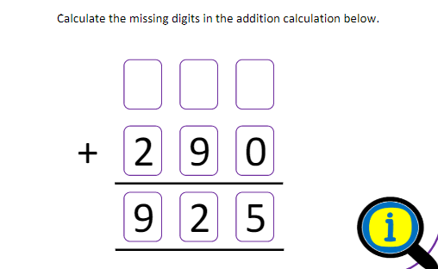

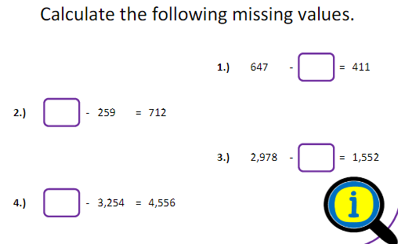
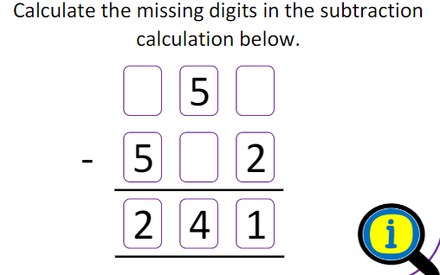

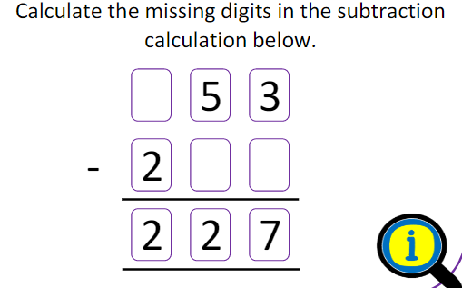
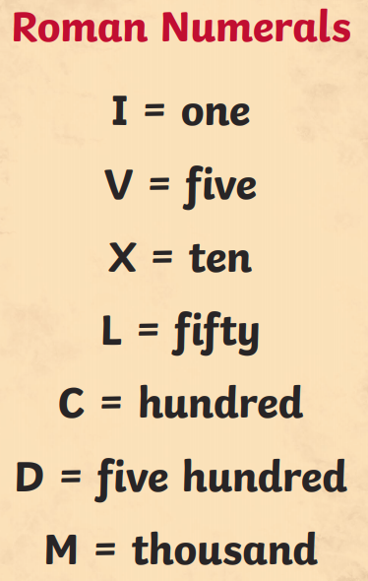
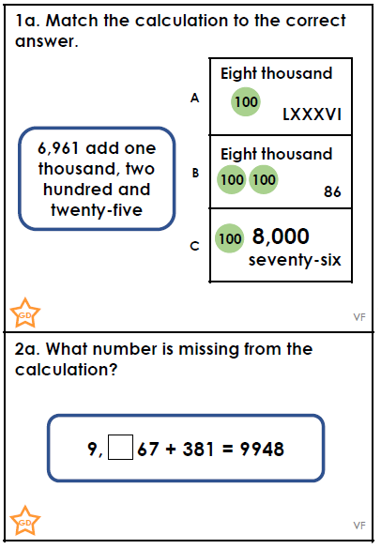
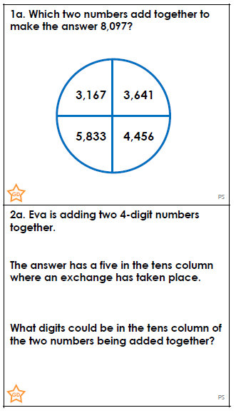
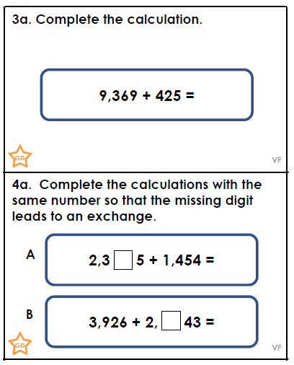
Trickiest

Maths Space Mission
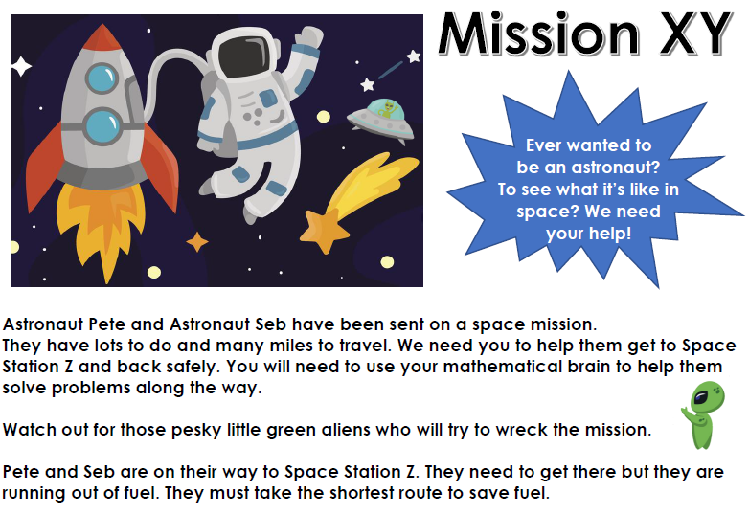
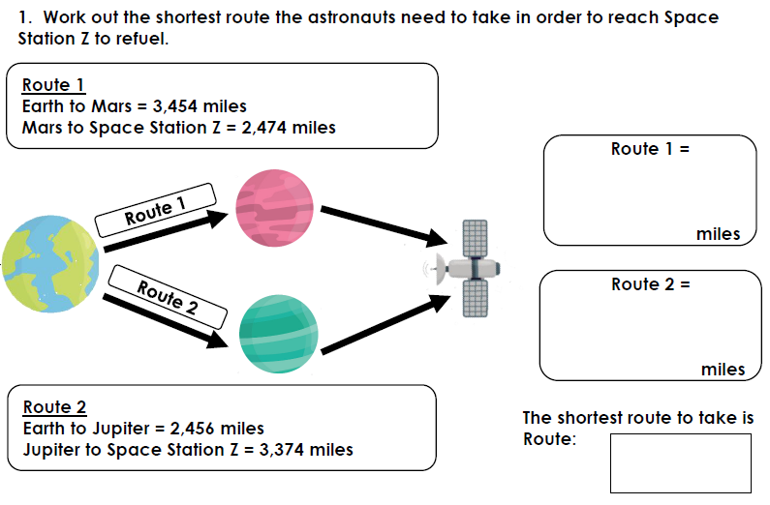
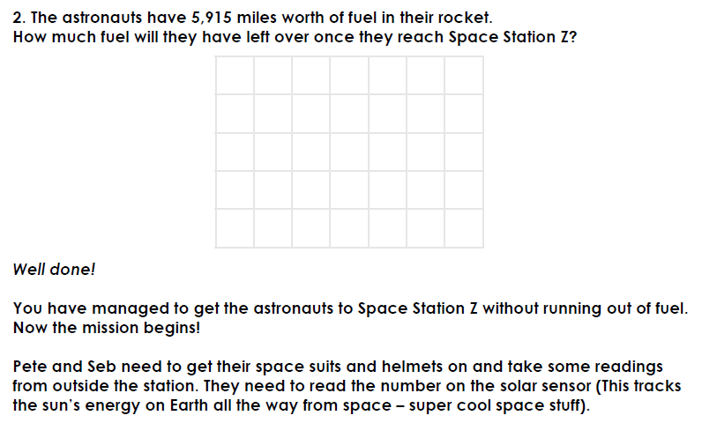
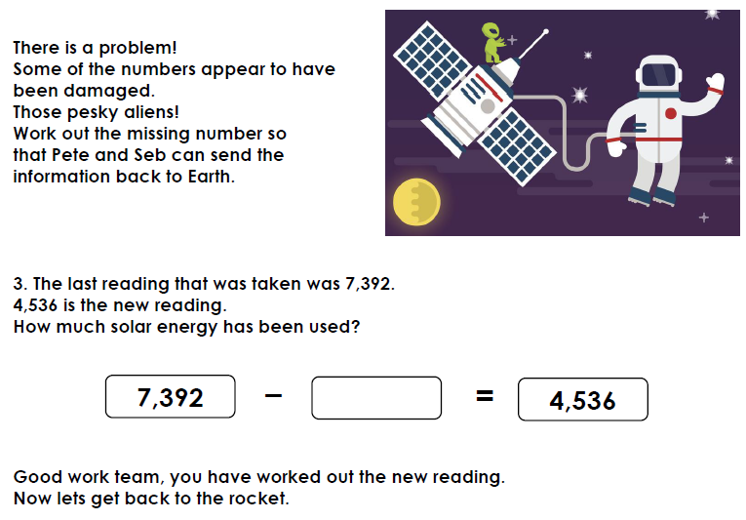

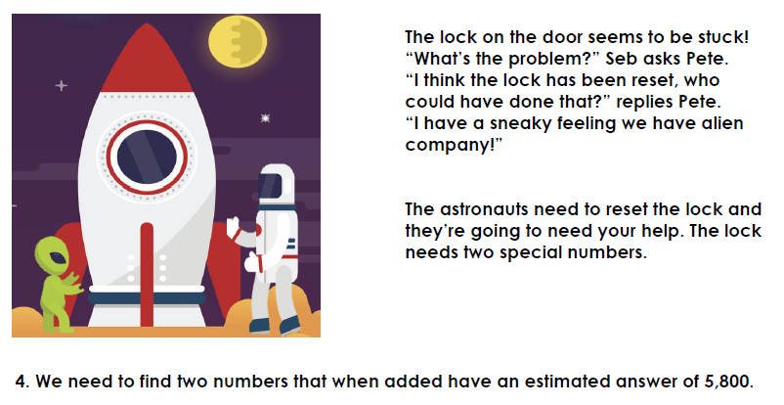
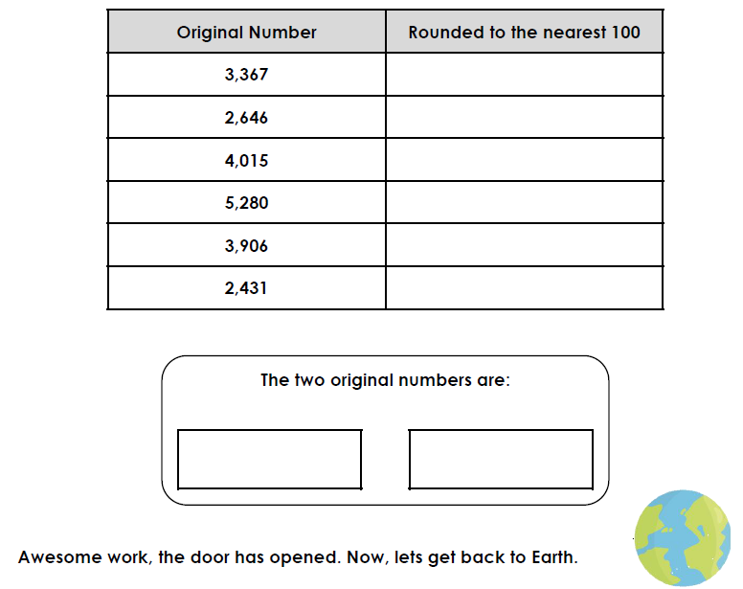

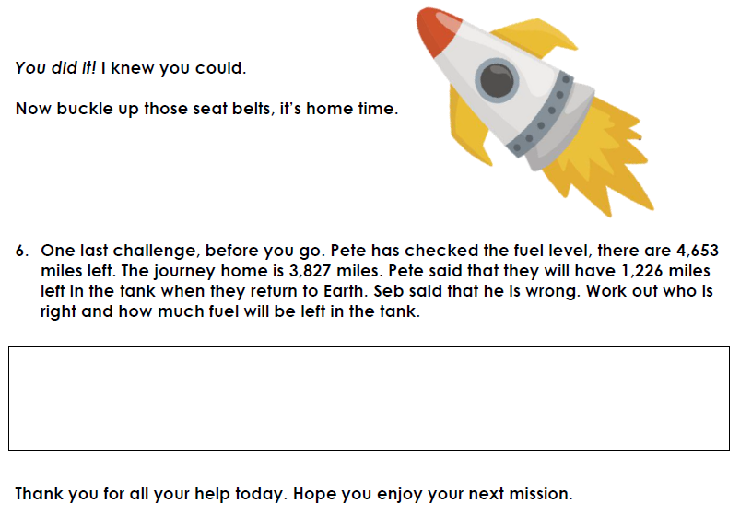
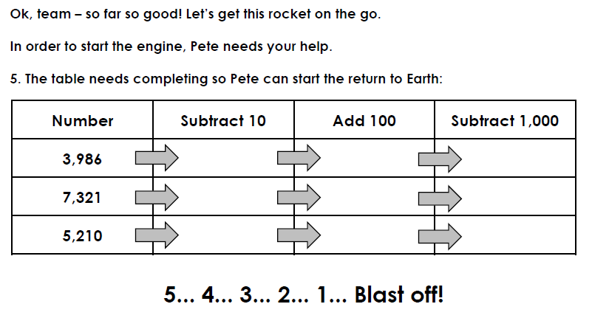

Multiplication – Tricky & Trickier
Use a formal written method like the one below to answer these questions

H T O
1 3 5
4 x
If you are confident, you can use the compact method without these steps.

--------------
2 0 O (5x4)
1 2 0 T (30x4)
4 0 0 H (100x4)
---------------
5 4 0

- 75 x 6
- 32 x 8
- 89 x 2
- 124 x 5
- 258 x 3
- 637 x 4
- 439 x 7
- 243 x 9

Division – Tricky & Trickier
Use a formal written method like the one below to answer these questions

2 3
If you are confident, you can use the division bracket method without these steps.

2 4 6

40 ÷ 2 = 20
6 ÷ 2 = 3
46 ÷ 2 = 23

- 93 ÷ 3
- 84 ÷ 4
- 363 ÷ 3
- 488 ÷ 4
- 138 ÷ 6
- 540 ÷ 4
- 868 ÷ 4
- 854 ÷ 7

Multiplication and Division - Trickiest

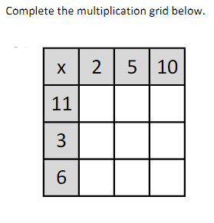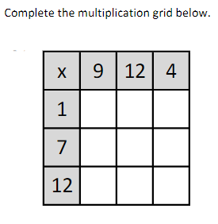

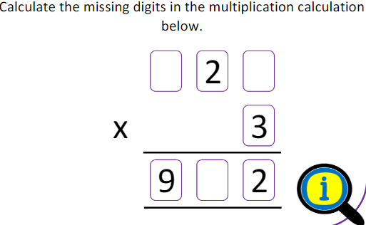
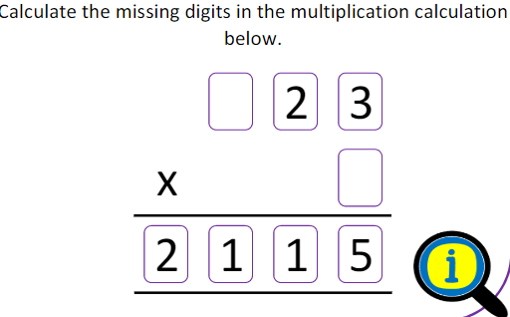
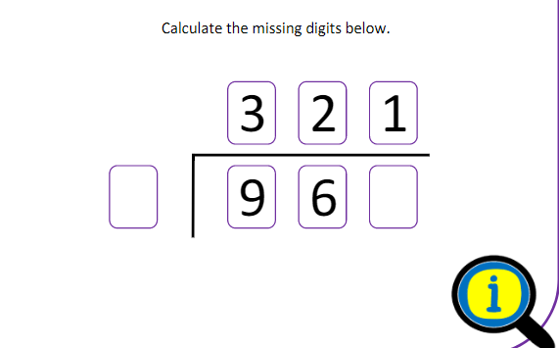
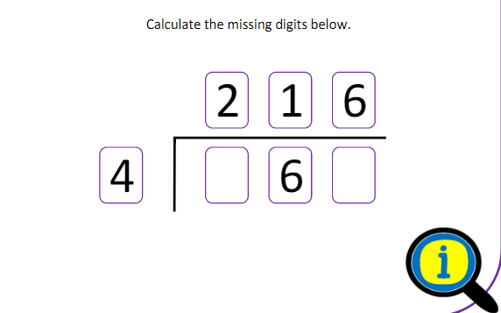
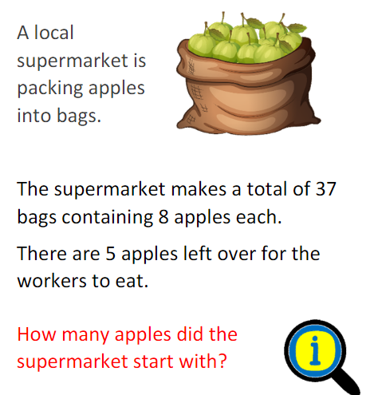
Times Tables
There are lots of great ways to practise your times tables while you’re not at school. There are lots of strategies on the next page, very similar to the spelling ones.

There are also lots of websites you can use to practise your times tables:
www.topmarks.co.uk has lots of great games
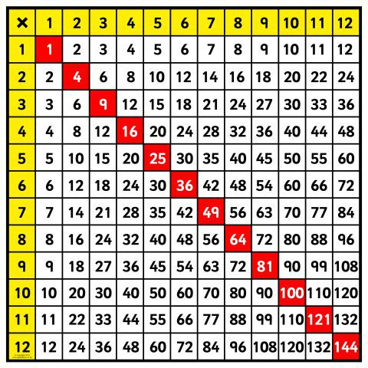
www.timestables.co.uk has some games as well as the practice area for the Multiplication Tables Check.
www.mathsframe.co.uk has lots of different games and activities to try.
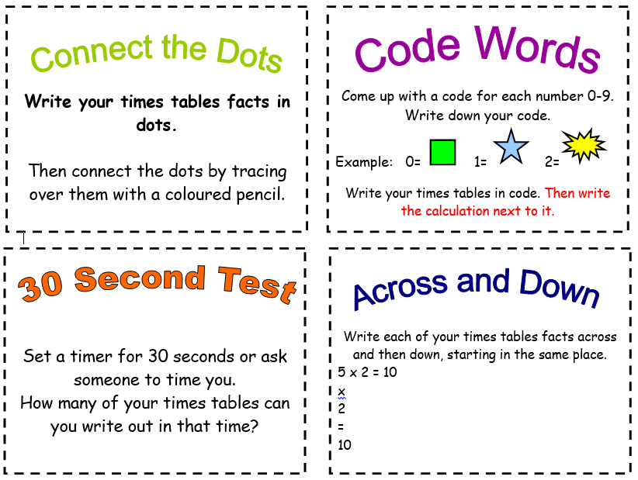
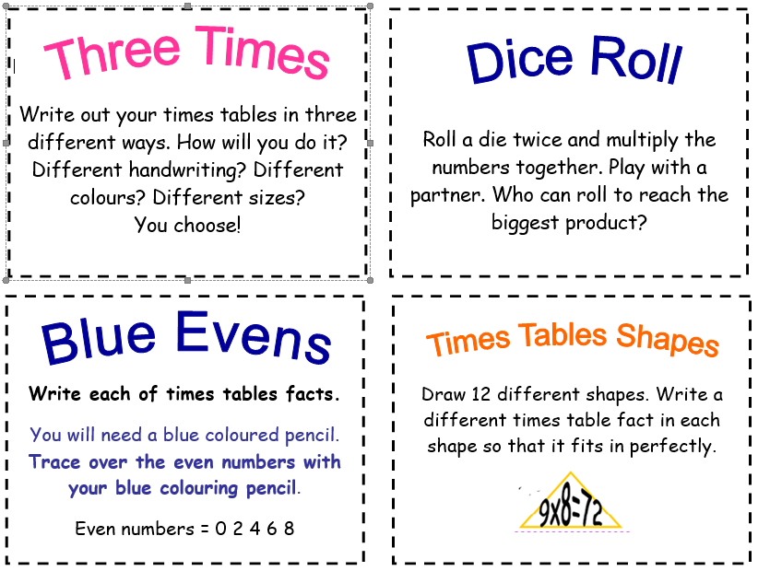
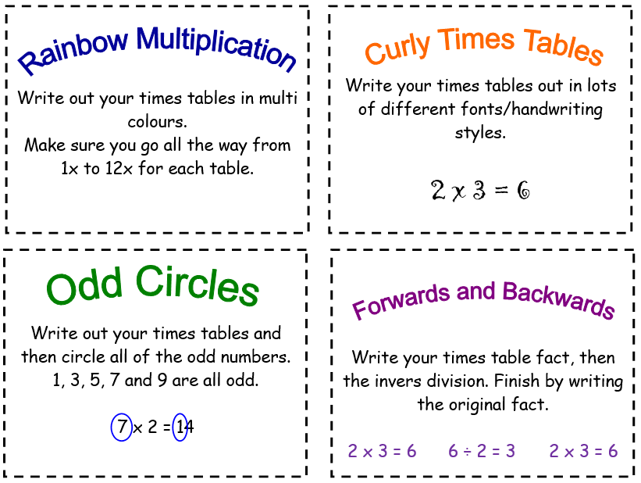
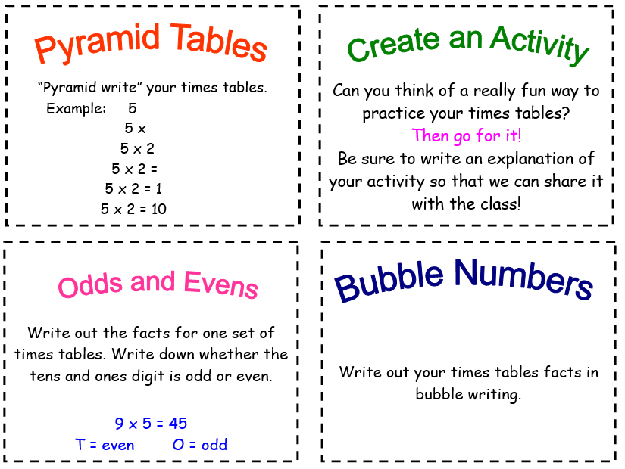

a

Times Tables Reasoning

3 x tables
- Sarah says, “I know my 3 times table so I can work out 30 x 70 without using a written method.” Explain why Sarah can do this.

- Fill in the gaps

 | 9 | 12 |  |  | 21

- David says, “Because 3 is odd, all multiples of 3 will be odd.” Is David correct? Explain your reasoning.

- James is buying CDs. He buys 3 CDs at a cost of £8 each. Draw a diagram to show your working out and then write the calculation.

4 x tables
- David says, “I know that the 4 times tables is linked to the 2 times table.” Explain why the two are linked.

- Anna says, “I know the answer to 4 x 16 without using a written method.” Explain how Anna has been able to calculate 4 x 16.

- Fill in the gaps

 | 200 | 240 |  |  | 360

- David spends £48 on four t-shirts of equal cost. How much does each shirt cost?

6 x tables
- Fill in the gaps:
6 x ____ = 24 48 ÷ ___ = 6
6 x ____ = 54 30 ÷ 6 = ___
6 x ____ = 18 72 ÷ ___ = 6

- David says, “I am not confident with my six times tables but I know my threes so I can use them to help.” Is David correct? Explain your reasoning.

- Create a word problem that requires you to use the 6 x table.

- David says, “All multiples of 6 are even numbers, whether I multiply them by an even number or an odd number.” Can you explain why this is?

7 x tables
- True or false? Every other number in the 7 times table is odd. Explain your answer.

- Helen is buying 5 birthday cakes at £7 each. Draw a diagram to show this calculation.

- Fill in the gaps:

7 |  |  | 28 |  | 42

- James says, “If I know 7 x 6, then I can solve 7 x 60 just as easily.” Is he correct? Explain your reasoning.

8 x tables
- David says, “I know without even solving the calculation that 2461 divided by 8 will have a remainder.” Is David correct? Explain your reasoning.

- Ben says, “I know my 8 times table so I can work out 800 x 5 without using a written method.” Explain why Ben can do this.

- Fill in the gaps:
8 x ____ = 48 48 ÷ ___ = 8
8 x ____ = 32 32 ÷ 8 = ___
8 x ____ = 16 16 ÷ ___ = 8

- What is the perimeter of a regular octagon if each side measures 7cm?

9 x tables
- David says, “I’m not very confident with my 9s but I know my 10s.” Explain how David can use his knowledge of the 10 times tables to help him work out his 9s.

- Fill in the gaps:

 | 27 | 36 |  |  | 63

- Always, sometimes, never? When you multiply a number by 9, the answer will be an odd number. Explain your reasoning.

- Sarah says, “If a number is a multiple of 9, then it will also be a multiple of 3.” Is Sarah correct? Explain your reasoning.

12 x tables
- Fill in the gaps below:

 | 36 | 48 |  |  | 84

- Sarah says, “Because 12 is a multiple of 4 that means any multiples of 12 will also be multiples of 4.” Is Sarah correct? Explain your reasoning.

- Always, sometimes, never? Because 12 is an even number, whatever number you multiply it by will give you an even answer. Explain your reasoning.

- How can you use your 2 x tables and 10 x tables to work out your 12 x tables? Explain your reasoning.

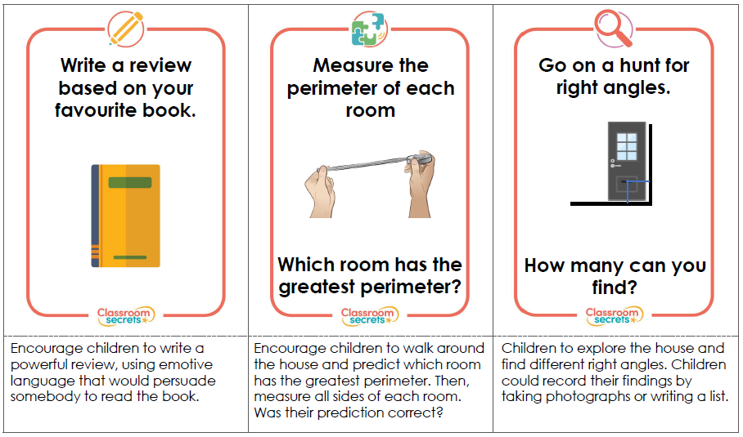
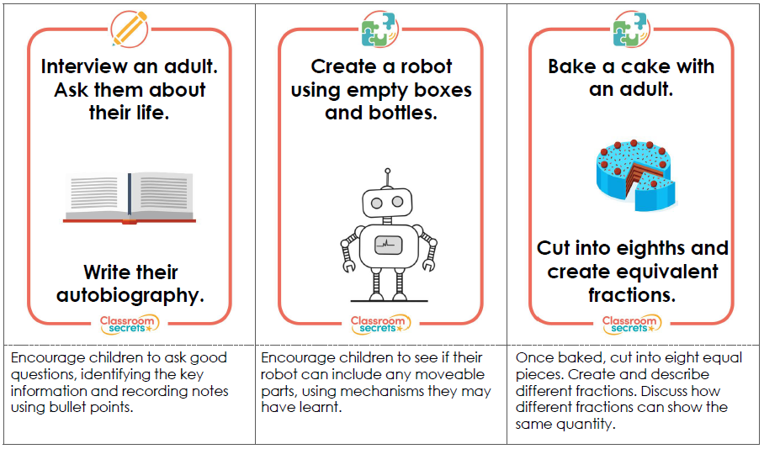
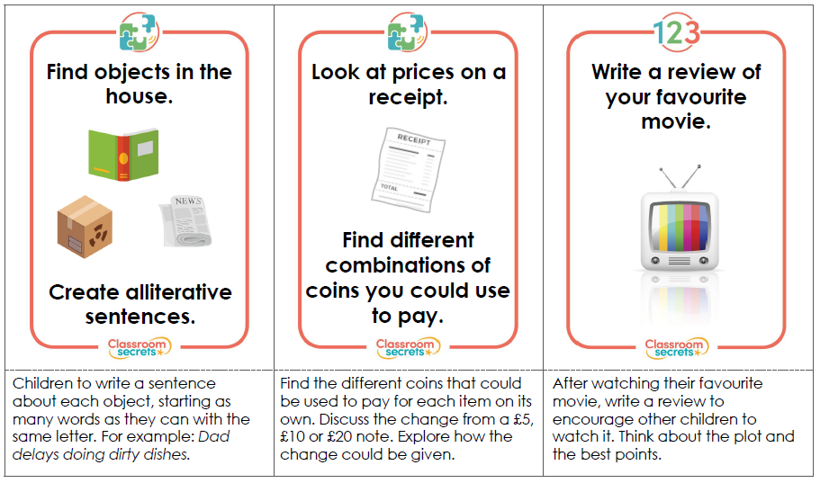
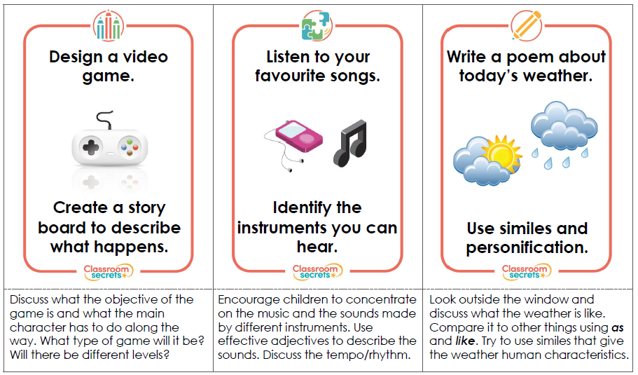
Practical Activities

Geography
Our geography topic this term is comparing Italy and the UK. We have learnt about Europe, the continent both place are in and have looked a little bit at the UK and Italy.
Spend some time researching and creating a fact file about a particular city or region of Italy. You might decide to make a hand drawn/written poster, PowerPoint presentation, poster in Word or Publisher, or even a little booklet.
You could use instructions like these to make your booklet: https://www.wikihow.com/Make-a-Paper-Book

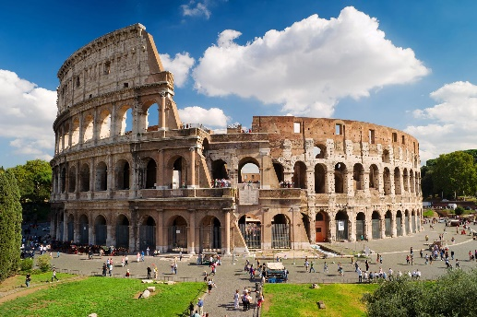
Find out about the physical and human geography of your chosen Italian city or region.
- Physical geography is the natural processes of the Earth e.g. climate, mountains, rivers, cities, etc.
- Human geography is the impact of people on the world e.g. population, trade, culture, economy

Think about the following questions:
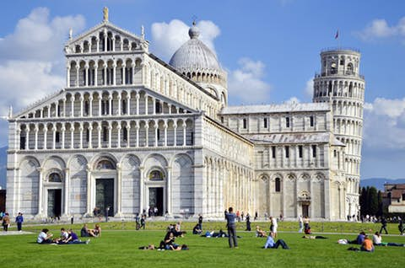
- Which continent and country is your chosen region in?
- What is the current population?
- What is the climate like? Is it different to other parts of Italy?
- What are the main physical geographical features such as rivers, mountains, volcanoes?
- Are there any famous landmarks in the chosen region?
- Have any famous historical events happened in the region?
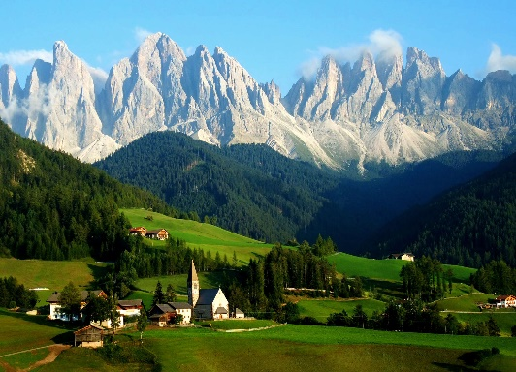
This website might be a good starting point for your research: https://www.kids-world-travel-guide.com/italy-facts.html

If you enjoy arts and crafts or making things, you could make a model or sculpture of a famous landmark from the region you have researched.
Art
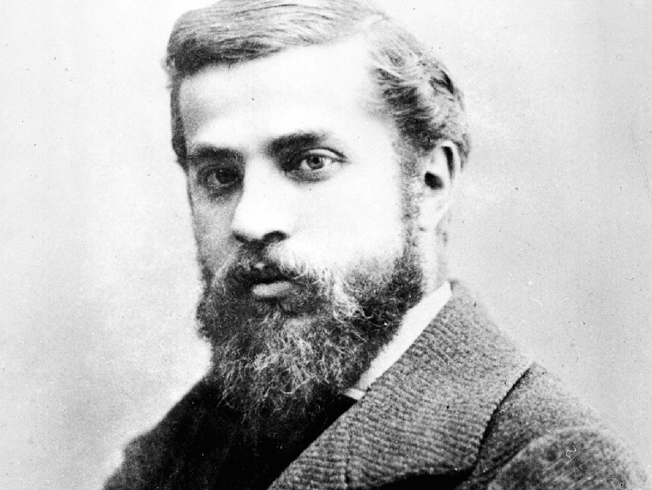
Next term we will be looking at one of the most well-known architects, Antoni Gaudi. Millions of tourists visit his masterpieces in Barcelona every year, such as Sagrada Familia.
There are lots of interesting facts about it such as the fact that it is still not completed, despite the project being started in 1882. It is estimated that it will be finished by 2026.
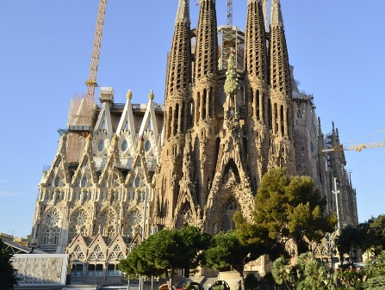
Gaudi is also famous for his contribution to the art world. He used a trencadis mosaic style which consists of joining together broken pieces of tiles. He didn’t like the shape of square tiles so he broke them into more natural shapes. A famous example of this art style is the Dragon in Park Guell.
In the close up of the dragon’s foot, you can see how the pieces of tiles fit together as if they were a jigsaw.
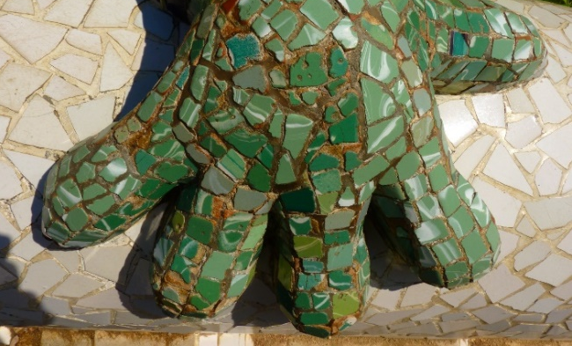
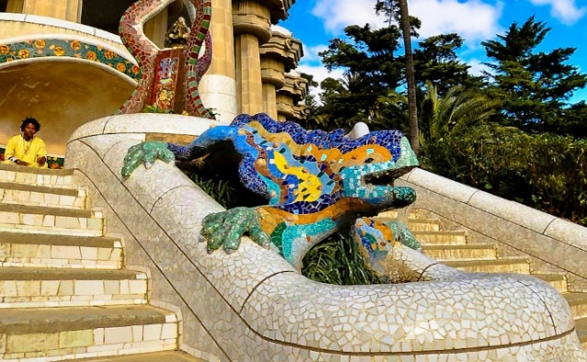
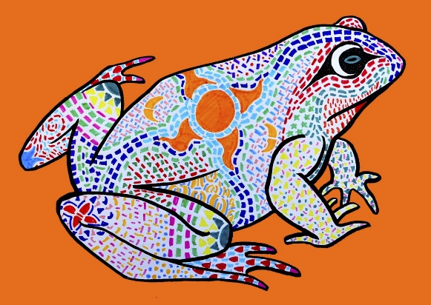
Research Gaudi, his architecture and art work, especially his mosaic work. Look for examples of how nature inspired his work. This research will be really useful when we come back after Easter and start studying Gaudi.

Have a go at creating a picture in the style of Gaudi’s trencadis mosaic style. Once you have done one, look at it closely and evaluate the similarities and differences between your work and Gaudi’s. Why don’t you try having another go? How will you improve it?

Science
Here are a range of different activities linked to our science topic. Choose to do as many or as few as you want.
Our topic this term is electricity. Remember that there are lots of dangers surrounding electricity and you need to stay safe if you are looking at or using electrical appliances. Make sure an adult knows what you are trying to do so they can help you!
Activity 1 | Activity 3 | Activity 5 | Activity 7 | Activity 9 | Activity 11
Research Thomas Edison and other inventors involved with electricity. What inventions do we still use today? | Draw a plan to illustrate the electrical appliances you have in and around your home. Show where they are in each room. | Create a poster to remind others how to use electricity safely. Make it eye catching and bold to get the message across. | Imagine you’re a famous inventor and you’re being interviewed about your inventions. What have you invented and why is it useful? | Design or make your own invention of the future. What materials will you used? What would it do? How would it work? Battery or mains powered? | Write a short evaluation about how you made your invention or write instructions of how you could make it. What worked well? What could you improve?
Activity 2 | Activity 4 | Activity 6 | Activity 8 | Activity 10 | Activity 12
Ask a member of your family what life was like before the most common electrical appliances such as mobile phones, computers, tablets. What did they do with their time instead? | Sort objects/appliances into battery powered and mains powered. You could present this in a table with photos, drawings and labels. | Design a three course meal that you could make without using electricity. | Imagine there is a power cut and there is no electricity for a day. How would you cope? What would you do?  Create a comic strip, diary or story about your day. | Write an electricity poem. It could be an acrostic poem, shape poem, haiku, free verse, rhyming or repetitive poem. Think about the poems we learnt about earlier in the term. | Use some of the facts you have learnt about electricity to make a quiz. When we come back to school we can have a go at your quizzes in class.

