YEAR 6
HOME LEARNING PACK - 1
NAME: __________________________________
CLASS: __________________________________

Contents
ENGLISH 3
WRITING - The Lighthouse……………………………………………………………………………………………………………..3
READING 8
SPELLING………………………………………………………………………………………………………………………………………10
GRAMMAR 13
MATHS 14
Times Tables 14
Times Tables Rock Stars 16
Additional Maths Activities at Education City 16
Calculation revision: 16
Maths Home Learning: 16
Rapid Reasoning: 27
NRich Activities: 35
SCIENCE 37
Light 37
HISTORY 41
How has life changed within living memory? 41
ART 42
OTHER IDEAS …………………………………………………………………………………………………………………………………..45

ENGLISH
There are a range of different activities in this booklet based on things we have already been learning about.
There are 2 main writing tasks relating to a short animation, The Lighthouse – writing a poem and a narrative. In addition to this, you should be practising your spellings every day and reading appropriate and challenging texts.
The Lighthouse – activity one
Click on the link below and watch the animation, stopping at the places detailed to think deeply about the questions being asked. Discuss them with an adult if they are available to watch the film with you.
https://www.literacyshed.com/the-lighthouse.html
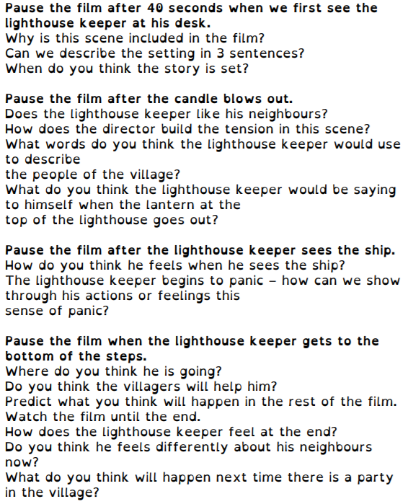
Watch the animation again and see how many of these things you can spot. Tick them when you see them. You may need to watch the animation for a third time to spot them all!
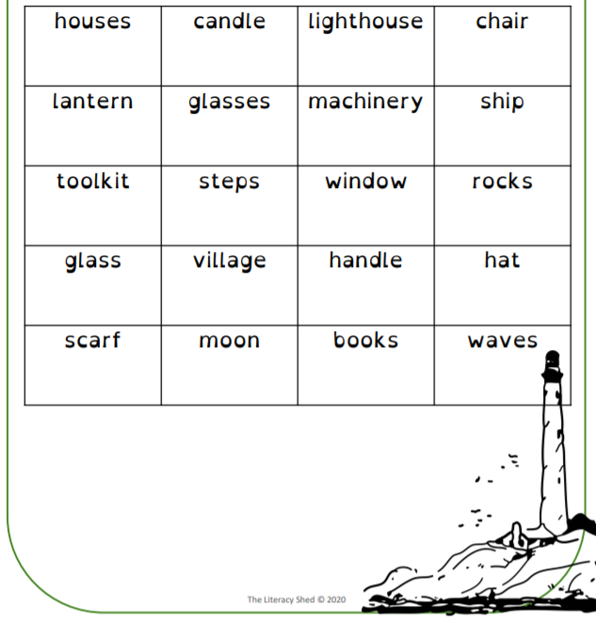

The Lighthouse – activity two
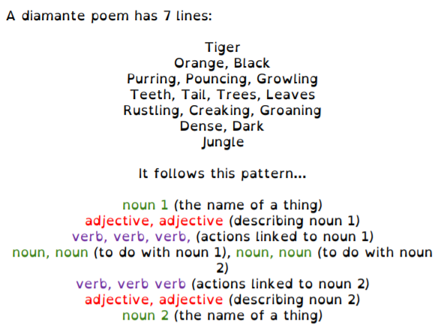
Can you create a diamante poem for the lighthouse and the sea? You may wish to use some of the ideas below to help you create your poem. Challenge yourself to use the most powerful and evocative language you can.
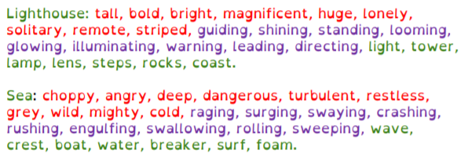

The Lighthouse – activity three
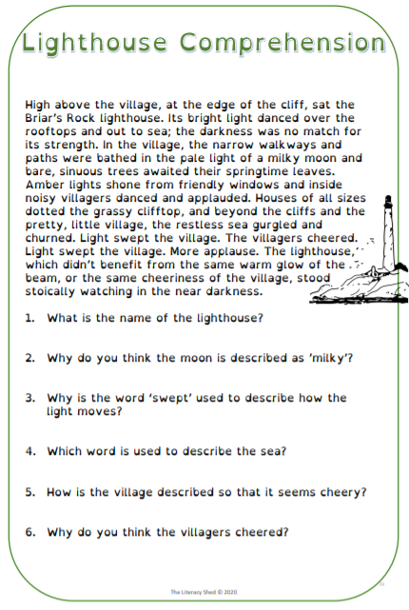
Using your current reading book, select a section which is of a similar length to the one above and devise six questions which use the following skills: retrieval, inference, vocabulary, explanation, prediction and sequencing or summarising.
Ask a member of your family to try answering your questions.

The Lighthouse – activity four
Watch the film again. Now, write the story from where the lamp smashes and the ship approaches? Remember to make your writing as exciting as possible.
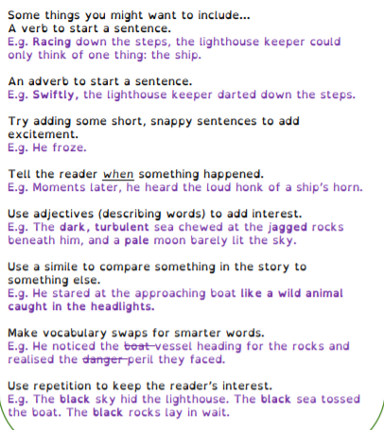
The Lighthouse – activity five
Complete your narrative and finish your piece of writing by editing it carefully. When editing, focus on:
- ensuring every sentence makes sense
- varying your sentence starters
- up-levelling your choice of vocabulary
- improving your punctuation
- correcting your spellings
You may wish then to produce and publish a final draft with illustrations or a border.

READING JOURNAL
Remember that you should be reading for 20 minutes each day. Hopefully, you will be able to find the opportunity to read aloud to someone for that amount of time. You may also be spending further time reading independently or perhaps, enjoying a bedtime story read by a family member.
A good way to ensure you are using all of your reading skills is to keep a reading journal. Each day you can record the title of the book you are reading and which pages you have read. Then, choose a prompt from below that is relevant to the section you have just read. Some prompts will be better suited to the opening of a story whereas others will be easier to respond to when you are further into the plot. Record your written response to the prompt in as much detail as you can. Remember that a really valuable reading skill is being able to support or justify your opinions with details or quotations from the text itself.
Keep enjoying your reading and we look forward to hearing your responses!

Can you recognise any literary devices?  E.g. similes, repetition, power of 3.  What effect do you think the author was intending them to have? | Think about the setting of your book.  How does the setting influence the action in the story?  How would the story change if it was set elsewhere? | Choose a section of the story where you think there was a transition between stages (introduction, problem, build-up, climax, resolution).  What clues are there that you are entering a different stage?
After a key event, predict how one character might react or change as a result.  Use clues from what you have already learnt about them to justify your prediction. | Pick 5 words that are new to you.  Find them in the text and then, for each one, suggest 3 synonyms that could be put in their place so the story would still make sense. | Choose a moment in the story when you think one character should have acted differently.  Write what you would say to them to persuade them to make a different choice.
Pick one character.  Write an explanation of how they are similar to a character from a different book you have read.  Which character do you prefer and why? | Choose what you think is a significant quotation from the section of the story you have read.  Explain why you think it is significant and how it might continue to be significant as the story continues. | Pick a section of the story where you felt a strong emotion in some way.  How do you think the author managed to make you feel like this?

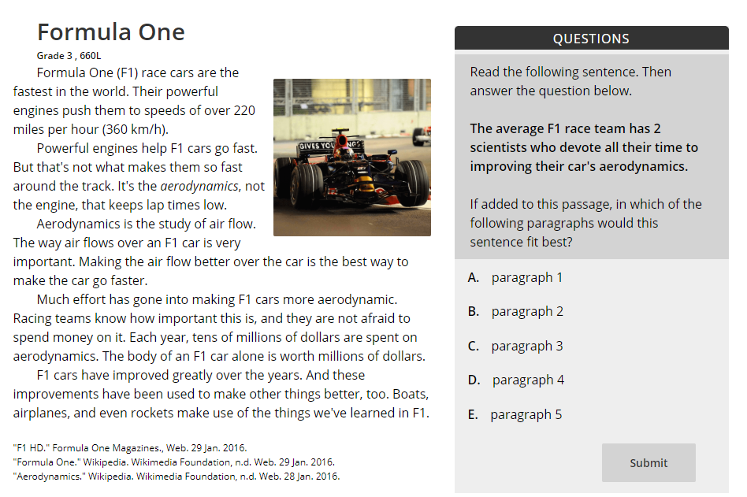
You can also log onto readtheory.org.

When you log into Read Theory, you will be presented with a short text and questions related to it. The website will give you harder or easier texts depending on how you answer the questions.
You earn both individual and class points by answering questions correctly as well as badges when you reach different levels.

SPELLING
Spelling Activities:
Using Spelling Frame (https://spellingframe.co.uk/) along with some of the different strategies included on the next page, practise spelling the next section of words from the Year 5/6 spelling list:
government guarantee harass hindrance
identity immediate immediately individual
interfere interrupt language leisure
Remember to login before you complete any tests or games so that your efforts are recorded.
You should continue to review previous words on the Year 5/6 spelling list – a copy of the list is included in this pack. In addition to the strategies included on the following page, you can also use the look, say, cover, write, check technique explained below. Just use your ideas book and remember to tick them off in your reading records when you have mastered them.
Look  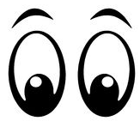 | Look at the word. How many parts are there?  What are the tricky bits?  Can you find any spelling patterns?
Say | Say the word to yourself.  Break the work up into syllables.  How many parts are there?  What sounds can you hear?
Cover | Cover up the word so you can’t see it.  Picture the word in your mind.
Write | Write down the word, remembering how it sounds and what it looks like.
Check | Check to see if it’s correct.  Tick the letters you got correct.  Write the word correctly if you made a mistake.

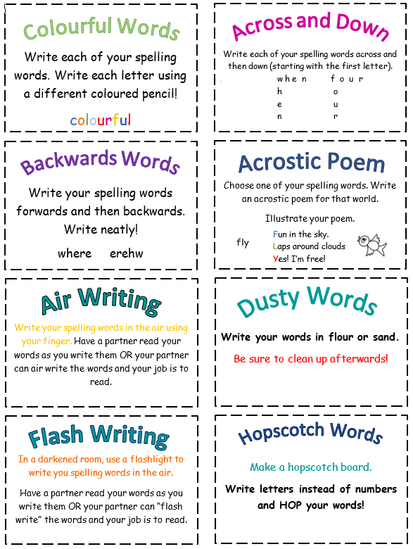
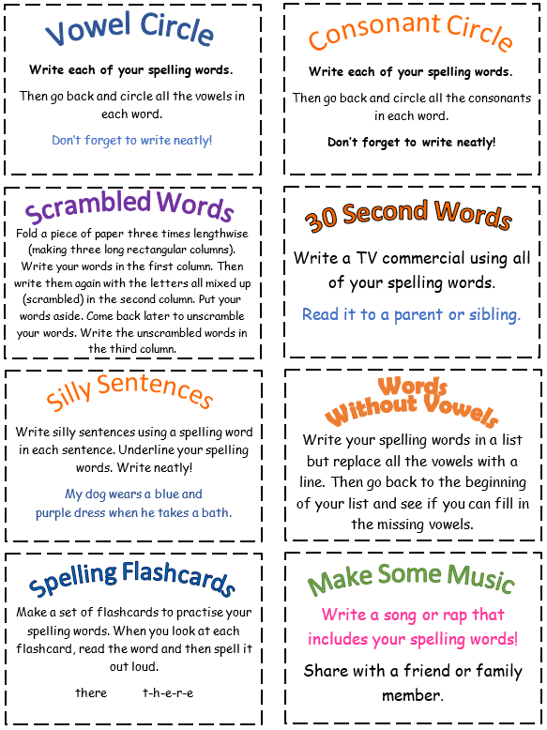

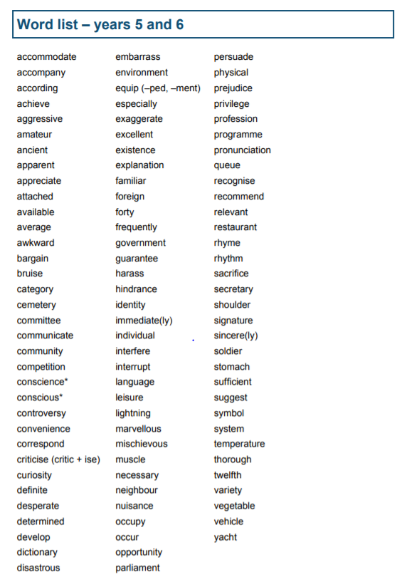

GRAMMAR AND PUNCTUATION
Continue to revise all the elements of grammar we have covered during your time at St Paul’s. You can do this by:
- tackling the previous SATs papers - http://www.satspapers.org/ks2english2016onwards.htm
- referring to the BBC Bitesize videos and instruction - https://www.bbc.co.uk/bitesize/topics/zhrrd2p
- going on to Education City -

Identify for yourself the areas you need to focus upon.

MATHS

Times Tables
There are plenty of great ways to practise your times tables while you’re not at school. There are lots of strategies on the next page, very similar to the spelling ones.
There are also a range of great websites you can use to practise your times tables too:
www.topmarks.co.uk has lots of great games
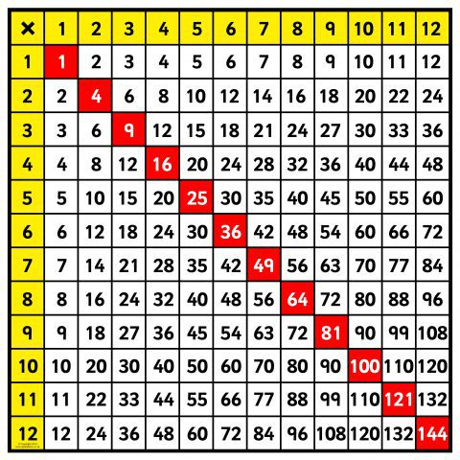
www.timestables.co.uk has some games as well as the practice area for the Multiplication Tables Check.
www.mathsframe.co.uk has lots of different games and activities to try.

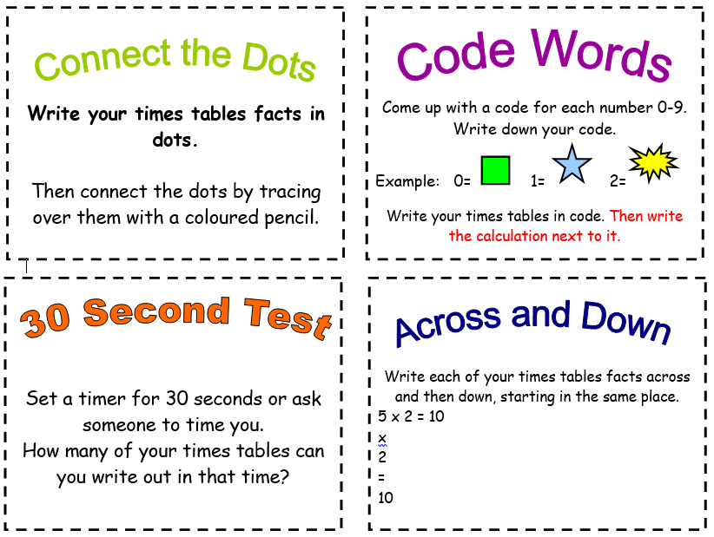
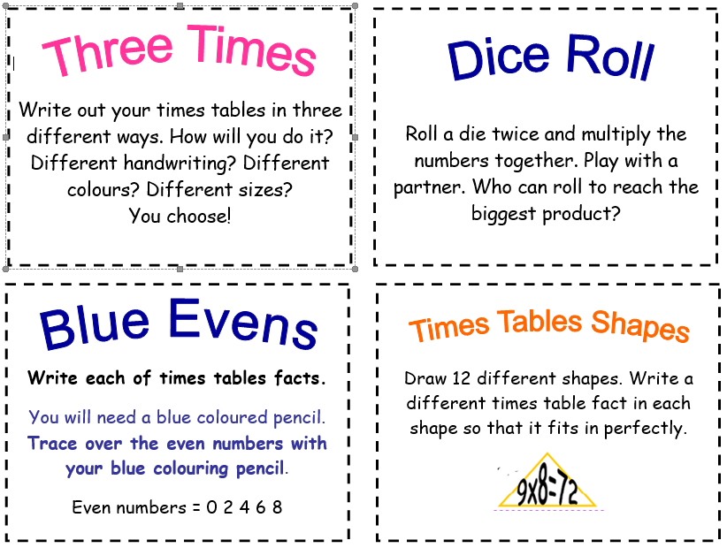
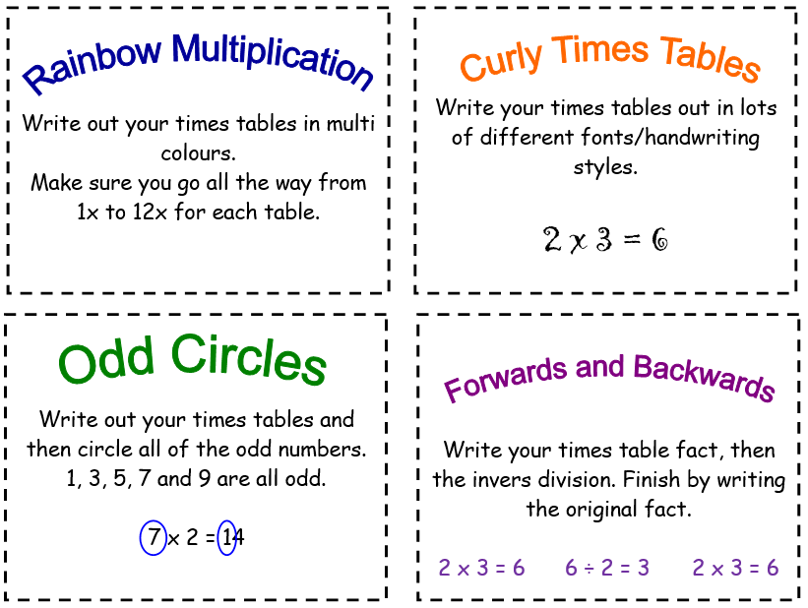
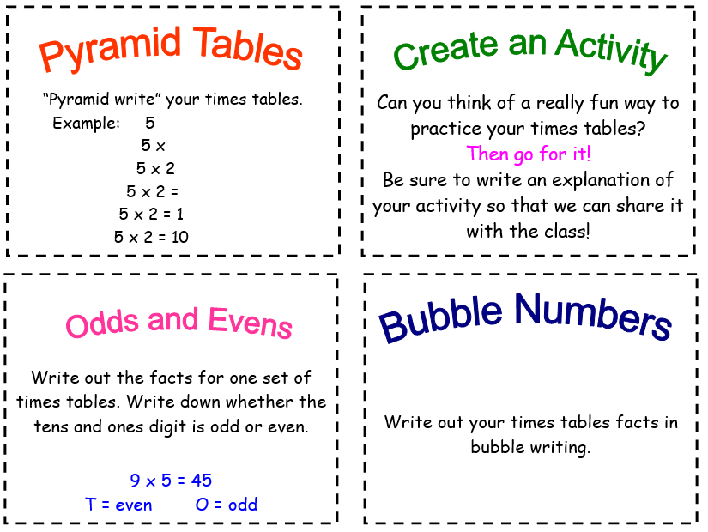

a

Times Tables Rock Stars
Login here:
https://ttrockstars.com/
You will have been sent login usernames and passwords.
You can download worksheets to practise each of your times tables.

Additional Maths Activities at Education City
Login here:
https://ec1.educationcity.com/
You will have been sent login usernames and passwords.

Calculation Revision
Work through each Rapid Reasoning task on a daily basis. This is revision for work covered during the course of year 5 and year 6. The tasks appear in this booklet (pp. 26-31) after the main Maths home learning for the week. The answers appear on p.32.

Maths Home Learning:
Once you have completed the Rapid Reasoning tasks, go to the following website where you can work on developing your understanding of ratio.
https://whiterosemaths.com/homelearning/year-6/
There is an online tutorial and then worksheets with answers to print out and complete. The worksheets are attached below if you would like to work on them in the booklet. The questions get more difficult as you go through each activity so you need to work through the questions from the start.

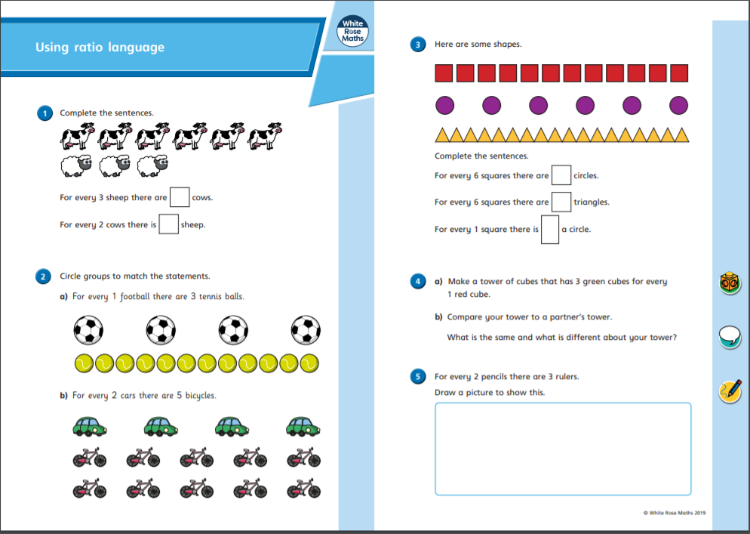
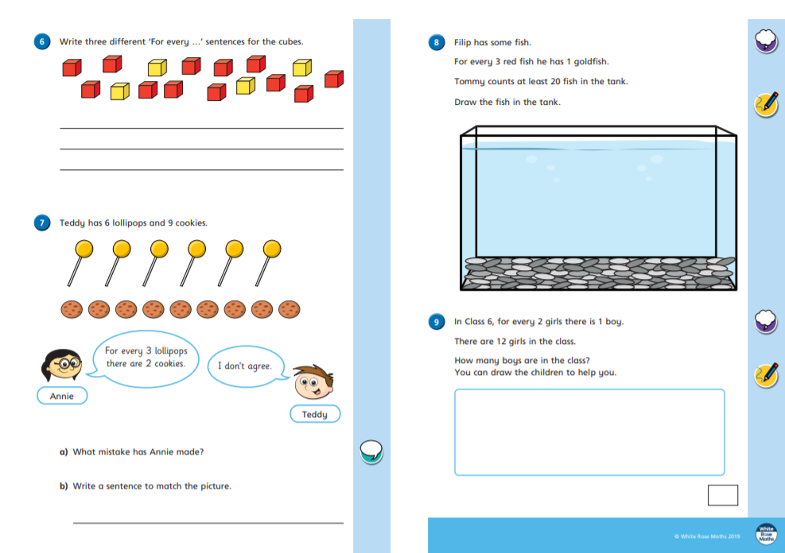
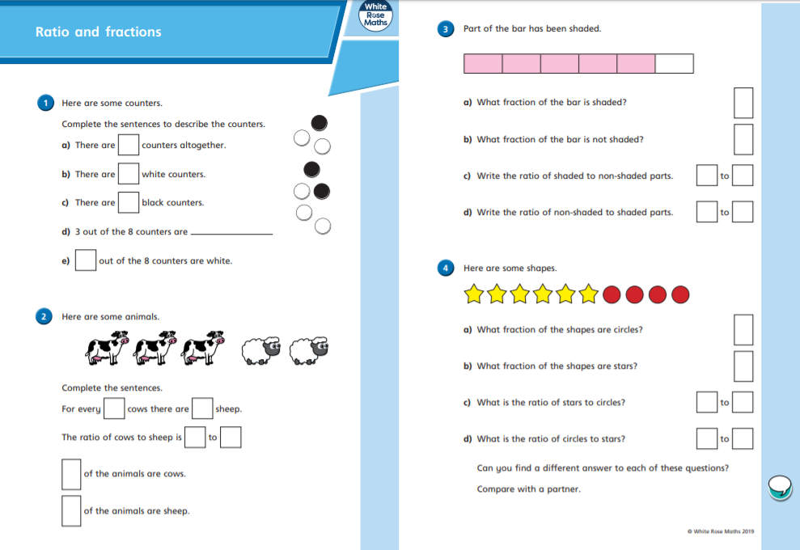
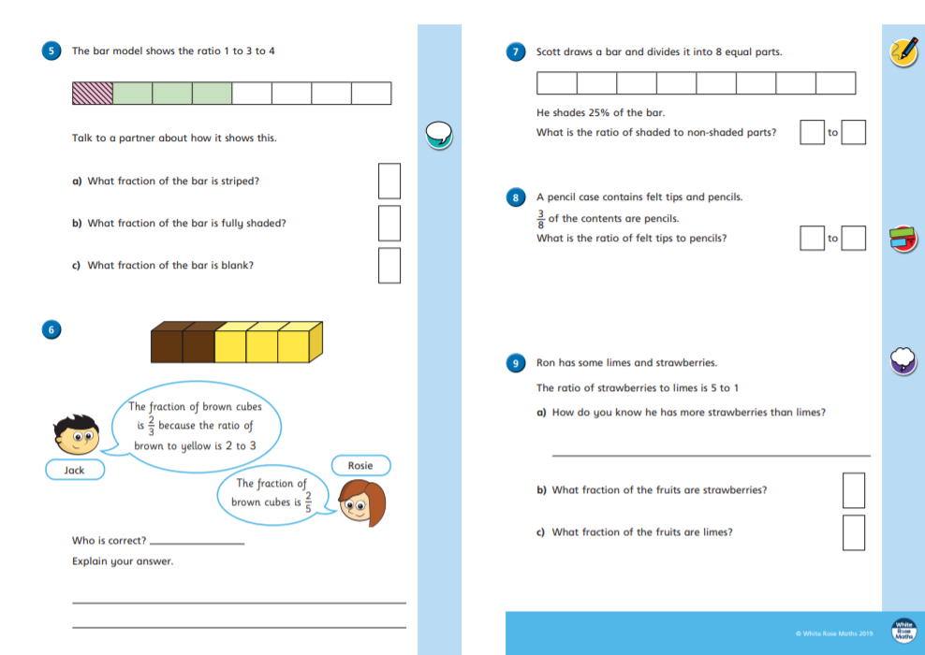
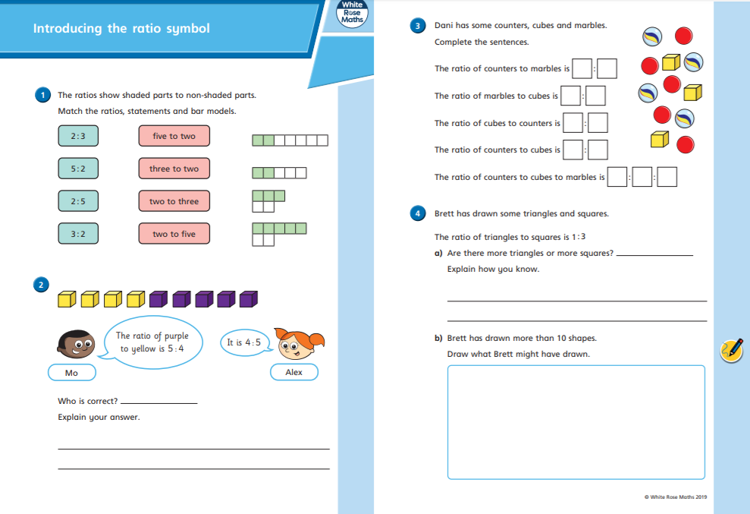
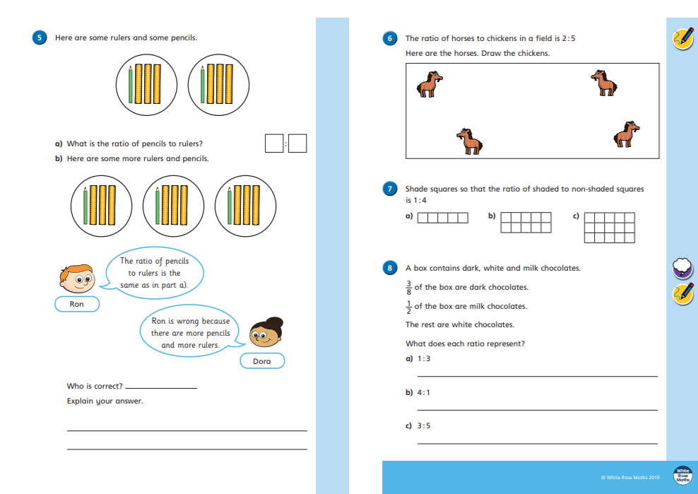
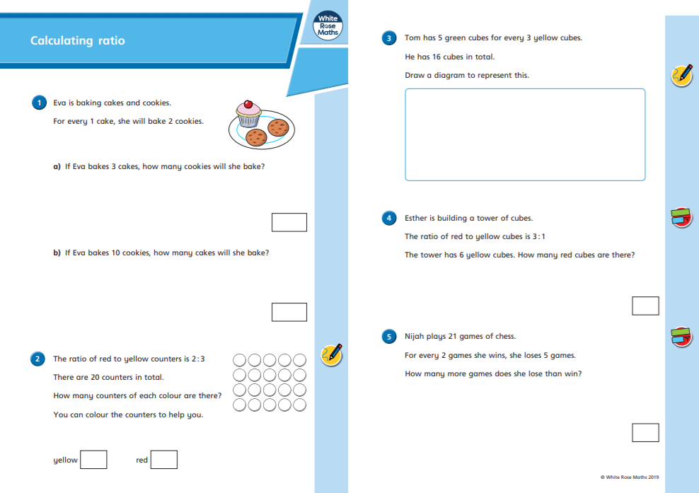
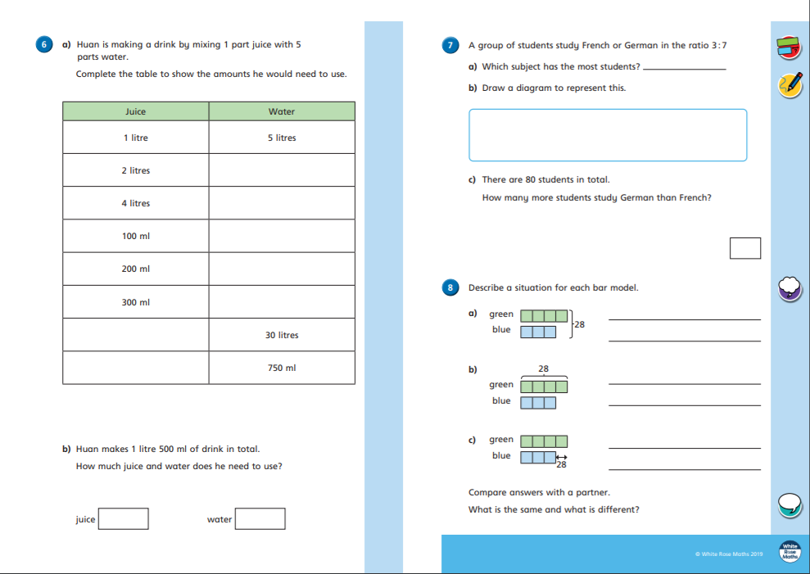
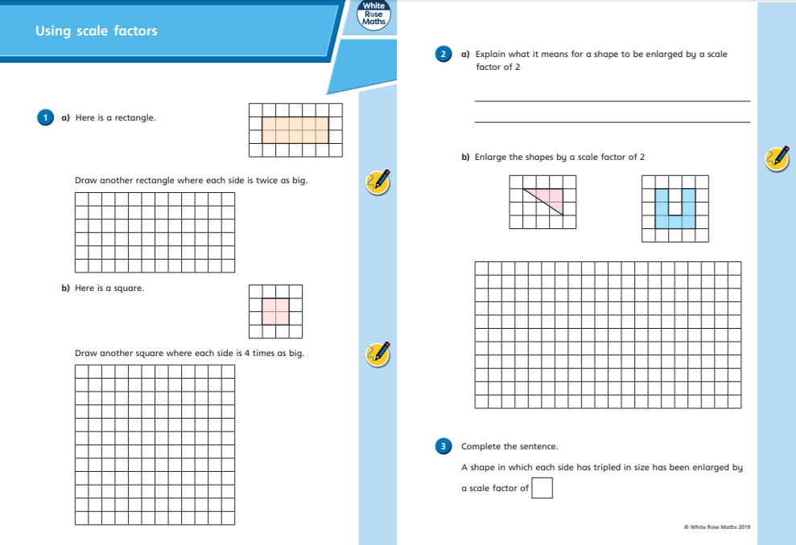
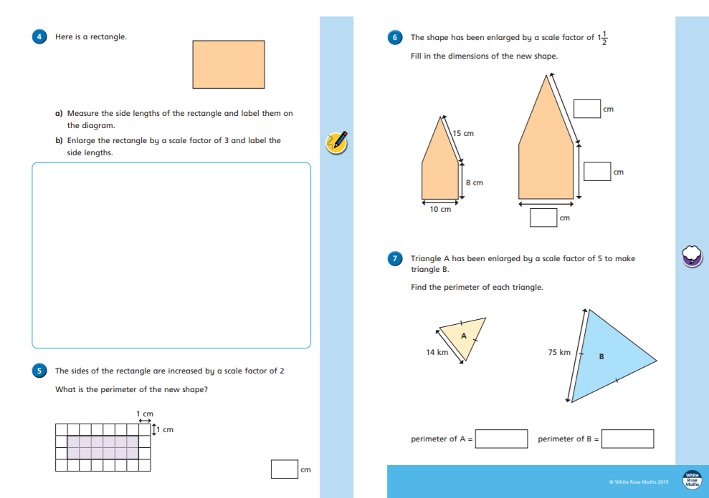
Rapid Reasoning
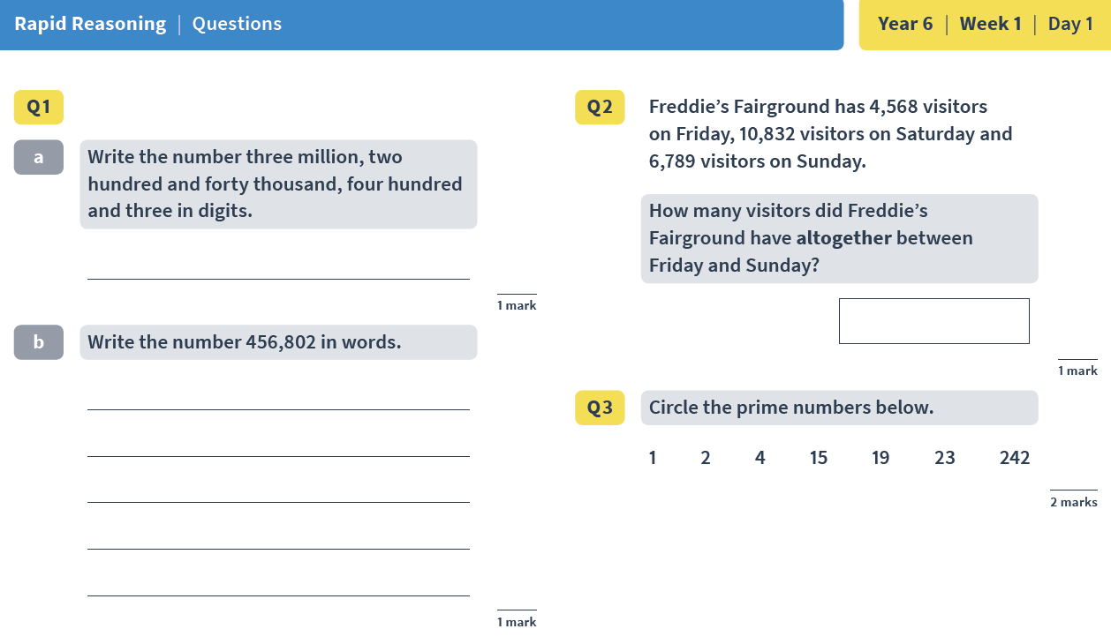
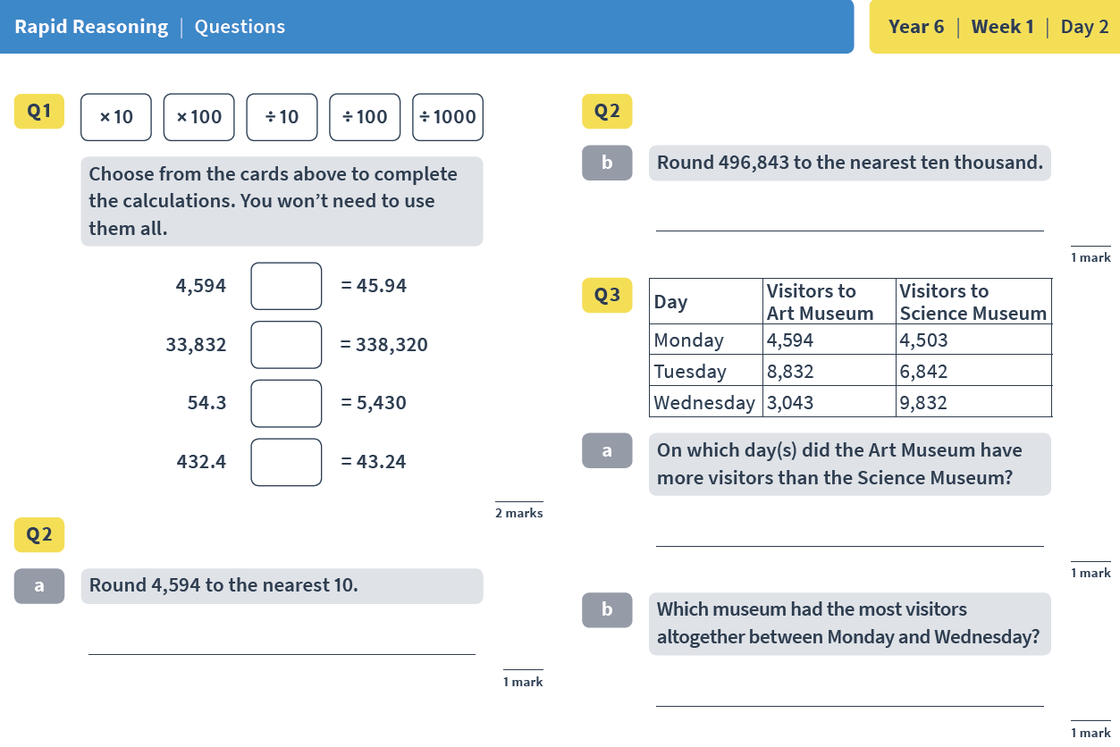
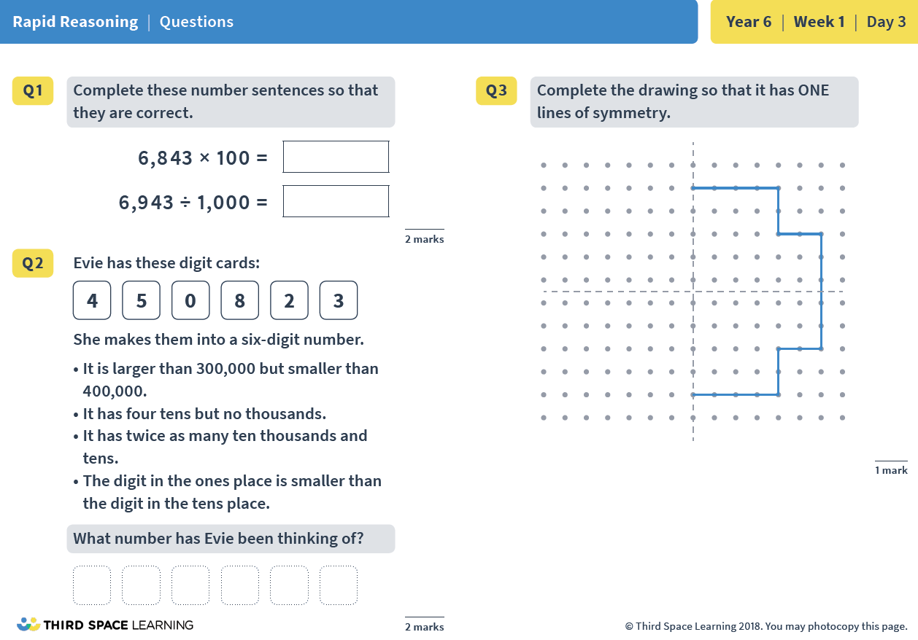
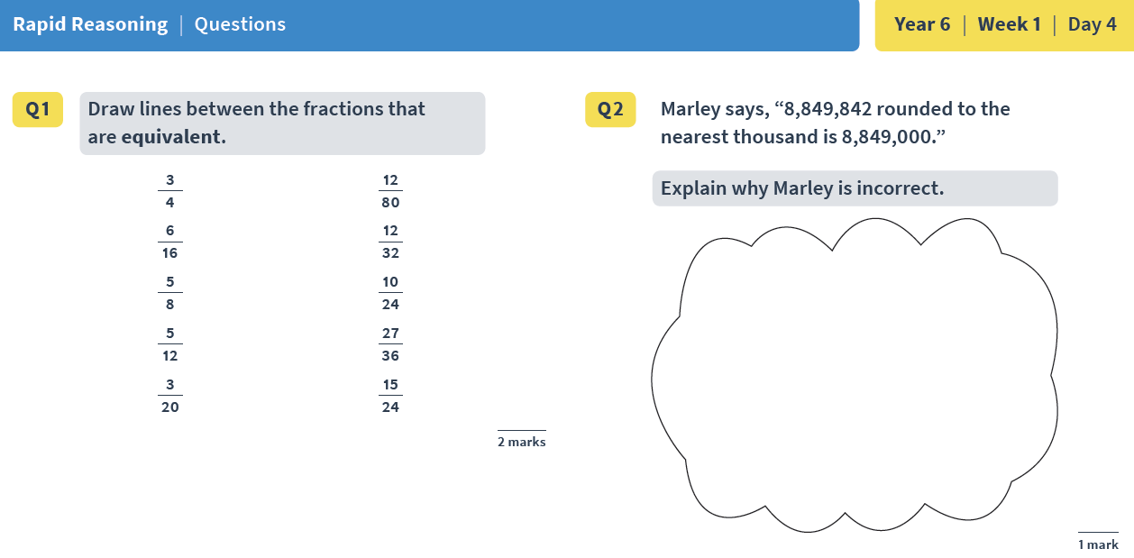

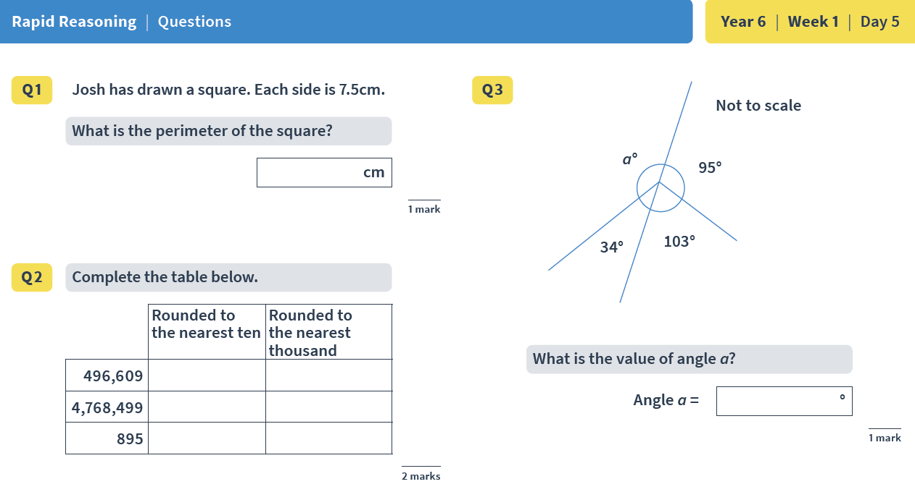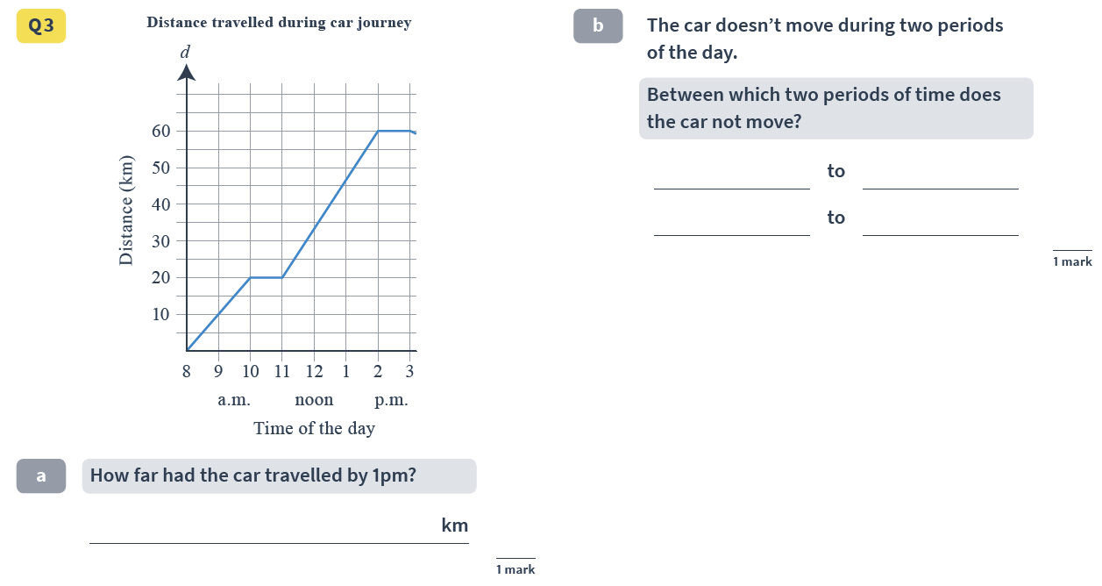

Rapid Reasoning answers:
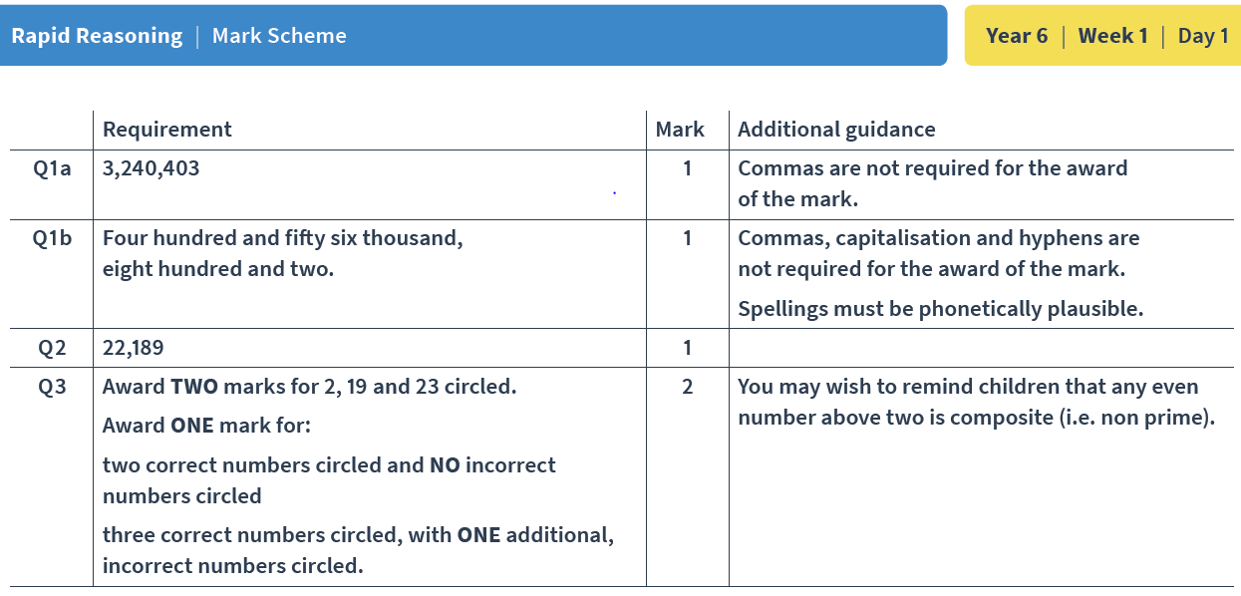 | 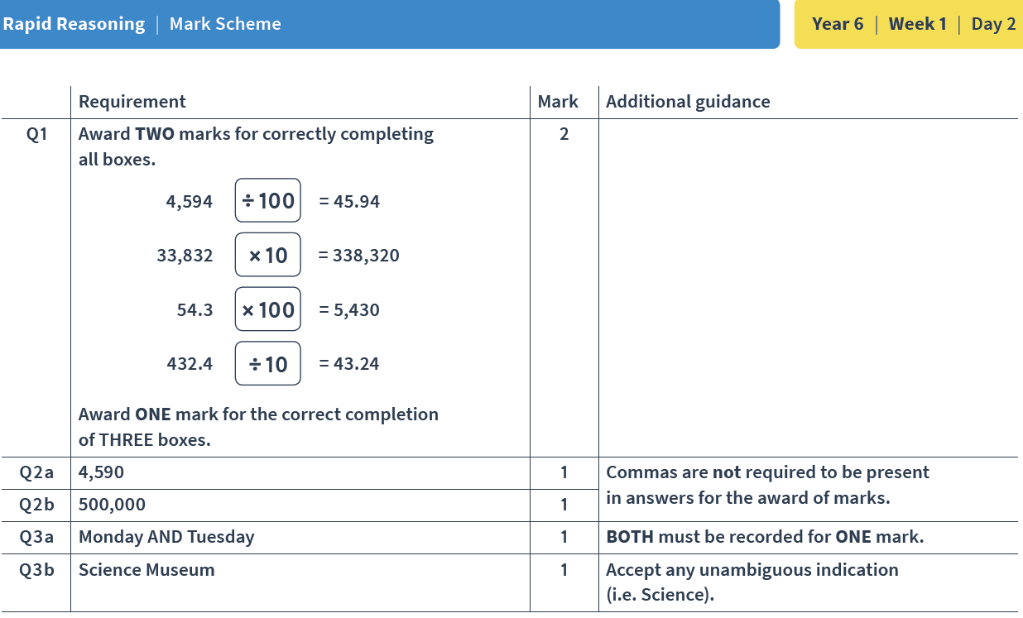
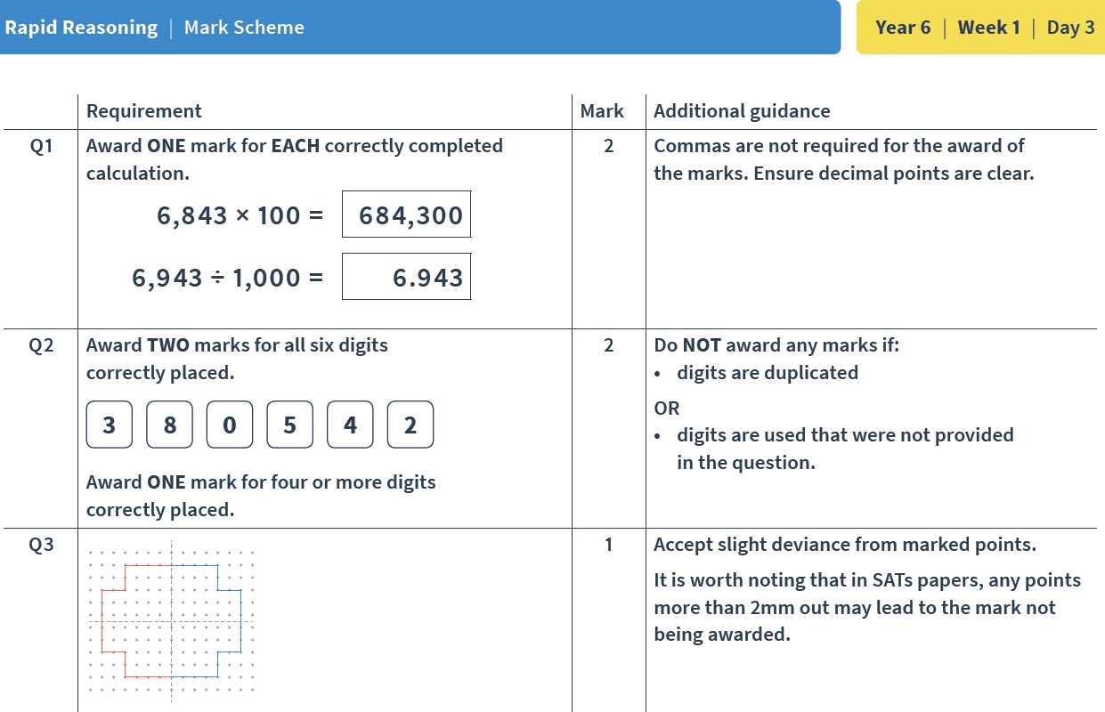 | 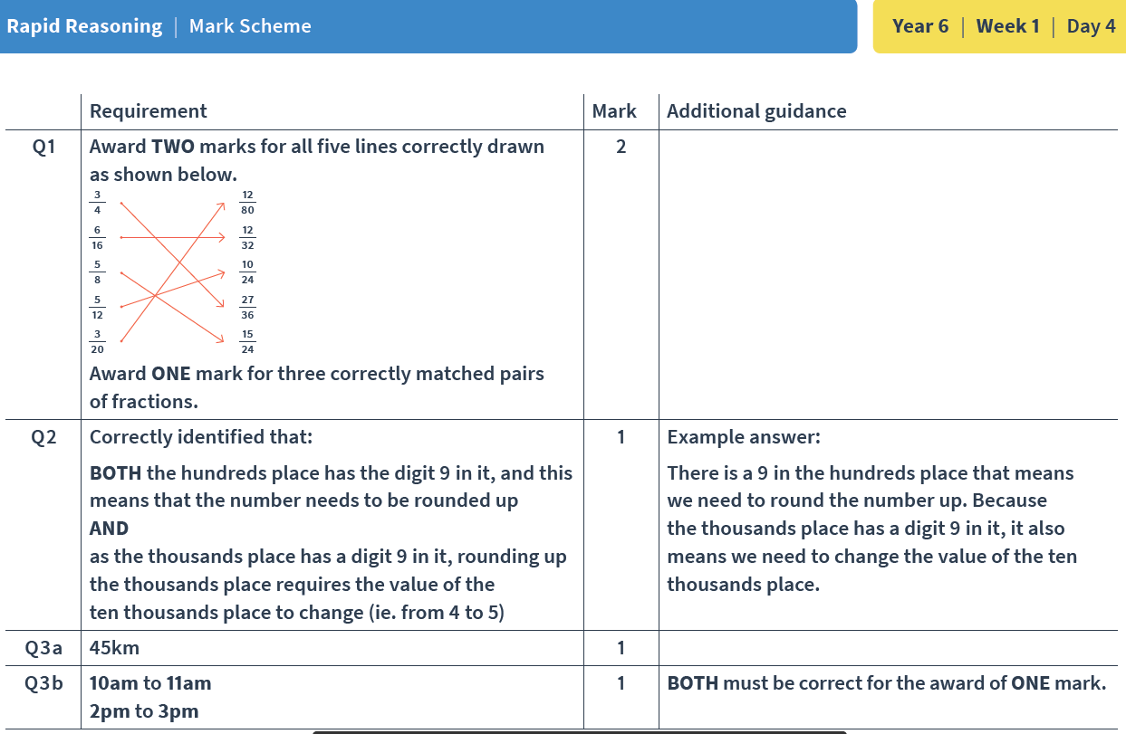
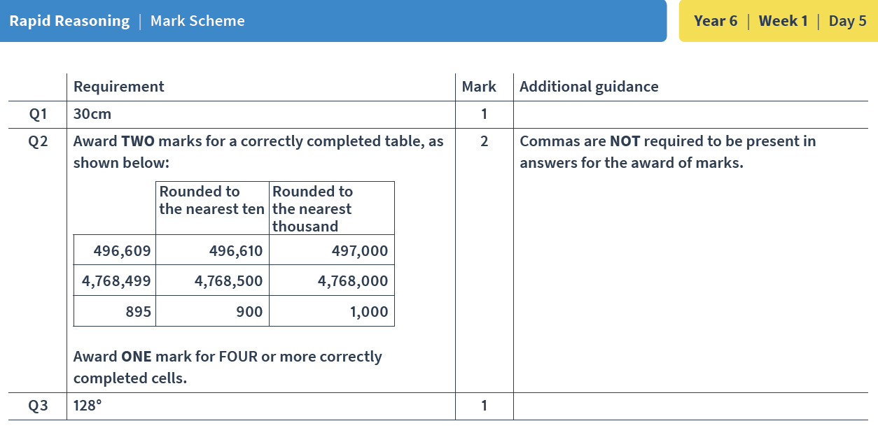

If you would like further challenge, please look at the following activities from NRICH – a fantastic site for ‘out of the box’ thinking. Try some of these ratio and proportion problems. https://nrich.maths.org/8959
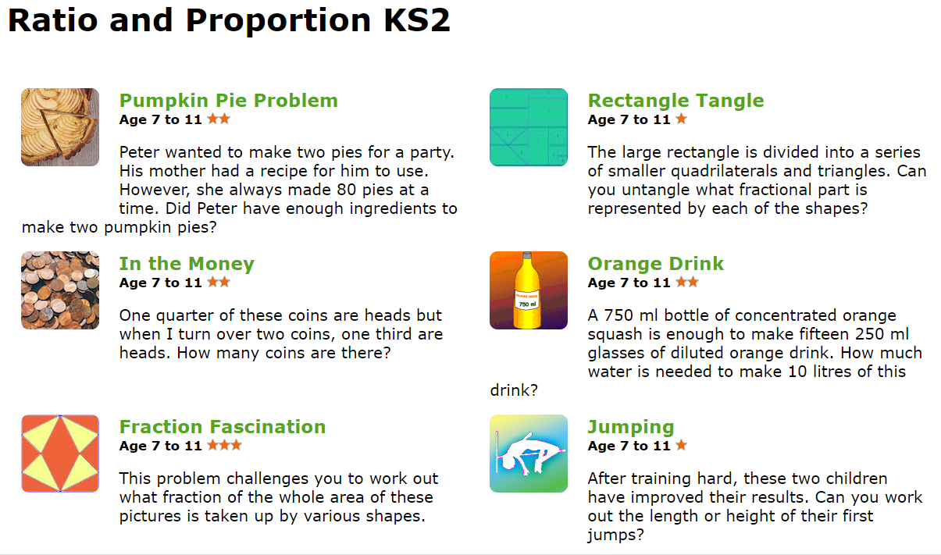

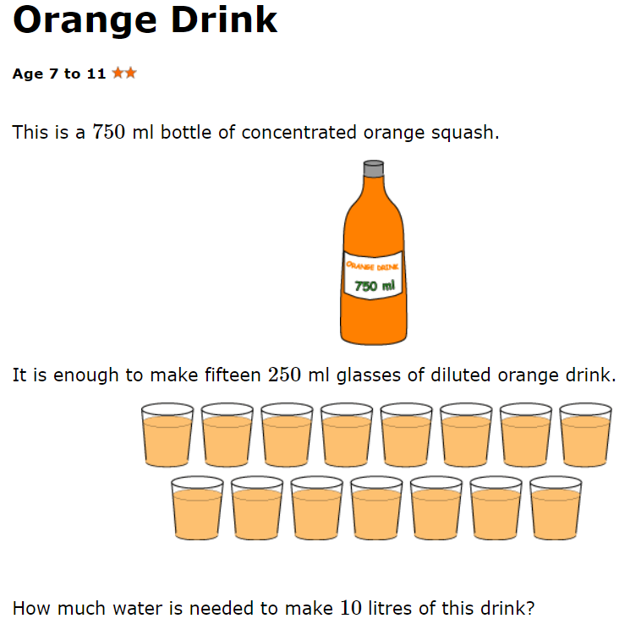
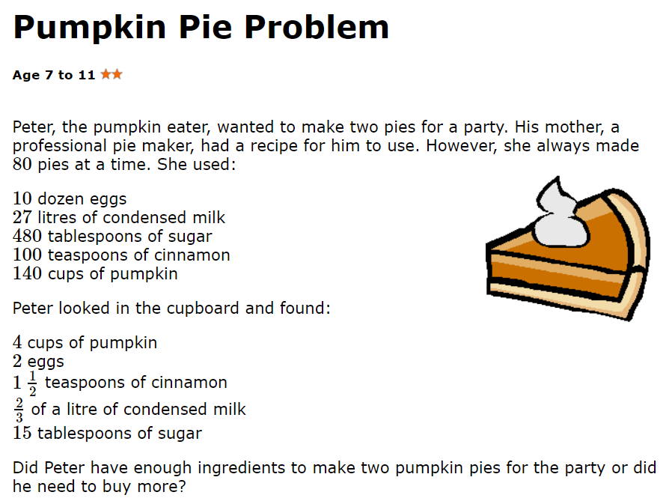

SCIENCE - LIGHT
Work through the Seeing Light slides, thinking carefully about how you would respond to each slide. Then, choose one of the activity sheets below (the first is the tricky work; the second, trickier and the third, trickiest.)
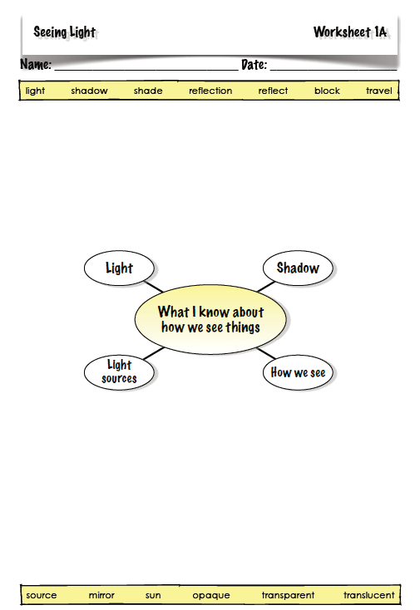
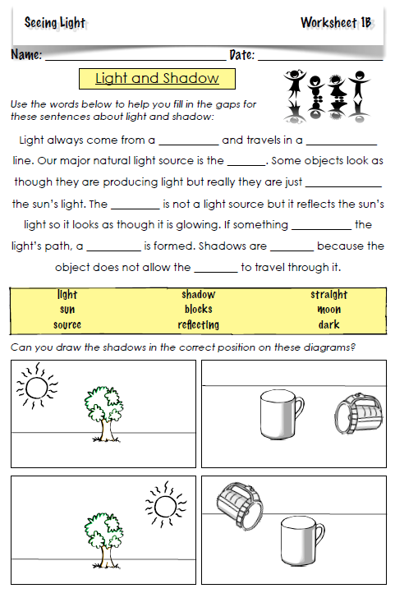
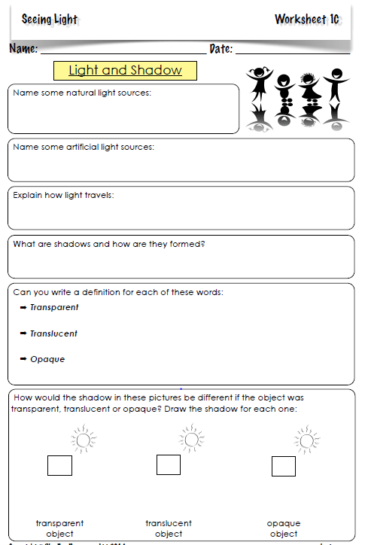

Collect together a number of opaque objects and, using a torch or an angle-poise lamp, put those objects in front of the light’s path.
- Look closely at the shape of the shadow.
- How can you change the size and shape of the shadow?
- Draw a diagram of one or more of the objects tested and annotate what is happening. Make sure you include the source of light, the object itself and the shadow. Draw the direction in which the light travels as a straight-lined arrow (drawn with a ruler!).
Now, repeat the above activity using some translucent and transparent objects.

Glossary
Opaque: If an object or substance is opaque, you cannot see through it.
Translucent: If a material is translucent, some light can pass through it.
Transparent: If an object or substance is transparent, you can see through it.

HISTORY

Please go to this website and complete Enquiry 1.

Enquiry 1 - How has life changed within living memory?

The aim of this pack is to introduce children to the concept of living memory as a chronological term and the disciplinary concepts of continuity and change, evidence and similarity and difference. All evidence can be gathered by speaking to family members over the phone, e-mail or via Skype.
​
The findings of the enquiry can be presented in whichever way suits your child best - be that using PowerPoint, a non-chronological report or drawing.
​​
This pro-forma is a guide through the process of creating the criteria that will be researched as part of the enquiry. Children can fill it in completely or use the principles as a guide - the choice is theirs!
​
The attached video is intended as an explanation to enable children to understand the enquiry process they are following and the historical concepts they will be considering.

https://www.mrtdoeshistory.com/home-learning-packs

MATHS in ART: Spirals in Circles

Work through the spirals Ppt. and pause at the page entitled Spirals in Circles. Be amazed about how many spirals there are around us without us really realising it. How many of these examples can you find in your own home? Are there any other examples of spirals that you can find around you?
Now, go on to look at the next section of the Ppt – Spirals in Circles – before going on to create spirals of your own. The templates are below. (What is the difference between the two templates?)

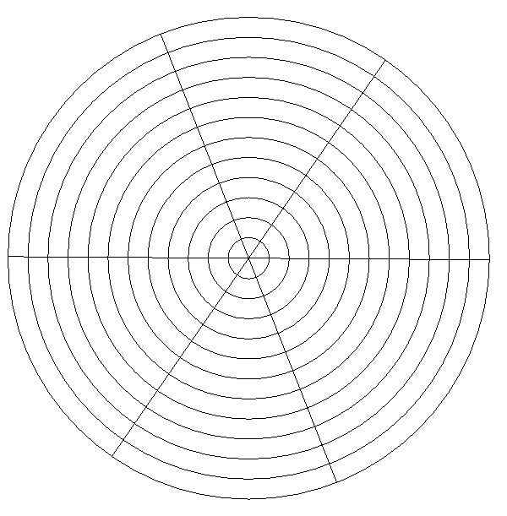
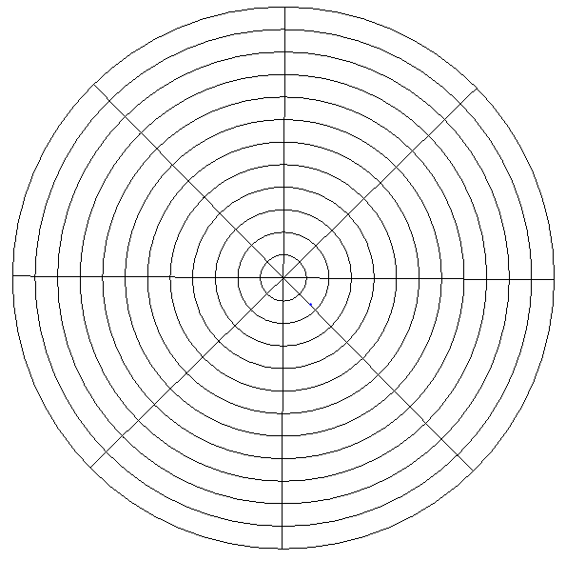

Using your login to Espresso coding will not only allow you to carry on with your coding activities, but also gives you access to a huge range of other activities that covers the whole curriculum.

Have fun exploring!

Website Link
https://www.discoveryeducation.co.uk/what-we-offer/discovery-education-espresso

Username: student4749
Password: apples
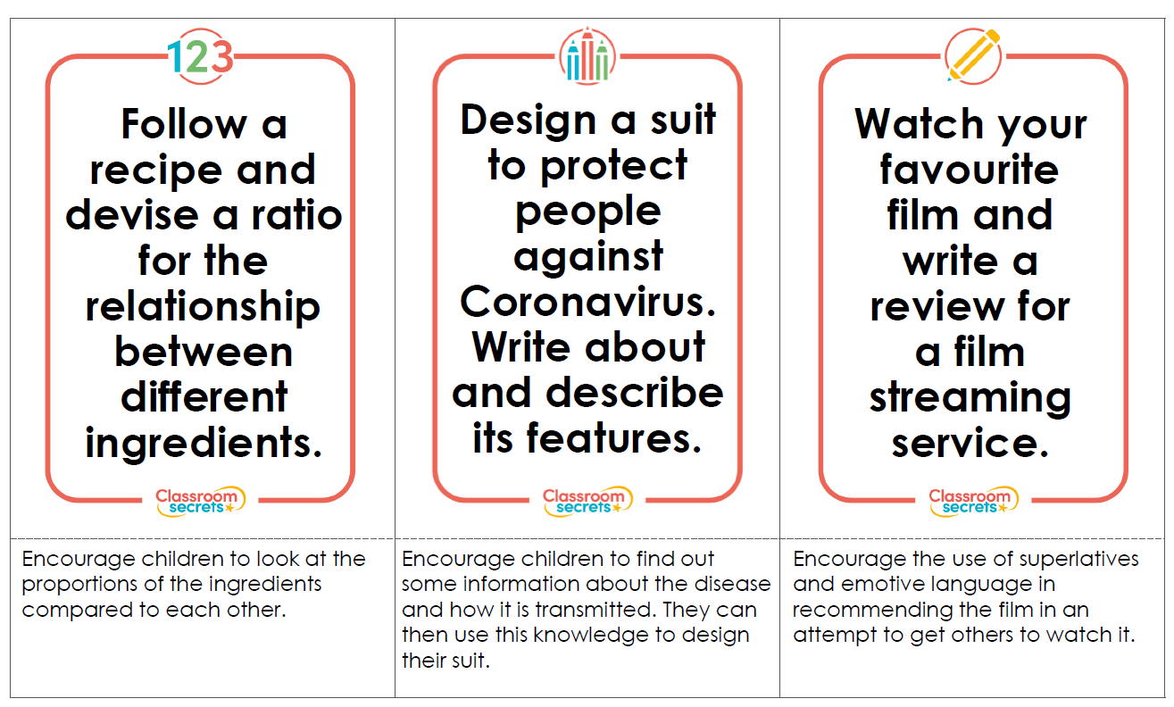
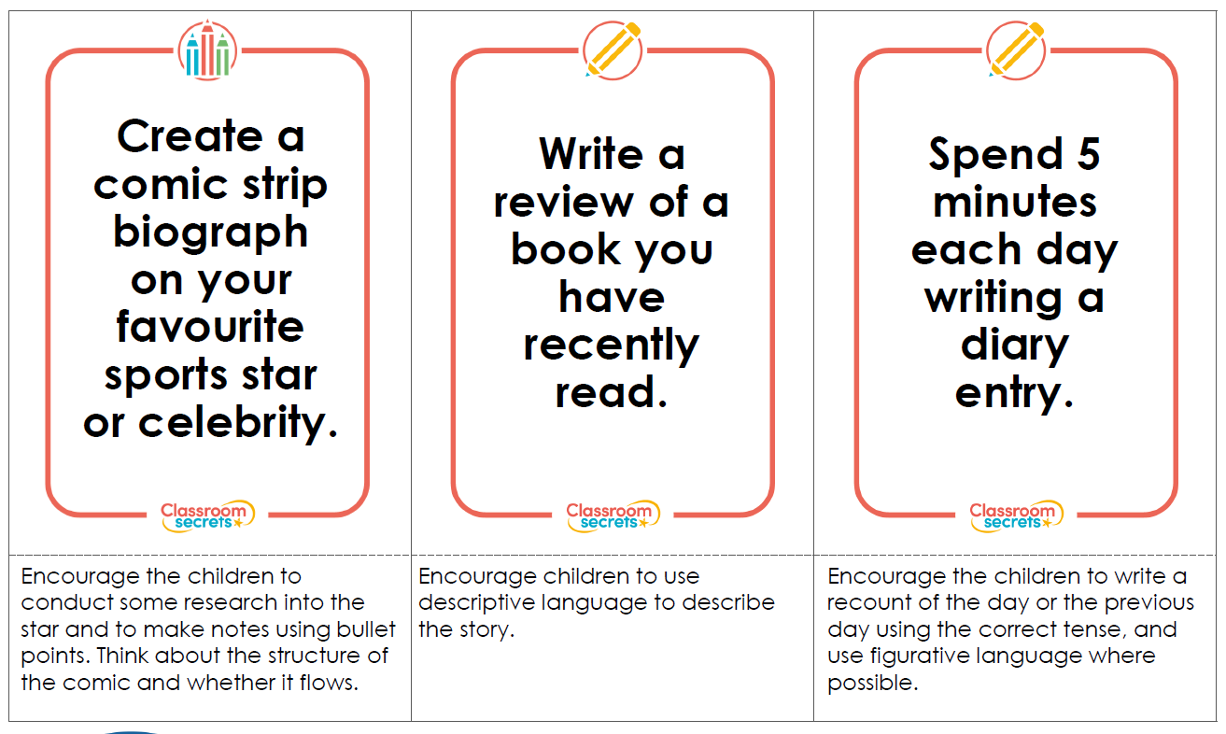
Home Challenge
 | Task | Notes/ Evidence
1 | Read a book in the most unusual place you can think of.
2 | Write your own rap/ song.
3 | Build the highest tower you can out of non-breakable household items.
4 | Create an obstacle course in your garden or sitting room.
5 | Build a den that at least two people can fit inside.
6 | Dress someone up in the craziest outfit you can think of.
7 | Create a video message which can be shared with family or friends
8 | Create clues for an indoor treasure hunt and challenge your family to complete it.
9 | Learn or choreograph a dance routine.
10 | Make a home restaurant; produce the menu; cook, or help to cook the food, and serve your family.
Click on the following link to access a range of technology, science and maths activities: https://www.stem.org.uk/sites/default/files/pages/downloads/Starters-for-STEM.pdf
