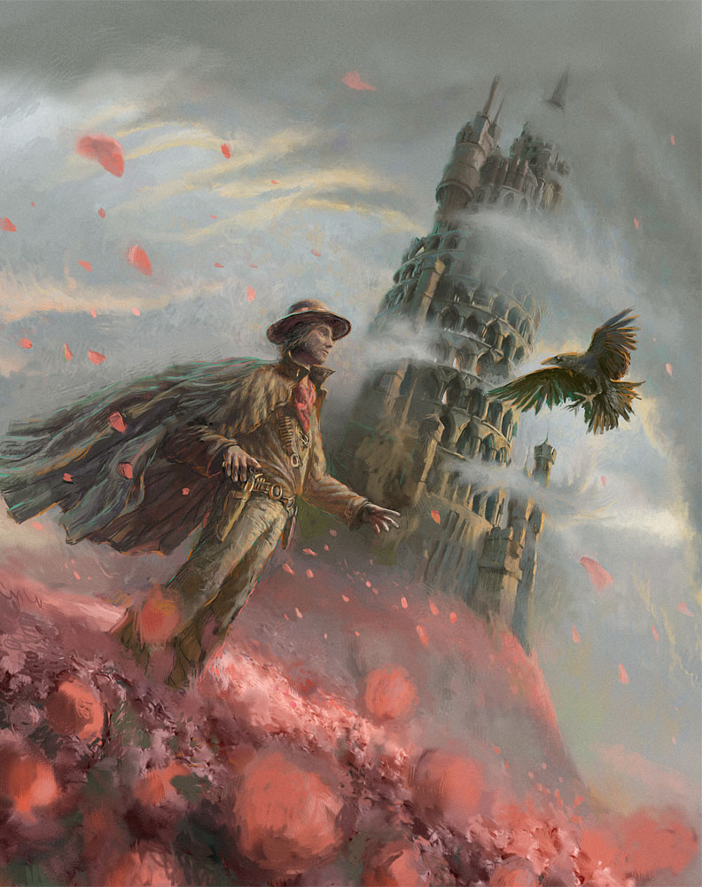

Dark Tower

- Who is this man? Where has he come from? What does his clothing tell you about his character?
- Do you think he is a good or bad character? Why?
- What is he doing?
- Is the bird friendly or is it going to attack him?
- Describe the tower in as much detail as you can.
- Why is it called ‘Dark Tower’?
- What do you think the tower is used for? Does anyone live there? Are there many visitors?
- What are the red things on the ground and in the air?
- What sounds could you hear if you were inside the picture?
- Use this picture as a stimulus to write one or more of the following:
  - a short narrative from the point of view of the man, the bird, another character in the story or the tower
  - a diary entry for the events of that day,
  - a newspaper report about the unusual events that took place that day
  - a leaflet advertising Dark Tower as a holiday destination.

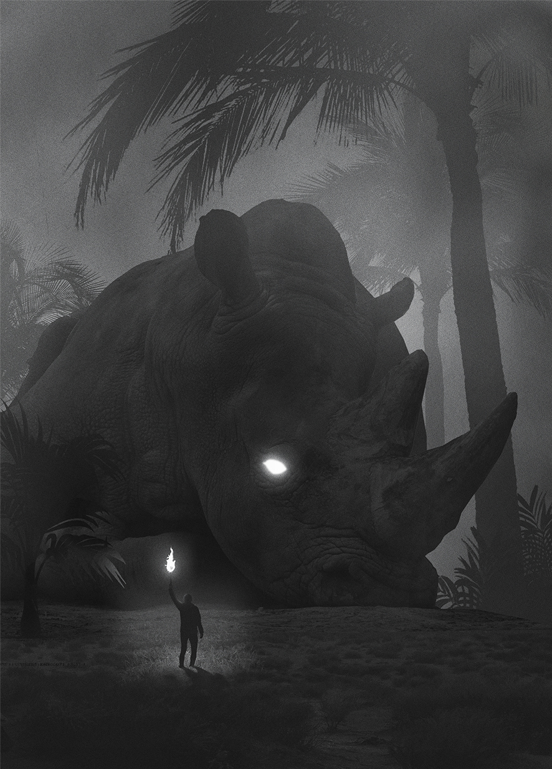
Fear

- What can you see? What do you think? What do you wonder?
- What is the rhinoceros doing? Is it injured? Why is its head resting on the ground?
- Why is its eye glowing?
- Can it see the man?
- What is the man doing? Why is he holding the flame torch above his head? Can he see the rhino?
- What is he going to do? Is he going to help the rhino?
- Is anyone else around? Are there any other rhinos?

- Which (the rhino or the man) is normal-sized?
- Why is the picture called ‘Fear’? Is the man fearful? Is the rhino?
- What is fear? List your thoughts, beginning each sentence ‘Fear is…’. Put them together into a poem (like this one: Fear Is). Consider what fear looks like, feels like, and what causes fear.

- What do you know about rhinoceros?
- Find out more here: https://www.savetherhino.org/ and watch this video: Save the Rhinos! Create an information page about the rhino.
- Some species of rhino face extinction for two reasons: they’re hunted by poachers for their horns, and their habitats are being destroyed. Find out more about this and plan an advertising campaign to save the rhinos. Will you write a letter or design a poster? How will you persuade people to act and make a difference? [Watch Mr P’s killer whale video campaign for inspiration: Would you let it happen to me? Whales in captivity.]

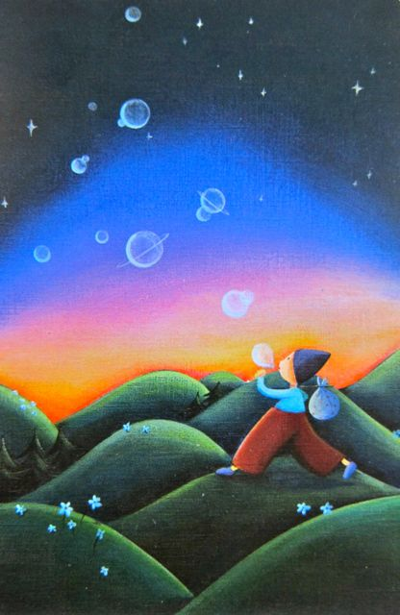

Bubble Planet

- What is this person doing?
- How old are they?
- What are they carrying in their sack?
- Where did he/she come from? Where is he/she going?
- Did they just discover how to make bubble planets or have they been doing this for a long time?
- What happens to the bubble planets after they are formed?
- Are they real planets? Is there life on any of them?
- Could the idea of a bubble planet have a deeper meaning?
- If you could create a planet, what would you make it from? What would the environment on your planet be like? Would there be any life? What kinds of creatures would live there? How would you keep your planet a safe place?

- Choose to write:
    - A story about the bubble planet maker
    - A biography for this person
    - An explanation – How Bubble Planets Are Made
    - Instructions – How To Make A Bubble Planet
    - A letter to the bubble planet maker from a World Leader whose planet is in danger
    - An informative guide to bubble planets

The Briefcase
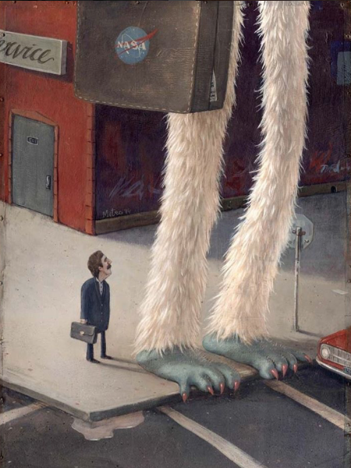

- Who (or what) do the giant legs belong to?
- What do you know about the creature? What can you infer?
- Why is there a NASA logo on its briefcase? What is hanging out of the briefcase?
- Where is it going? Why is it standing on the side of the road?
- What is the man looking at? What is he thinking?
- What are the similarities and differences in this picture?
- Write some top secret NASA case files about this creature. Why is it here? Is it on a mission? What are its duties? Is it the only one? Are there any findings
The Imaginator

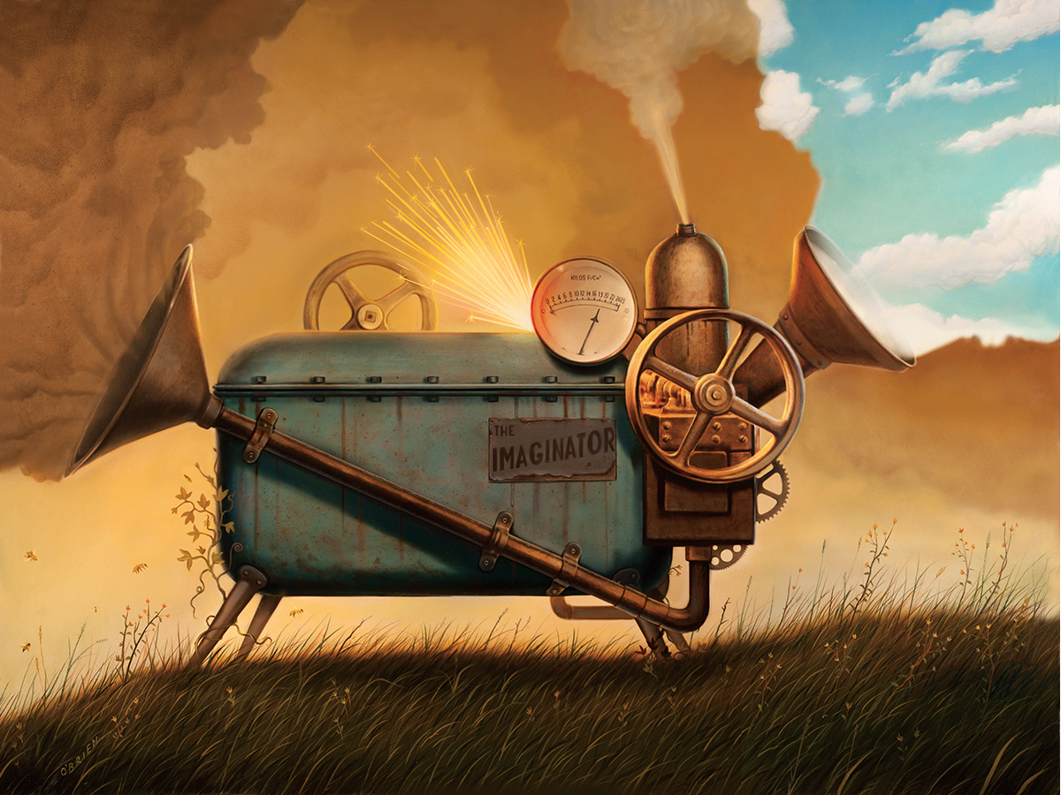
- How does The Imaginator work? What goes in and what comes out? What’s creating the sparks? Does it need electricity to function? Write an explanation of how it works.
- Who made The Imaginator?
- Who does this one belong to? Why is it here?
- Are there any others? Where are they sold?
- Create an advert for The Imaginator. Who is the target market? Why would they need one? What are its best features?
- Why is imagination important? What can we do to keep the imagination active?

