YEAR 3
HOME LEARNING PACK
NAME: __________________________________
CLASS: ___________________________________

Contents
SPELLING 3
MATHS 6
Times Tables 6
Calculation revision: 11
ENGLISH: NARRATIVE 28
ENGLISH: EXPLANATION 29
GEOGRAPHY 30
ART 32
PRACTICAL ACTIVITIES …………………………………………………………………………………………………………………… 35
OTHER IDEAS …………………………………………………………………………………………………………………………………. 39

SPELLING
Spelling Activities:
Using some of the different strategies included on the next page, practise spelling the words from the following two lists:
Homophones (words that sound the same but have different meanings and spellings):
See how many of these homophones you can find in your reading. Come to school with ideas on how to remember which spelling to use:
- Meat / meet
- Hear / here
- Knot / not
What other homophones can you find?
Prefixes: super- and auto-
- Automatic
- Autograph
- Autobiography
- Autopilot
- Superman
- Superstar
- Superficial
- Supernatural

You can also practise the words on the Year 3/4 spelling list which are included in this pack. In addition to the strategies included on the following page, you can also use the look, say, cover, write, check technique explained below. Just use your ideas book and remember to tick them off in your reading records when you have mastered them.
Look  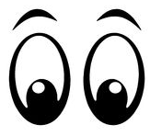 | Look at the word. How many parts are there?  What are the tricky bits?  Can you find any spelling patterns?
Say | Say the word to yourself.  Break the work up into syllables.  How many parts are there?  What sounds can you hear?
Cover  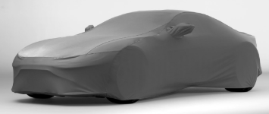 | Cover up the word so you can’t see it.  Picture the word in your mind.
Write | Write down the word, remembering how it sounds and what it looks like.
Check | Check to see if it’s correct.  Tick the letters you got correct.  Write the word correctly if you made a mistake.
You can also play some spelling games here: https://spellingframe.co.uk/
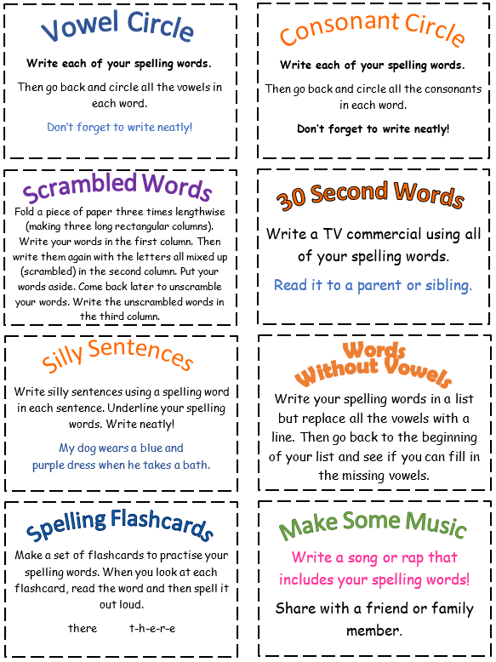
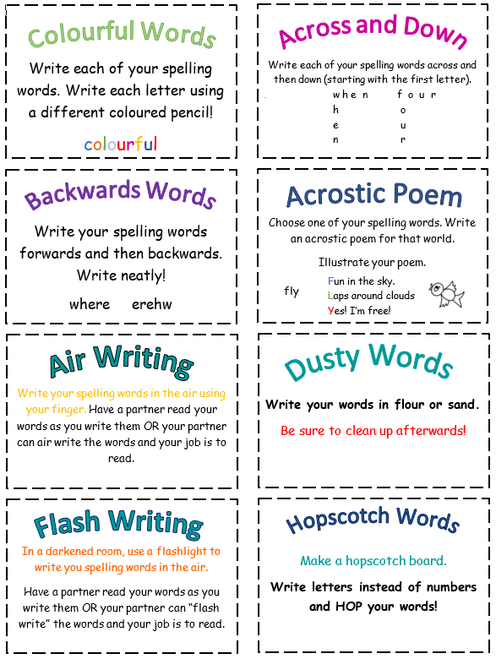
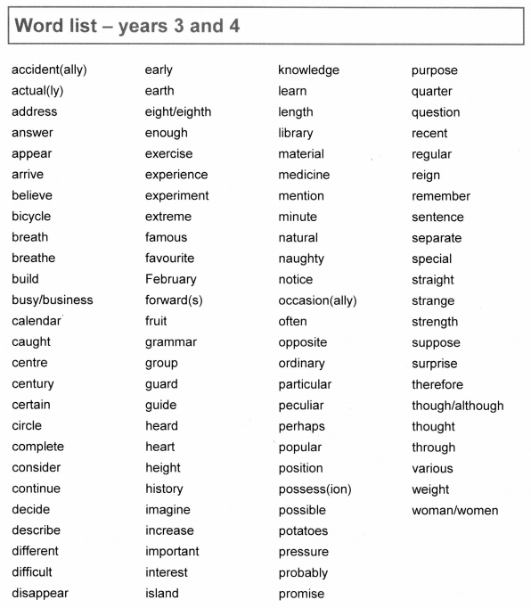

If you have a brown spelling book of your own, you can choose to practise those spellings instead.

MATHS

Times Tables
There are plenty of great ways to practise your times tables while you’re not at school. There are lots of strategies on the next page, very similar to the spelling ones.
There are also a range of great websites you can use to practise your times tables too:
www.topmarks.co.uk has lots of great games
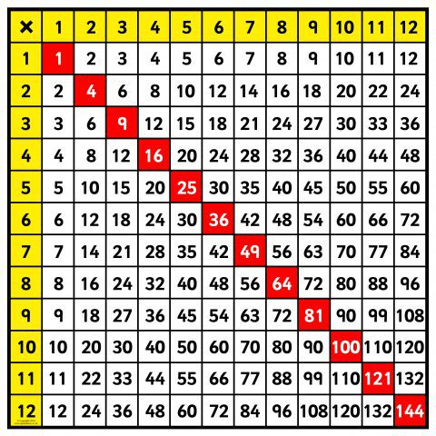
www.timestables.co.uk has some games as well as the practice area for the Multiplication Tables Check.
www.mathsframe.co.uk has lots of different games and activities to try.
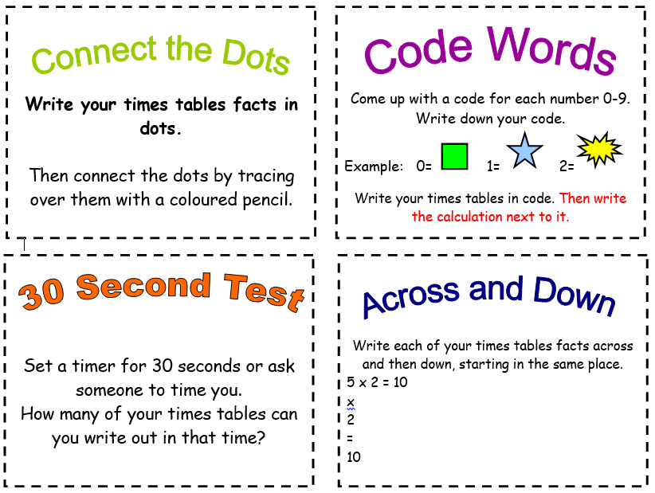
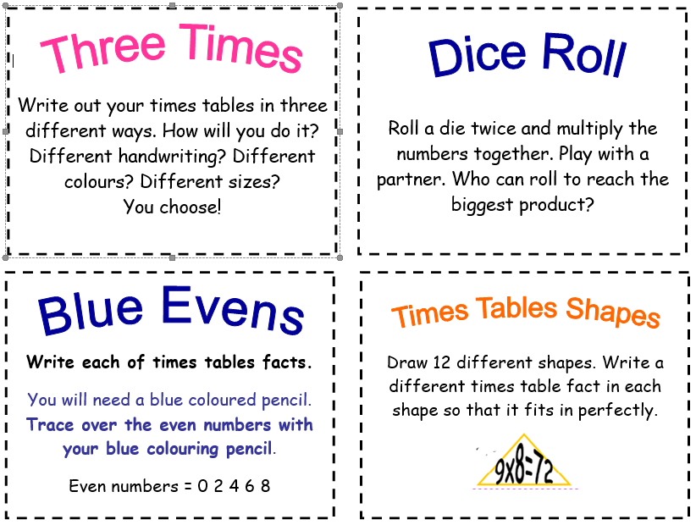
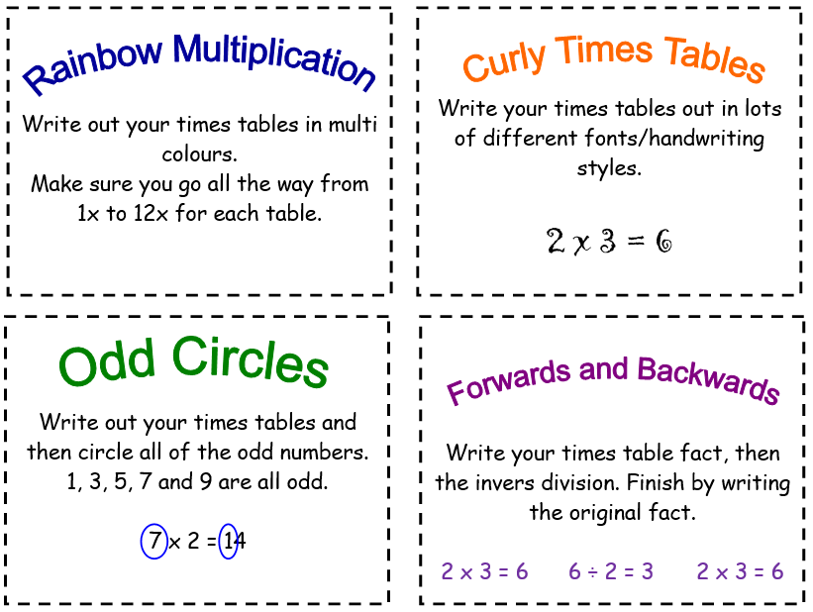
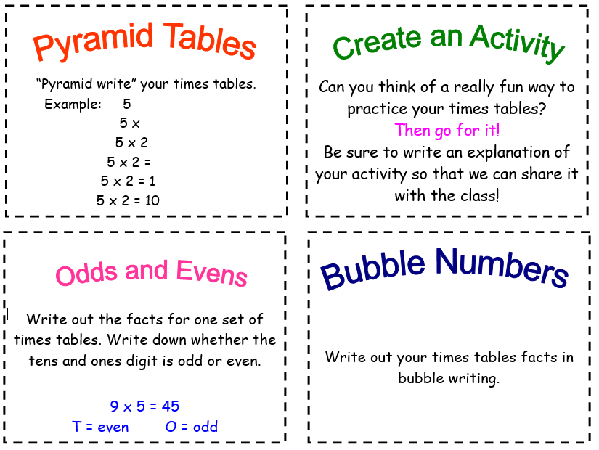

a

Times Tables Reasoning
3 x tables
- Sarah says, “I know my 3 times table so I can work out 30 x 70 without using a written method.” Explain why Sarah can do this.

- Fill in the gaps

 | 9 | 12 |  |  | 21

- David says, “Because 3 is odd, all multiples of 3 will be odd.” Is David correct? Explain your reasoning.

- James is buying CDs. He buys 3 CDs at a cost of £8 each. Draw a diagram to show your working out and then write the calculation.

4 x tables
- David says, “I know that the 4 times tables is linked to the 2 times table.” Explain why the two are linked.

- Anna says, “I know the answer to 4 x 16 without using a written method.” Explain how Anna has been able to calculate 4 x 16.

- Fill in the gaps

 | 200 | 240 |  |  | 360

- David spends £48 on four t-shirts of equal cost. How much does each shirt cost?

6 x tables
- Fill in the gaps:
6 x ____ = 24 48 ÷ ___ = 6
6 x ____ = 54 30 ÷ 6 = ___
6 x ____ = 18 72 ÷ ___ = 6

- David says, “I am not confident with my six times tables but I know my threes so I can use them to help.” Is David correct? Explain your reasoning.

- Create a word problem that requires you to use the 6 x table.

- David says, “All multiples of 6 are even numbers, whether I multiply them by an even number or an odd number.” Can you explain why this is?

7 x tables
- True or false? Every other number in the 7 times table is odd. Explain your answer.

- Helen is buying 5 birthday cakes at £7 each. Draw a diagram to show this calculation.

- Fill in the gaps:

7 |  |  | 28 |  | 42

- James says, “If I know 7 x 6, then I can solve 7 x 60 just as easily.” Is he correct? Explain your reasoning.

8 x tables
- David says, “I know without even solving the calculation that 2461 divided by 8 will have a remainder.” Is David correct? Explain your reasoning.

- Ben says, “I know my 8 times table so I can work out 800 x 5 without using a written method.” Explain why Ben can do this.

- Fill in the gaps:
8 x ____ = 48 48 ÷ ___ = 8
8 x ____ = 32 32 ÷ 8 = ___
8 x ____ = 16 16 ÷ ___ = 8

- What is the perimeter of a regular octagon if each side measures 7cm?

9 x tables
- David says, “I’m not very confident with my 9s but I know my 10s.” Explain how David can use his knowledge of the 10 times tables to help him work out his 9s.

- Fill in the gaps:

 | 27 | 36 |  |  | 63

- Always, sometimes, never? When you multiply a number by 9, the answer will be an odd number. Explain your reasoning.

- Sarah says, “If a number is a multiple of 9, then it will also be a multiple of 3.” Is Sarah correct? Explain your reasoning.

12 x tables
- Fill in the gaps below:

 | 36 | 48 |  |  | 84

- Sarah says, “Because 12 is a multiple of 4 that means any multiples of 12 will also be multiples of 4.” Is Sarah correct? Explain your reasoning.

- Always, sometimes, never? Because 12 is an even number, whatever number you multiply it by will give you an even answer. Explain your reasoning.

- How can you use your 2 x tables and 10 x tables to work out your 12 x tables? Explain your reasoning.

Calculation revision:
We have included some questions below that cover the topics we have learned to date. Don’t worry if you don’t have any Maths resources at home, you can use things in your house or you could draw them to help you.
There are three lists of questions: tricky, trickier and trickiest – choose the level of challenge you would like to attempt.

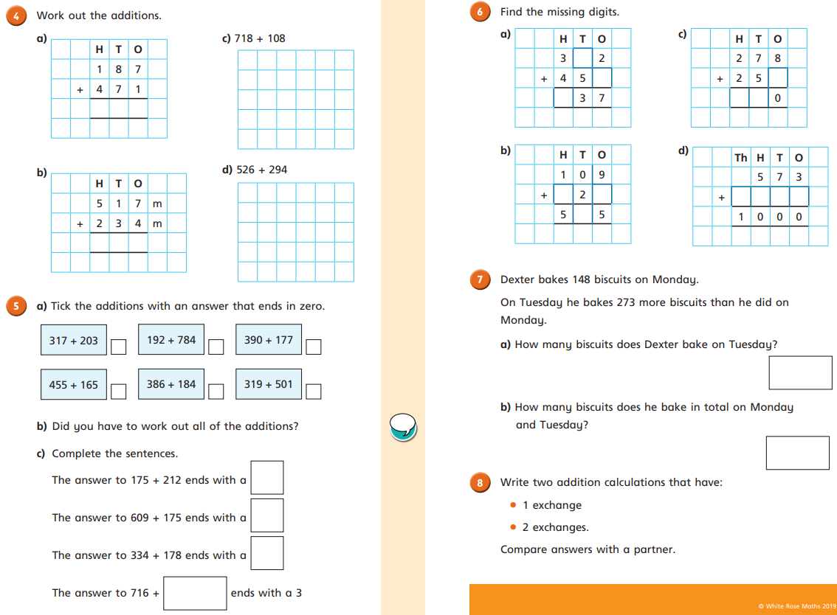
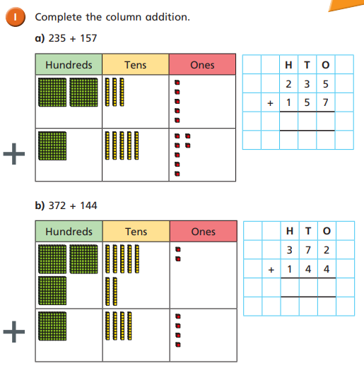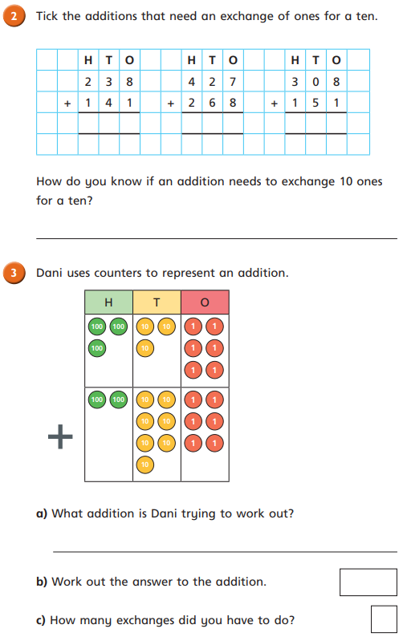
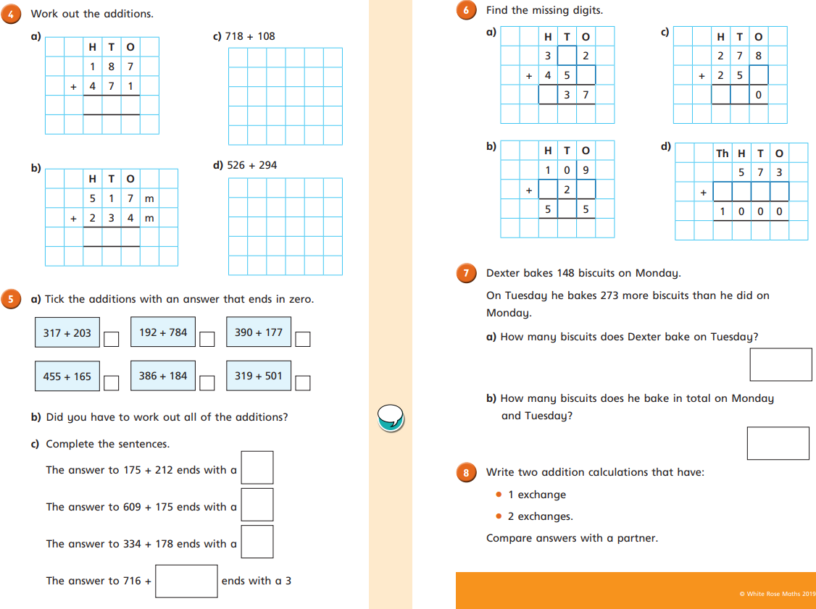

Answer the following questions in the spaces provided, drawing a model first to help you solve it. Remember to show ALL your working out.
- Jean buys 250 crates of apples. She buys 64 more crates of oranges than apples. How many crates of oranges does she buy? How many crates of fruit does she buy altogether?
- There are 493 girls in the stadium. There are 225 more girls than boys. How many boys are there? How many children are there altogether?

- Farmer Freddy planted 450 apple trees. He planted 235 more cherry trees than apple trees. How many cherry trees did he plant? How many trees did he plant altogether?

- There are 725 students in the cafeteria. 529 students are girls. How many boys are there? How many more girls than boys are there?
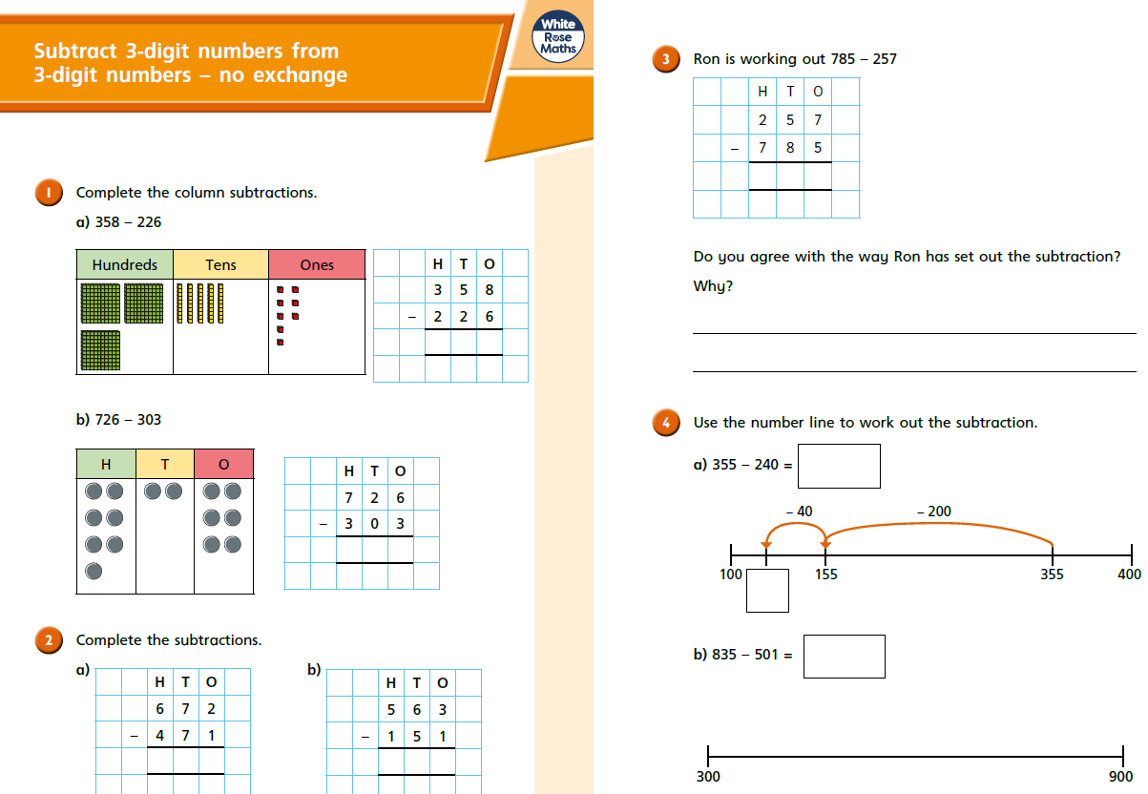
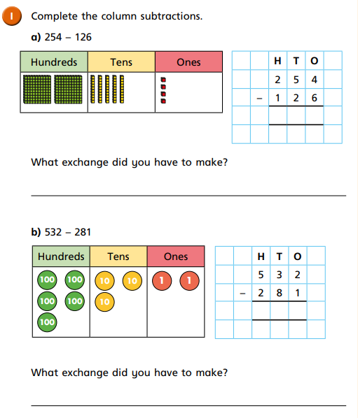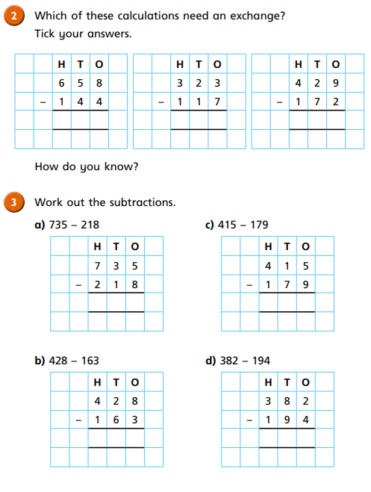
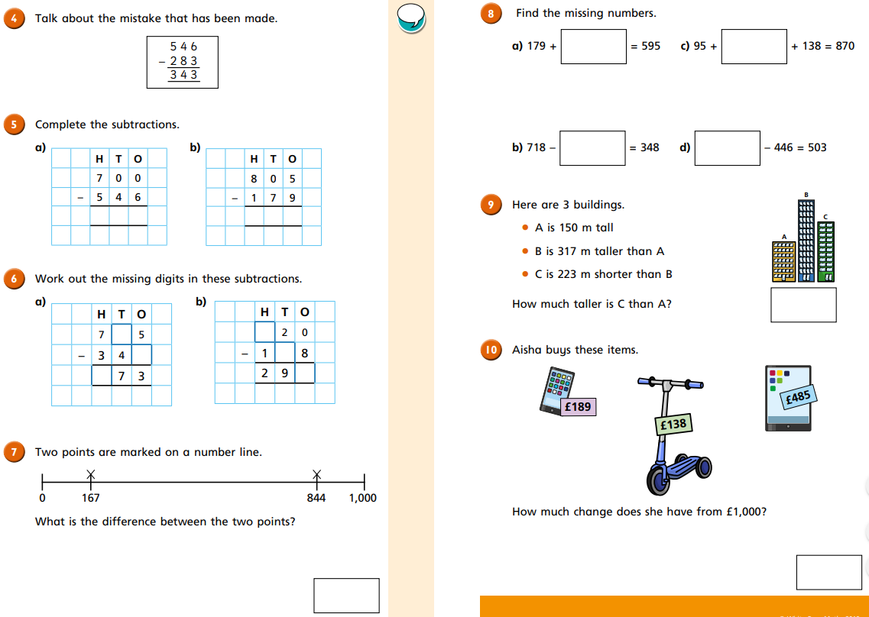
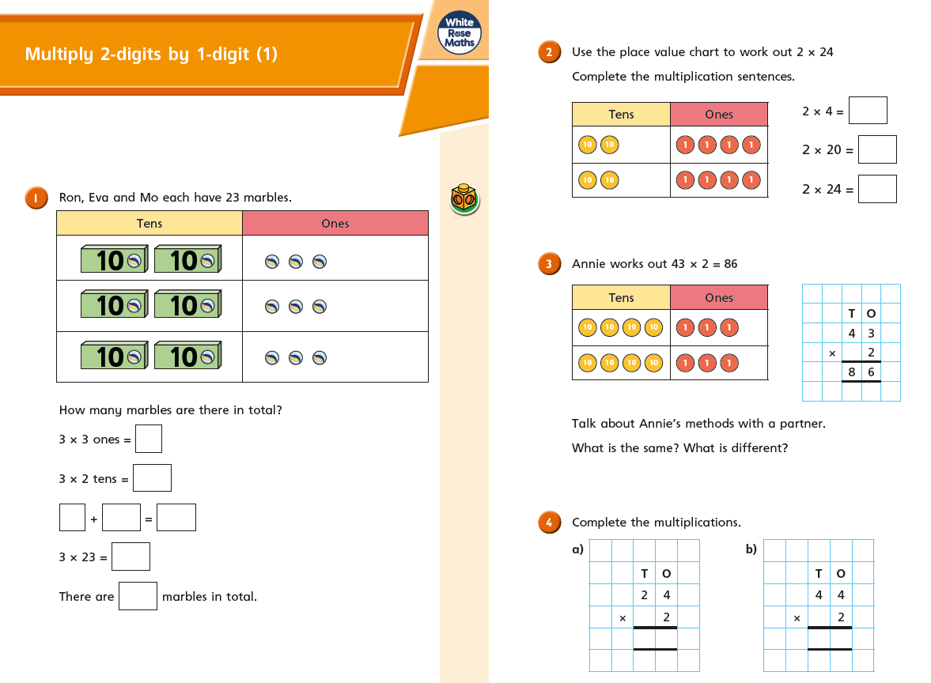
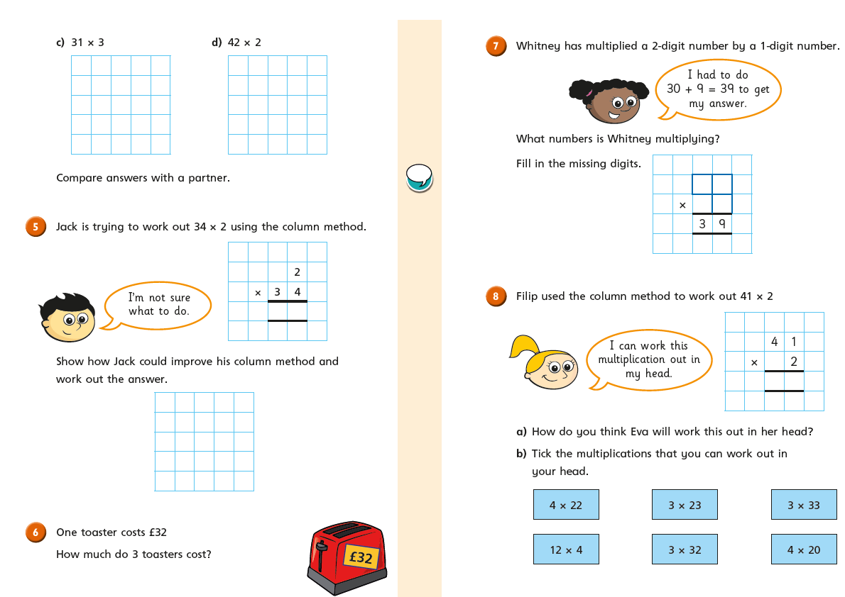
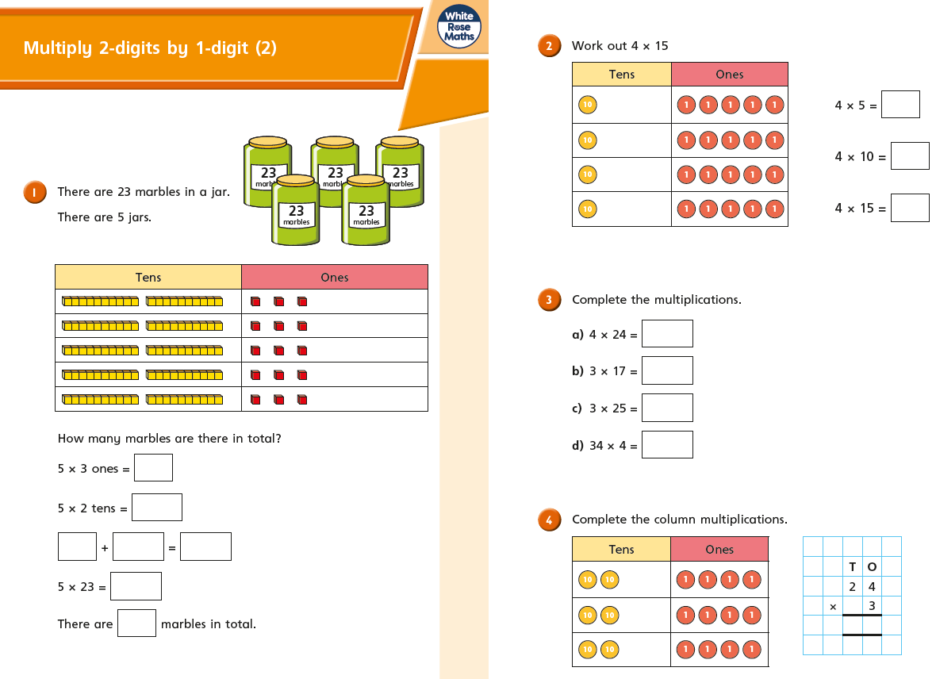
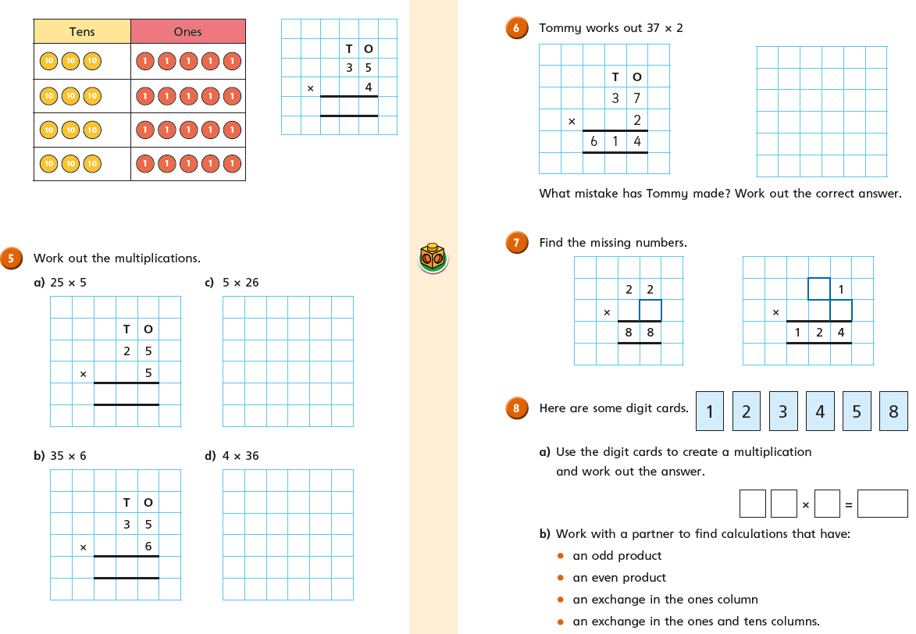
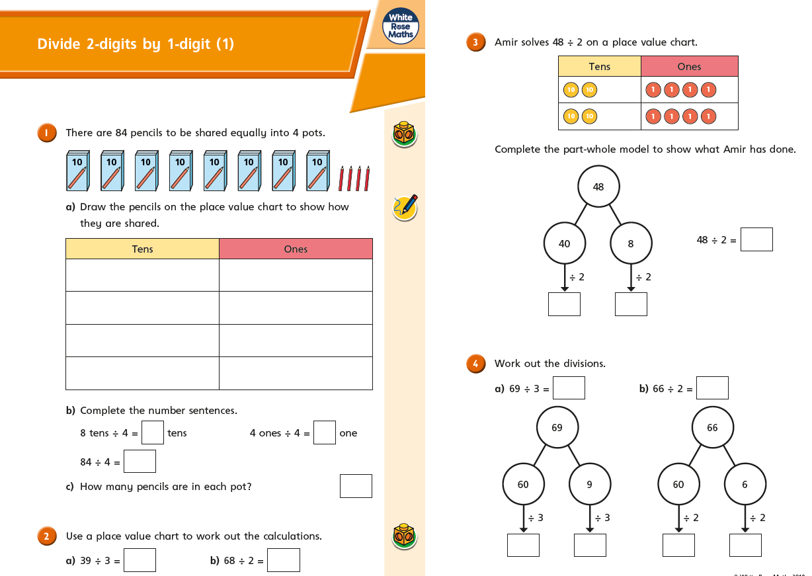
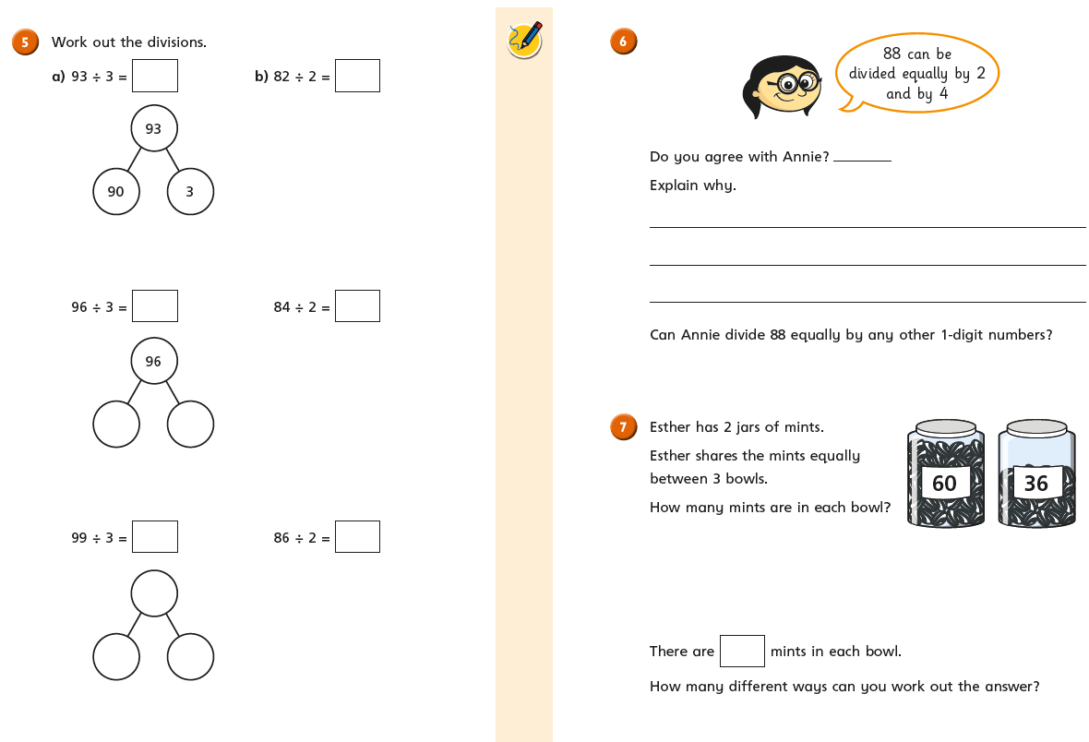
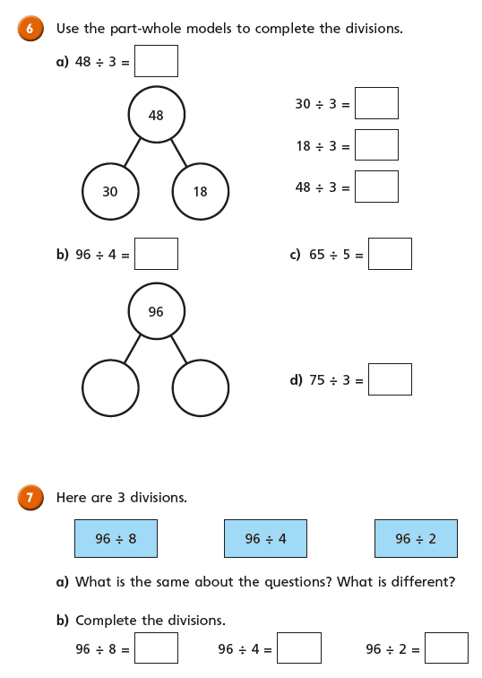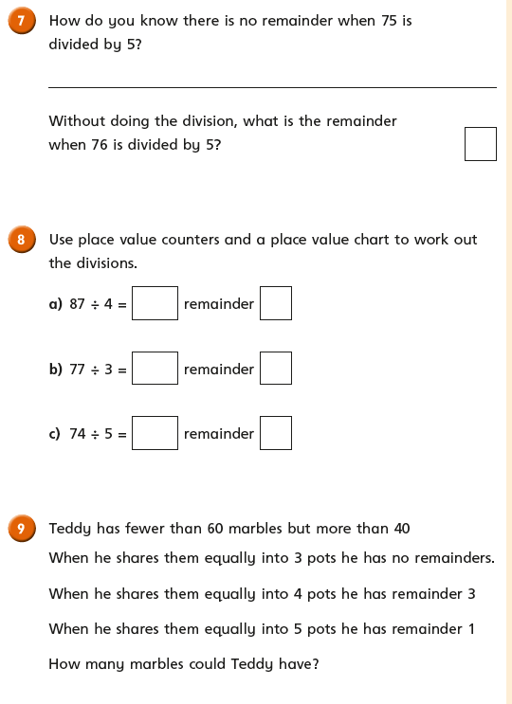
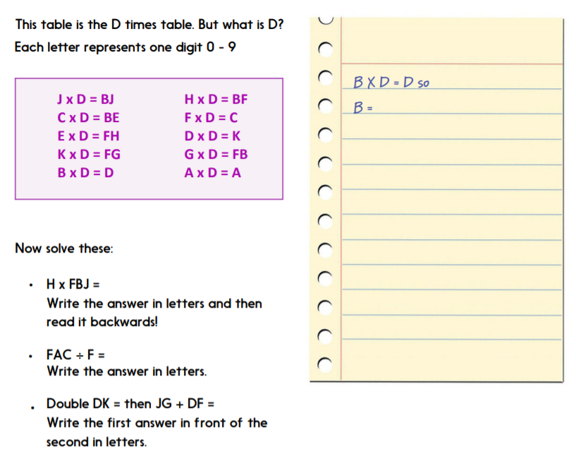
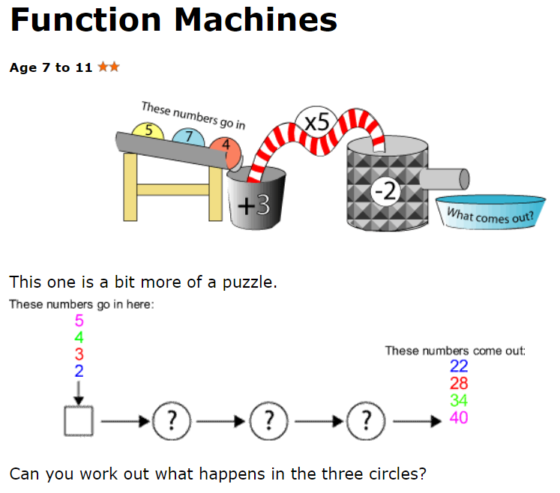

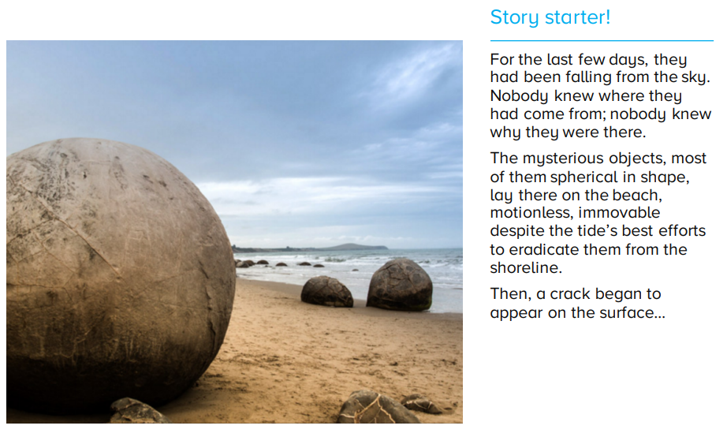
ENGLISH: NARRATIVE

Before you start writing your story, consider the following:
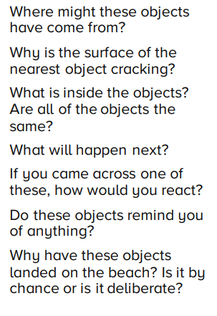
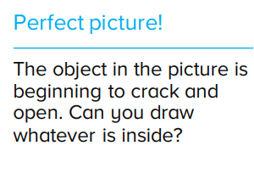

Use the success criteria below to write your story in your ideas book.
- Expanded noun phrases + punctuation | - Make improvements with peer | - Fronted adverbials of time (place + manner) | - Prepositions for time, place or cause
- Punctuation  A . ? ! ,  “ z”  - ‘ contraction | - Prefixes (anti-, im-, auto-, super-, sub-)  - Use -ly to form adverbs  - Year 3/4 Spelling (begin) | PLUS  Conjunctions  Adverbs  a/an | CHALLENGE  Use: adjectives and adverbs to describe a character;  Paragraphs; subordinating conjunctions

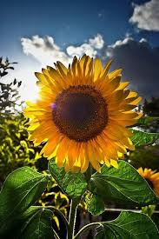
ENGLISH: EXPLANATION

THE PERFECT SUNFLOWER
How do plants grow?
Do some scientific research on how plants grow and write an explanation text for how a plant grows. You will need to think about:
- What does the plant grow from e.g. a seed?
- How is the seed planted?
- What does the seed need to grow?
- What are the stages of the plant’s growth?
- What are the different parts of the plant called and what is their function?
- What happens when the plant dies?

Use the success criteria below to write an explanation text.
- Expanded noun phrases + punctuation | - Use sub-headings to separate sections | - Fronted adverbials of time (place + manner) | - Prepositions for time, place or cause
- Punctuation  A . ? ! ,  “ z”  - ‘ contraction | - Prefixes (anti-, im-, auto-, super-, sub-)  - Use -ly to form adverbs  - Year 3/4 Spelling (begin) | PLUS  Causal conjunctions  Adverbs  a/an  Paragraphs | CHALLENGE  Use: adjectives and adverbs to describe a character;  subordinating conjunctions

GEOGRAPHY
Key Question 1: How is the UK landscape used?

Look at the pictures below. Sort them into the categories of physical and human geography. Remember that:
- physical geography – natural features of the Earth’s surface
- human geography – how human behaviour affects or is influenced by the Earth’s surface

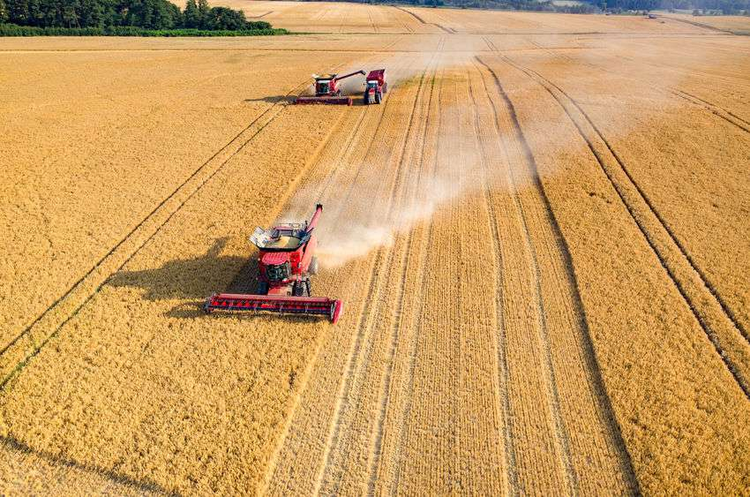
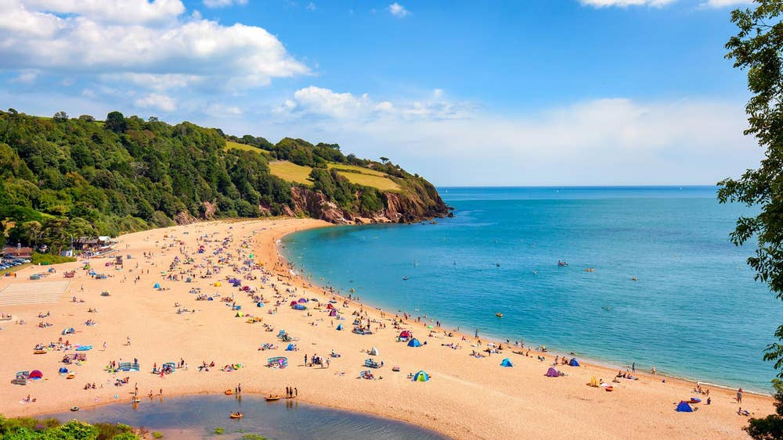

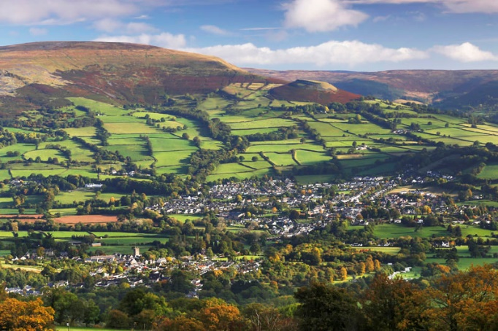
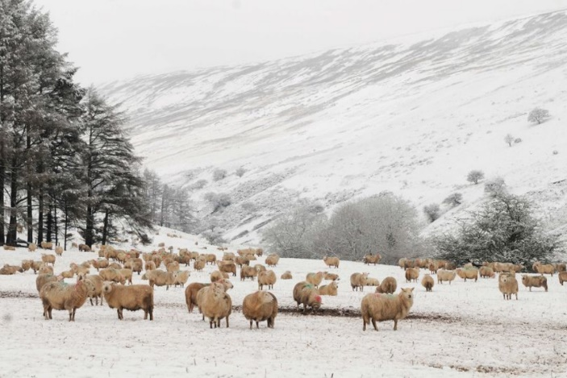

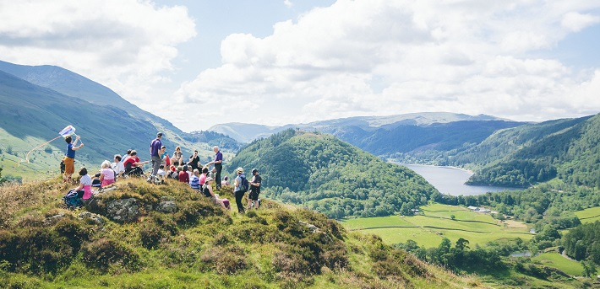
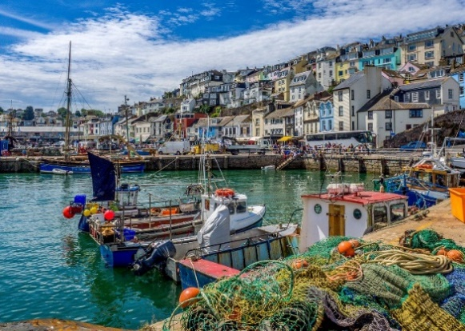

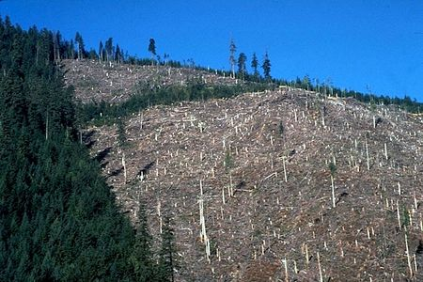

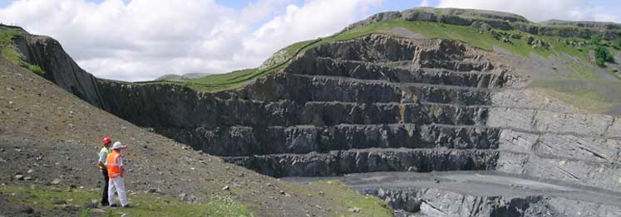

It is important to realise that the shape of the land affects how humans use the land. Look at the following websites for information.
https://www.bbc.co.uk/bitesize/topics/zshp34j/articles/z62qy9q
https://www.oddizzi.com/teachers/explore-the-world/country-close-up/united-kingdom/economy/

Now, match the land use photos with different parts of the UK by looking at an Atlas or Google Earth. What might the reasons be for the variation in population and land use?

Complete these sentences in your ideas book:
Where there are more hills and mountains…
Where the landscape is flatter…
Where there is coast...

Key Question 2: How does the Isle of Skye compare to Wokingham?

Have a look here: https://www.bbc.co.uk/bitesize/clips/z2h34wx and on Google Earth, zoom in on Skye.

Using the internet or by asking friends and family, do some research on the Isle of Skye (see the information leaflet attached).

Create a fact file about Skye in your ideas book e.g. physical features, location, weather, population, main industries etc.

ART
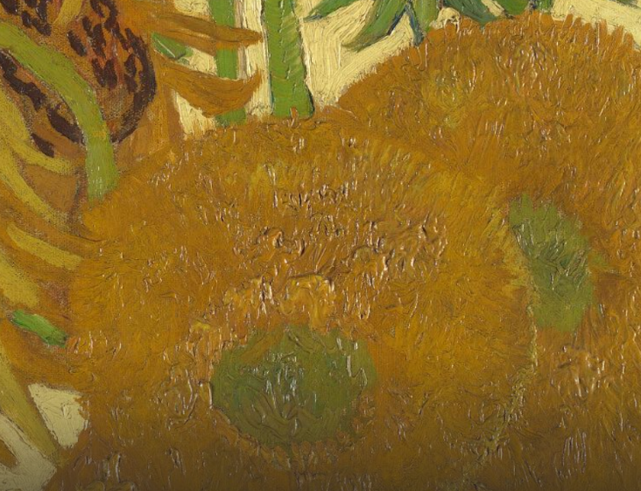
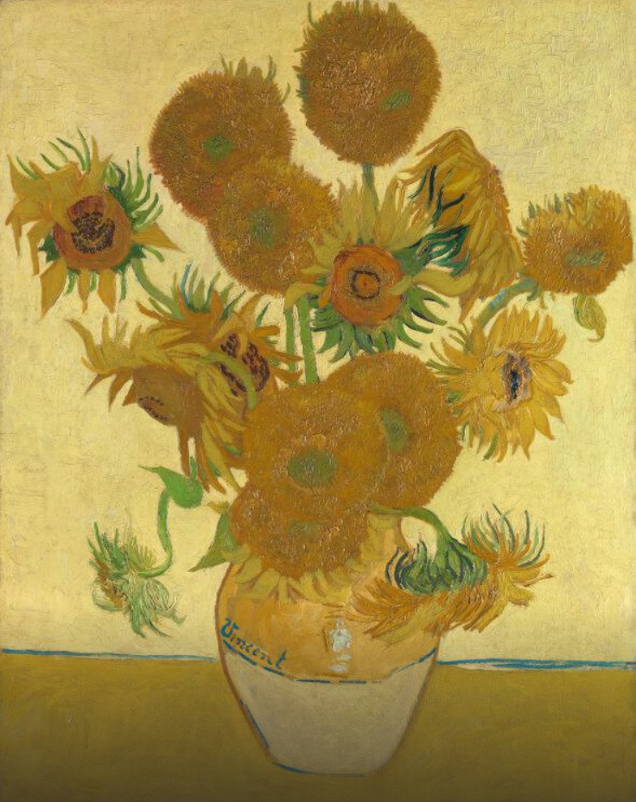
Following on from your science research and explanation writing, here is the famous picture ‘Sunflowers’, painted by Van Gogh.
Read the following information and do your own research on both the painting and the artist. Look at some of his other paintings; which one is your favourite?
You can then choose a painting to recreate using whichever medium you would like. You could use paint, crayons, colour pencils or you could create a collage using a range of different materials.
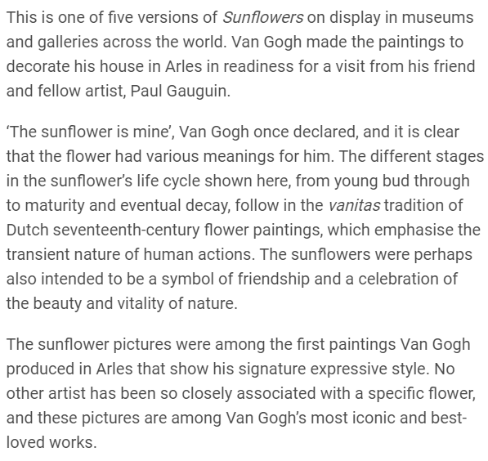

https://www.nationalgallery.org.uk/paintings/vincent-van-gogh-sunflowers

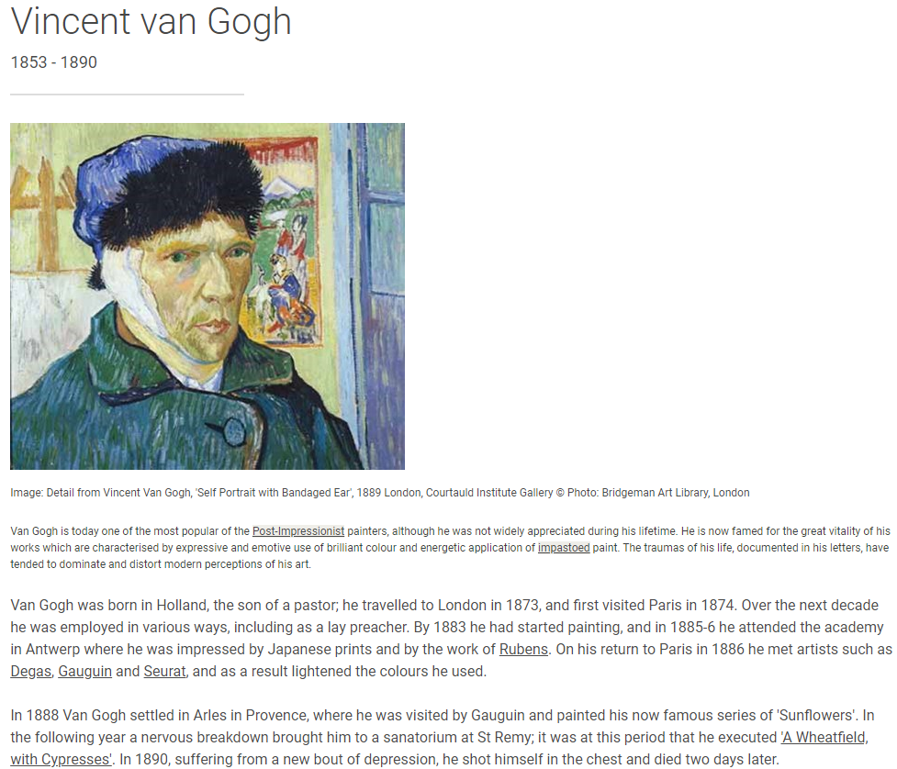

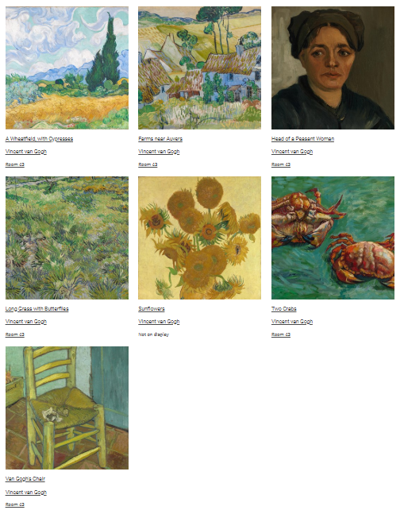

You could also research Andy Goldsworthy, a sculptor who specialises in working both in and with nature.
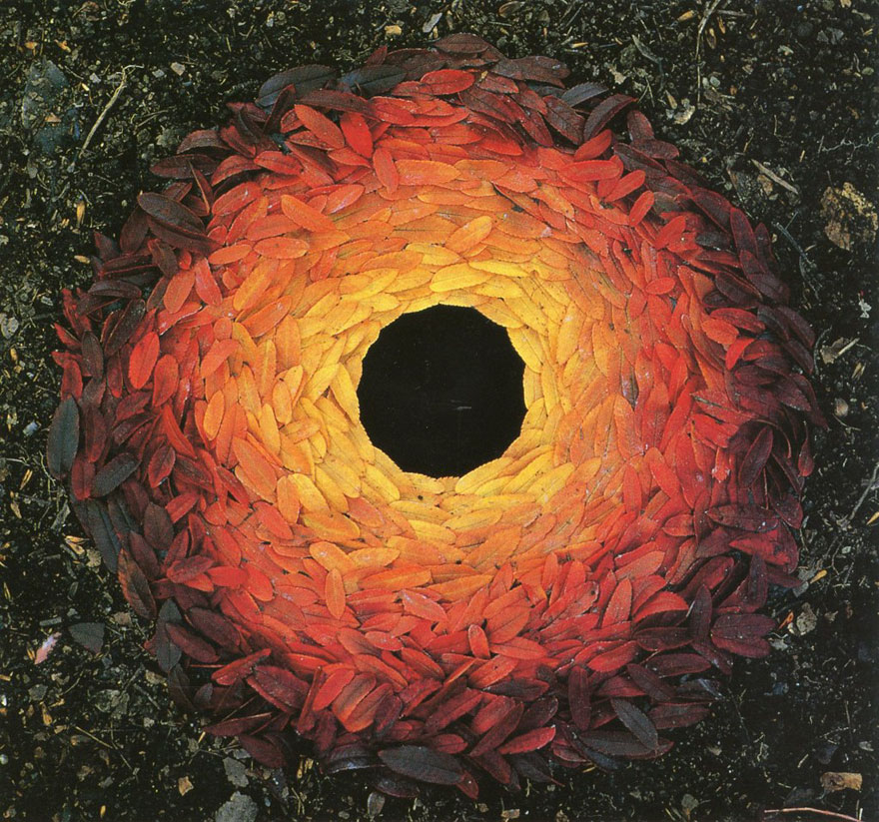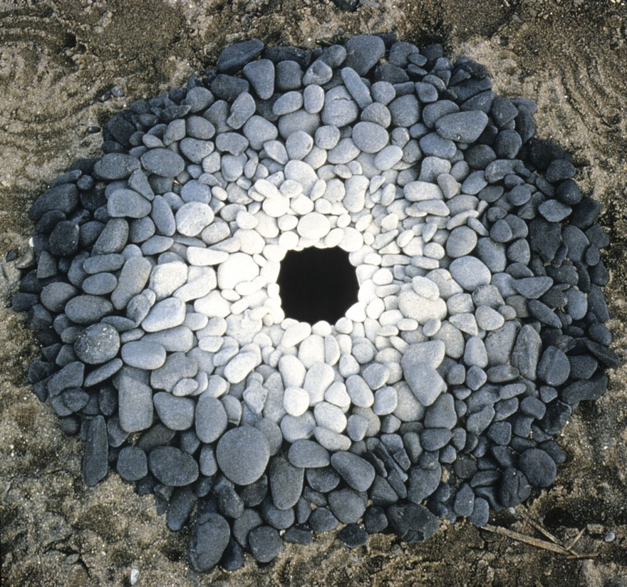

You could then have a go at creating your own sculpture or collage, either using natural materials from outside if you are able to, or using recycled materials. Take a picture of your creation and stick it in your ideas book.

