YEAR 5
HOME LEARNING PACK
NAME: __________________________________
CLASS: ___________________________________

YEAR 5 SPELLING
Spelling Activities:
Using some of the different strategies included on the next page, practise spelling the words from the following lists:
Homophones (words that sound the same but have different meanings and spellings):
See how many of these homophones you can find in your reading. Come to school with ideas on how to remember which spelling to use:
- isle/aisle
- aloud/allowed
- night/knight
What other homophones can you find?
Prefixes: dis- de- mis- re-
- disappear
- devalue
- misbehave
- re-enter
Suffixes: -ate, -ise, -ify
- pollinate
- activate
- realise
- apologise
- solidify
- classify
You can also practise the words on the Year 5/6 spelling list which are included in this pack. In addition to the strategies included on the following page, you can also use the look, say, cover, write, check technique explained below. Just use your ideas book and remember to tick them off in your reading records when you have mastered them.
Look  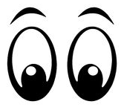 | Look at the word. How many parts are there?  What are the tricky bits?  Can you find any spelling patterns?
Say  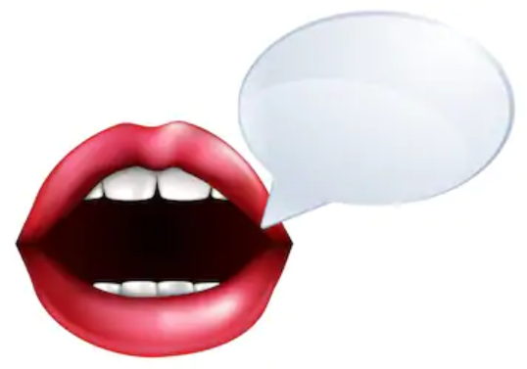 | Say the word to yourself.  Break the work up into syllables.  How many parts are there?  What sounds can you hear?
Cover  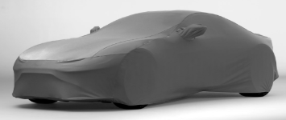 | Cover up the word so you can’t see it.  Picture the word in your mind.
Write | Write down the word, remembering how it sounds and what it looks like.
Check | Check to see if it’s correct.  Tick the letters you got correct.  Write the word correctly if you made a mistake.
You can also play some spelling games here: https://spellingframe.co.uk/
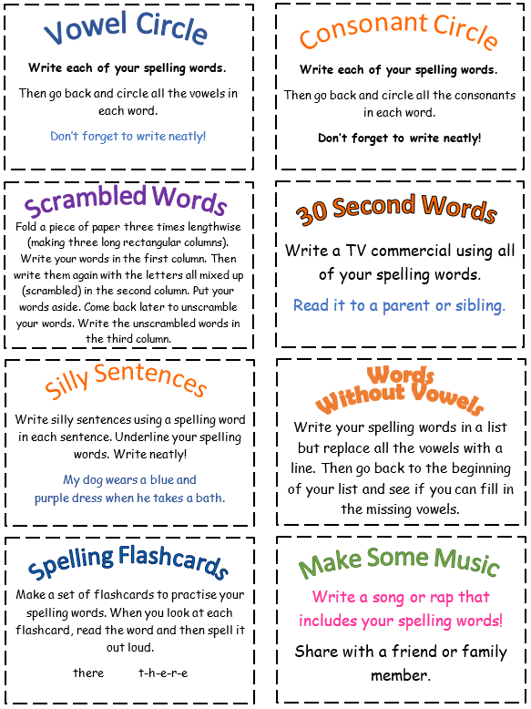
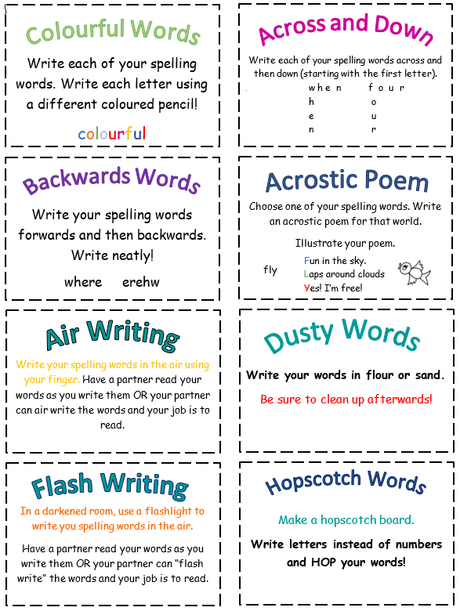
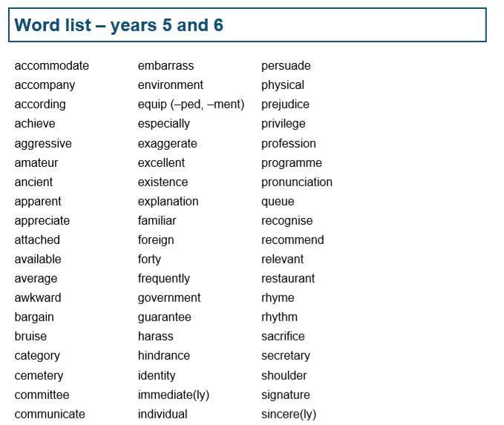

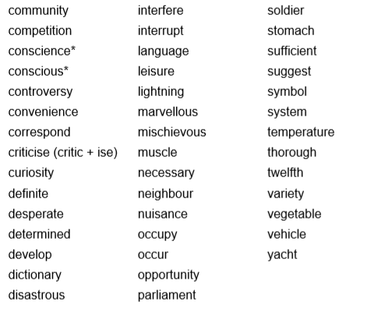

Times Tables
There are lots of great ways to practise your times tables while you’re not at school. There are lots of strategies on the next page, very similar to the spelling ones.

There are lots of great websites you can use to practise your times tables too:
www.topmarks.co.uk has lots of great games
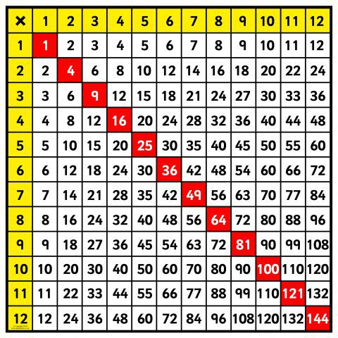
www.timestables.co.uk has some games as well as the practice area for the Multiplication Tables Check.
www.mathsframe.co.uk has lots of different games and activities to try.
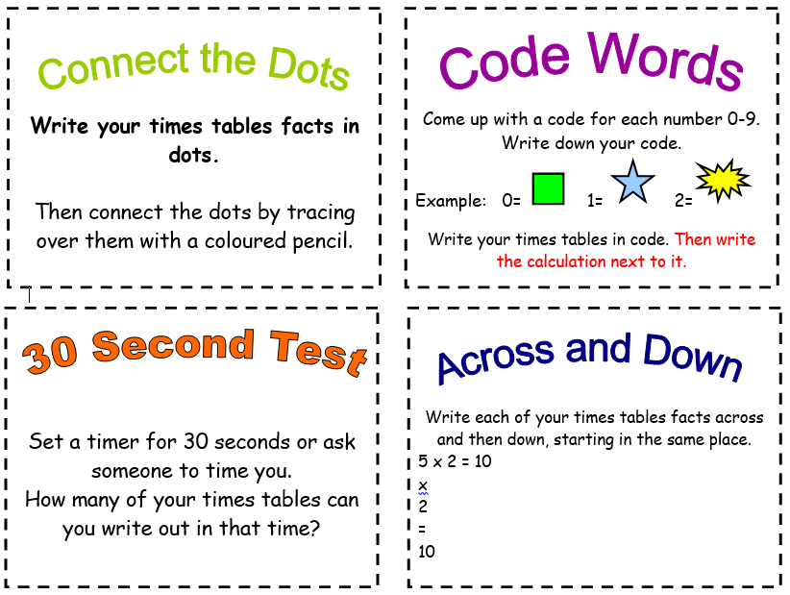
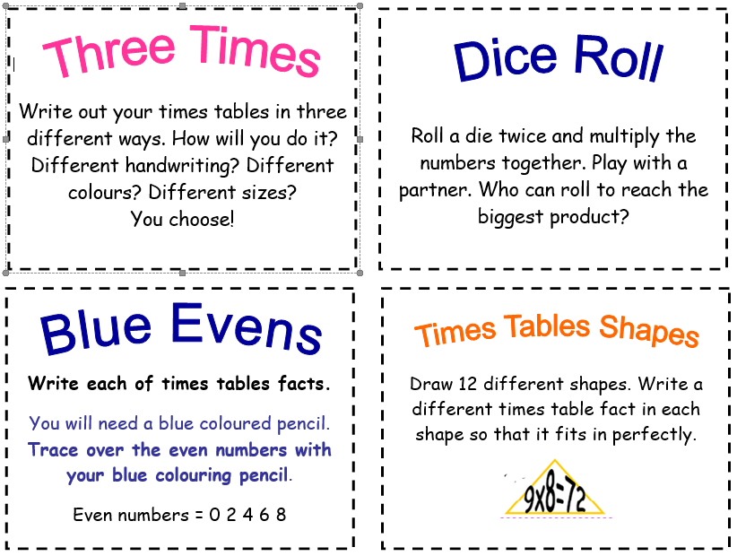
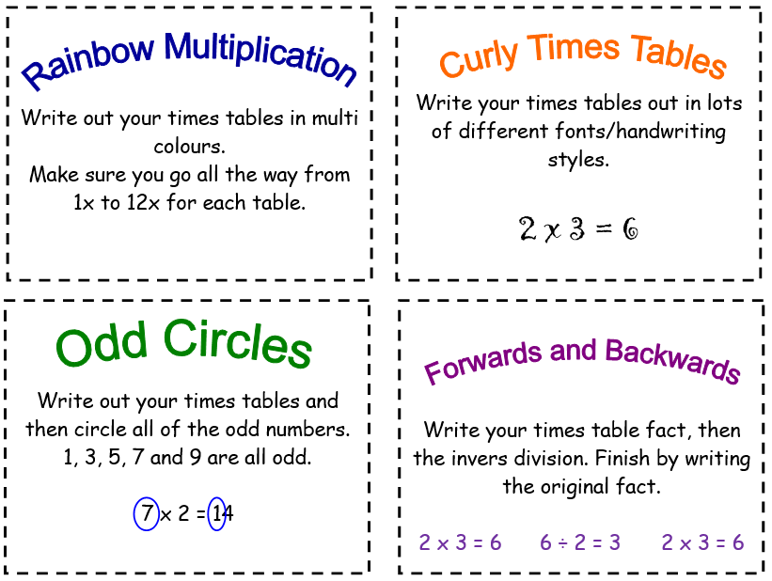
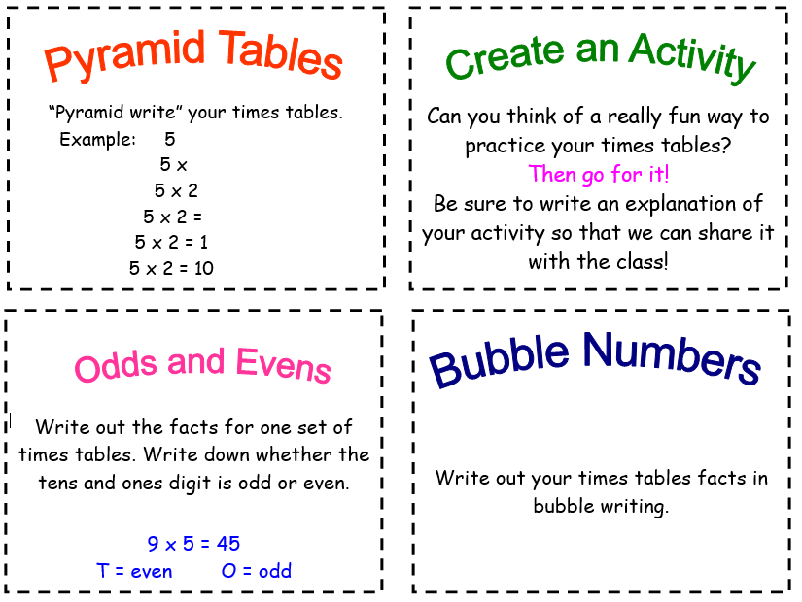

a

Times Tables Reasoning
3 x tables
- Sarah says, “I know my 3 times table so I can work out 30 x 70 without using a written method.” Explain why Sarah can do this.

- Fill in the gaps

 | 9 | 12 |  |  | 21

- David says, “Because 3 is odd, all multiples of 3 will be odd.” Is David correct? Explain your reasoning.

- James is buying CDs. He buys 3 CDs at a cost of £8 each. Draw a diagram to show your working out and then write the calculation.

4 x tables
- David says, “I know that the 4 times tables is linked to the 2 times table.” Explain why the two are linked.

- Anna says, “I know the answer to 4 x 16 without using a written method.” Explain how Anna has been able to calculate 4 x 16.

- Fill in the gaps

 | 200 | 240 |  |  | 360

- David spends £48 on four t-shirts of equal cost. How much does each shirt cost?

6 x tables
- Fill in the gaps:
6 x ____ = 24 48 ÷ ___ = 6
6 x ____ = 54 30 ÷ 6 = ___
6 x ____ = 18 72 ÷ ___ = 6

- David says, “I am not confident with my six times tables but I know my threes so I can use them to help.” Is David correct? Explain your reasoning.

- Create a word problem that requires you to use the 6 x table.

- David says, “All multiples of 6 are even numbers, whether I multiply them by an even number or an odd number.” Can you explain why this is?

7 x tables
- True or false? Every other number in the 7 times table is odd. Explain your answer.

- Helen is buying 5 birthday cakes at £7 each. Draw a diagram to show this calculation.

- Fill in the gaps:

7 |  |  | 28 |  | 42

- James says, “If I know 7 x 6, then I can solve 7 x 60 just as easily.” Is he correct? Explain your reasoning.

8 x tables
- David says, “I know without even solving the calculation that 2461 divided by 8 will have a remainder.” Is David correct? Explain your reasoning.

- Ben says, “I know my 8 times table so I can work out 800 x 5 without using a written method.” Explain why Ben can do this.

- Fill in the gaps:
8 x ____ = 48 48 ÷ ___ = 8
8 x ____ = 32 32 ÷ 8 = ___
8 x ____ = 16 16 ÷ ___ = 8

- What is the perimeter of a regular octagon if each side measures 7cm?

9 x tables
- David says, “I’m not very confident with my 9s but I know my 10s.” Explain how David can use his knowledge of the 10 times tables to help him work out his 9s.

- Fill in the gaps:

 | 27 | 36 |  |  | 63

- Always, sometimes, never? When you multiply a number by 9, the answer will be an odd number. Explain your reasoning.

- Sarah says, “If a number is a multiple of 9, then it will also be a multiple of 3.” Is Sarah correct? Explain your reasoning.

12 x tables
- Fill in the gaps below:

 | 36 | 48 |  |  | 84

- Sarah says, “Because 12 is a multiple of 4 that means any multiples of 12 will also be multiples of 4.” Is Sarah correct? Explain your reasoning.

- Always, sometimes, never? Because 12 is an even number, whatever number you multiply it by will give you an even answer. Explain your reasoning.

- How can you use your 2 x tables and 10 x tables to work out your 12 x tables? Explain your reasoning.

Maths
We have included some questions below that cover the topics we have learned to date. Don’t worry if you don’t have any Maths resources at home, you can use things in your house or you could draw them to help you.
There are two levels of challenge: tricky and trickiest – choose the level of challenge you would like to attempt.

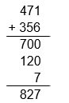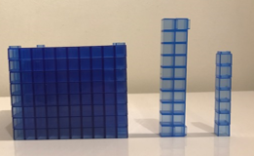 | 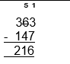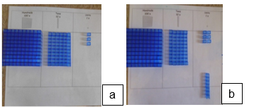  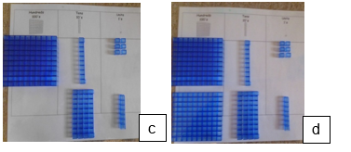
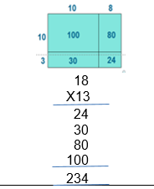  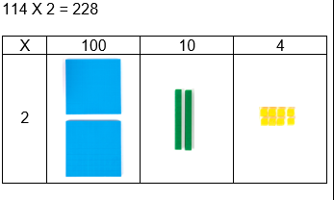 | 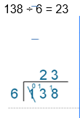  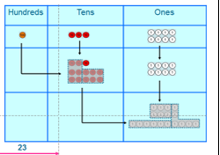

Tricky
Choose whether a written method or mental method would be more efficient to use before answering.
1) 345 + 23 | 2) 489 + 271 | 3) 407 + 239
4) 1,742 + 156 | 5) 2,267 + 1,134 | 6) 499 + 499
7) I ate 7 biscuits on Monday, 15 on Tuesday and 35 on Wednesday. How many biscuits did I eat altogether? | 8) At the shop I bought a CD for £5.99 and a chocolate bar for 64p. How much did I spend altogether? | 9) What is 67 more than 54?

Trickiest
Choose whether a written method or mental method would be more efficient to use before answering.
1) 345 + 78 | 2) 1489 + 271 | 3) 6,407 + 1,239
4) 742 + 156 | 5) 267 + 134 | 6) 499 + 499
7) I ate 7 biscuits on Monday, 15 on Tuesday and 35 on Wednesday. How many biscuits did I eat altogether? | 8) At the shop I bought a CD for £5.99, a book for £2.40 and a chocolate bar for 64p. How much did I spend altogether? How much change would I get from £10? | 9) What is 467 more than 754?

Tricky
Choose whether a written method or mental method would be more efficient to use before answering.
1) 745 – 315

2) 467 – 352

3) £1.65 – 47p

4) 5,861 – 3,500

5) 242 – 89

6) I have 50 buns and Bob has 78. How many more buns does Bob have than me?

7) What is the difference between 504 and 237?

8) I spent 89p on chocolate and sweets. How much change did I get from £2?

9) What is 67 less than 149?

Trickiest
Choose whether a written method or mental method would be more efficient to use before answering.
1) 745 – 377

2) 2,467 – 1,329

3) £1.60 – 47p

4) 5,861 – 3,599

5) 242 – 189

6) I have 45 buns and Bob has 78. How many more buns does Bob have than me?

7) What is the difference between 1,504 and 1,237?

8) I spent 89p on chocolate and sweets. How much change did I get from £5?

9) What is 67 less than 149?

Tricky
1) 26 x 4 | 2) 44 x 3 | 3) 15 x 5
4) 412 x 3 | 5) 123 x 6 | 6) 210 x 3
7) 27 x 10 | 8) 134 x 20 | 9) 51 x 10

Trickiest
1) 126 x 4 | 2) 344 x 3 | 3) 115 x 5
4) 2,412 x 3 | 5) 1,123 x 6 | 6) 3,210 x 3
7) 27 x 13 | 8) 134 x 23 | 9) 51 x 14

Tricky
1) 45 ÷ 3 | 2) 68 ÷ 4 | 3) 52 ÷ 6
4) 57 ÷ 5 | 5) 219 ÷ 7 | 6) 126 ÷ 4
7) 465 ÷ 5 | 8) 1,122 ÷ 3 | 9) 3,276 ÷ 2
Trickiest
1) 145 ÷ 3 | 2) 168 ÷ 4 | 3) 252 ÷ 6
4) 157 ÷ 5 | 5) 219 ÷ 7 | 6) 126 ÷ 4
7) 4,165 ÷ 5 | 8) 1,122 ÷ 3 | 9) 3,276 ÷ 9

Tricky and Trickiest
- These fractions are all out of order. Find their equivalent fractions if the denominator is 16 and then write them in order from smallest to largest. Some may be the same fraction.
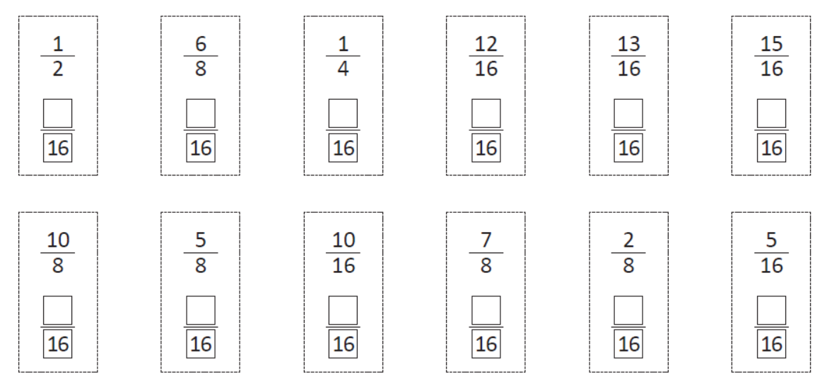
- Shade the second shape in each pair to match the first one. Write the equivalent fractions underneath.

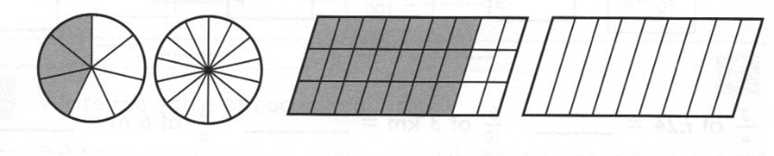
- Complete the equivalent fractions.

- Write < or > between each pair of fractions.

5. Put he correct symbol < > = to compare these fractions
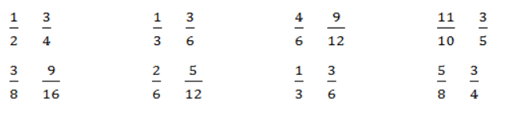

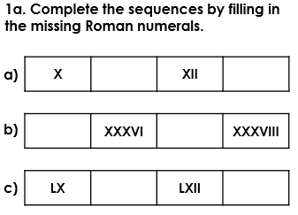
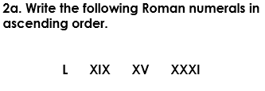
Tricky

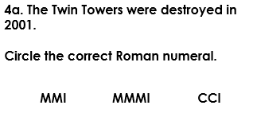
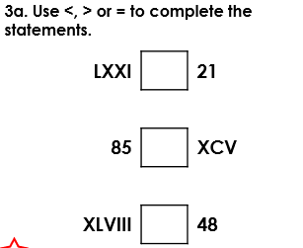

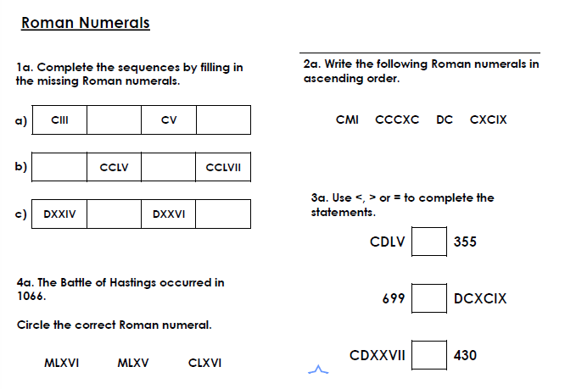
Trickiest

Tricky
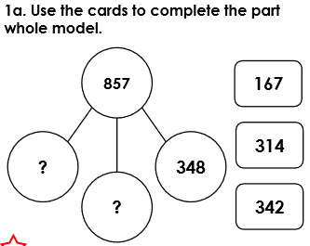

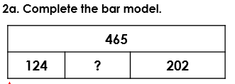

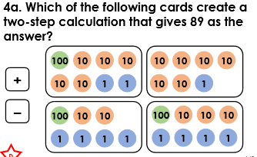
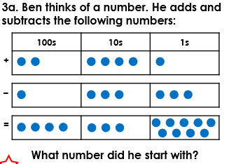

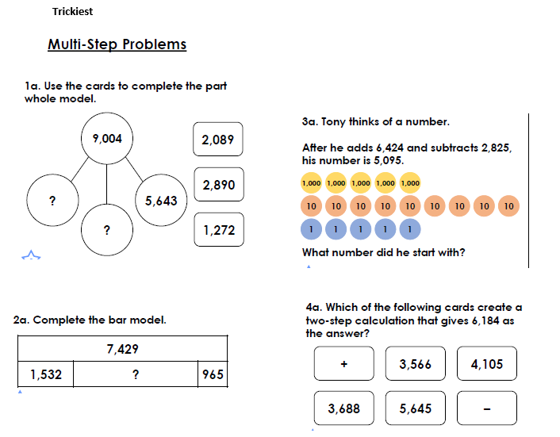
Trickiest

Additional maths problems and activities you might like to try:

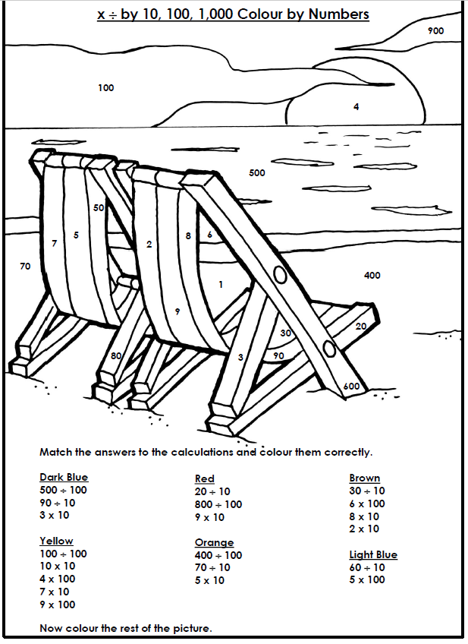
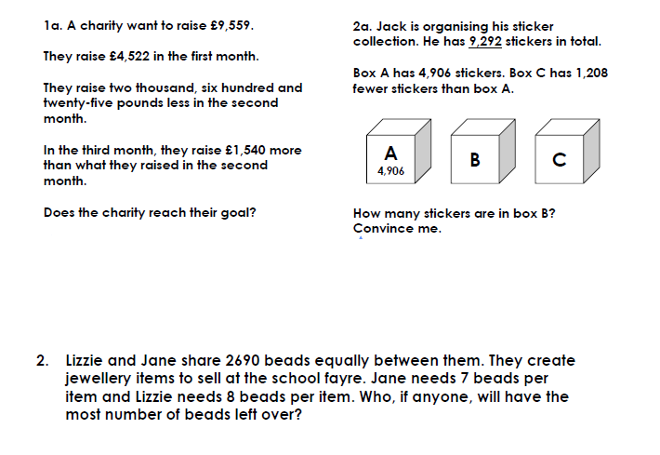

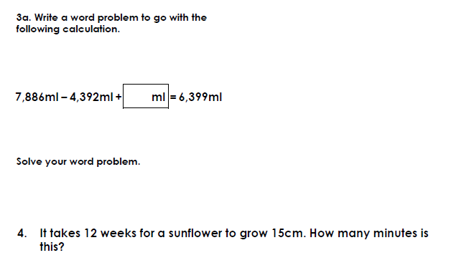

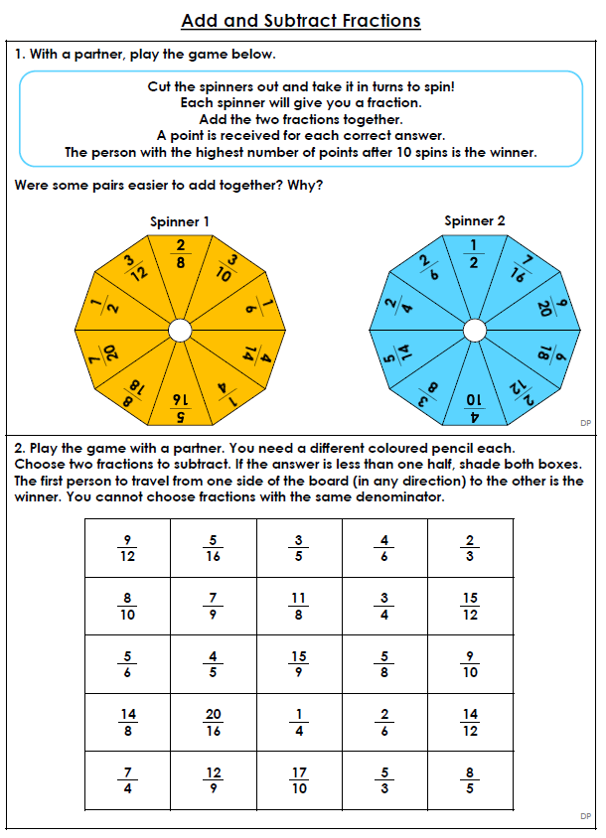

Read Theory
Use your Read Theory username and password to login to Read Theory:
https://readtheory.org/auth/login
Read carefully through each text and answer the questions. If you get a question wrong, make sure you read the explanation as to why you got it wrong.

English fiction

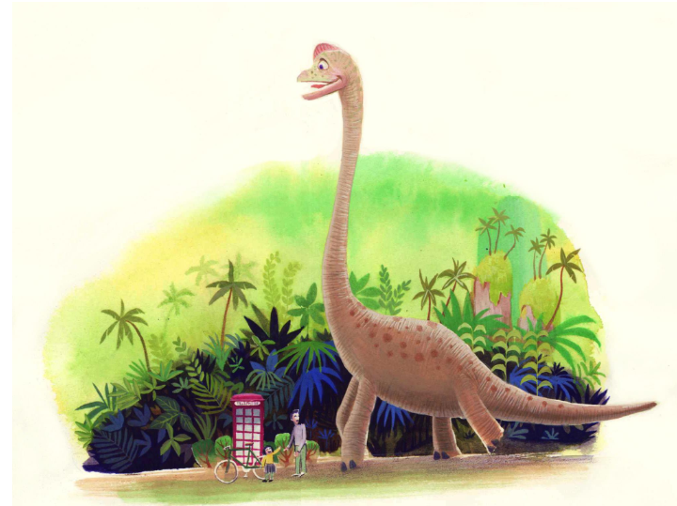
- Where is this?
- Why is the dinosaur here?
- Are there any others around?
- How does it feel about the people? How do the people feel about the dinosaur? Have they seen a dinosaur before?
- Where do you think it’s going? Is it looking for something?
- What do you predict will happen next?

Activities to choose from
Write a story which includes the characters in this picture. Can you include what happened before this part of the story? Can you include what will happen next?

Alternatively, imagine which other unusual locations the telephone box and people could turn up in. Write a story with your chosen location as the setting.

Success criteria:
- Paragraphs
- Describe the setting through the experiences of the characters
- Expanded noun phases
- Fronted adverbials of time, place and manner
- Speech and accurate speech punctuation
- Relative clauses
- Subordinate clauses
- Powerful verbs and adverbs
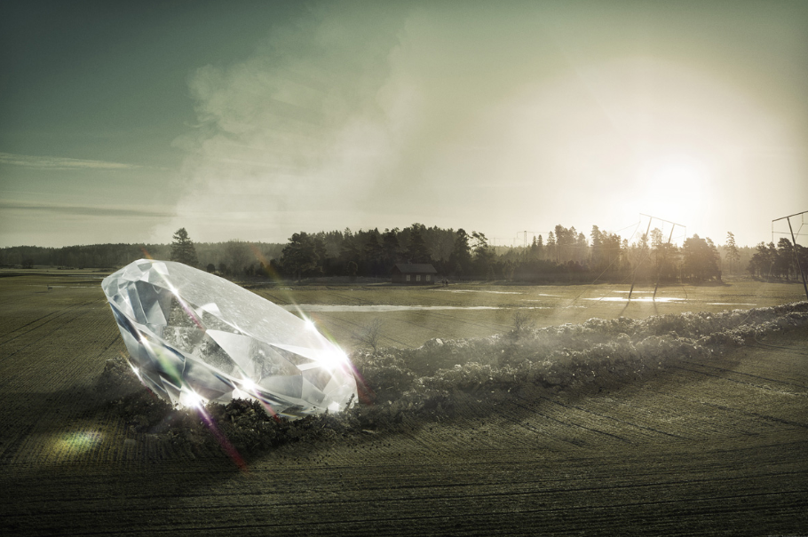
English non-fiction
- What has happened here?
- Where did the diamond come from?
- How long has it been here for?
- Has anyone seen in it yet? Did anyone see where it came from?
- Who might be the first person to discover it?
- What do you think they will do?
- What would you do if you discovered this?

Activities to choose from
Can you write a newspaper report about the discovery of the diamond? Include quotes from eyewitnesses and/or experts.
Success criteria:
- Headline
- Introduction addressing the 5Ws: Where? Why? Who? What? When?
- Paragraphs
- Direct and reported speech
- Relative clauses
- Subordinate clauses
- Brackets for parenthesis
- Fronted adverbials of time
Alternatively, you could write a recount from the perspective of one of the following people: owner of the house in the background; farmer who owns the field; local policeman or an eyewitness. This could be in the form of a diary entry.

Success criteria:
- Paragraphs
- Chronological order
- Fronted adverbials of time, place, manner
- Relative clauses
- Subordinate clauses
- Parenthesis
- Modal verbs
- opinions

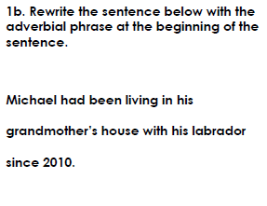
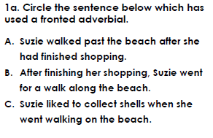

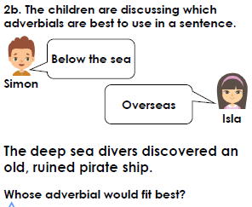
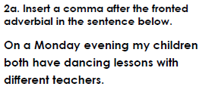
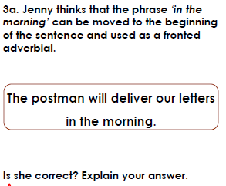

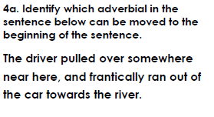

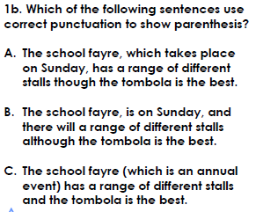
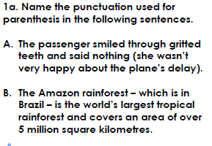

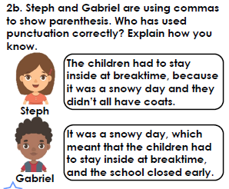
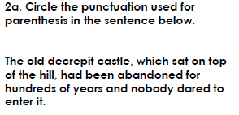

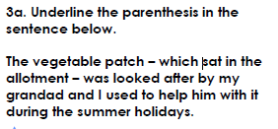
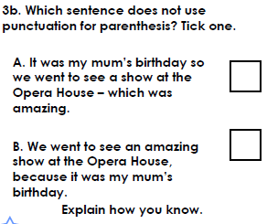
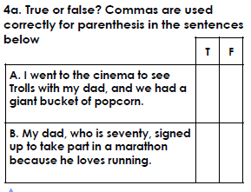

Topic
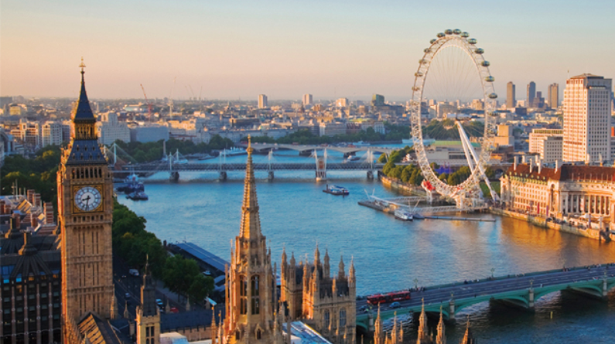
London
In the summer term, we will be learning about London.
Spend some time researching and create a fact file about London. This can be presented in any format you like e.g. poster, PowerPoint, publisher.
Find out about the physical and human geography of London.
- physical geography – the natural processes of the Earth e.g. climate, mountains, rivers etc.
- human geography – the impact and behaviour of people and how they relate to the physical world e.g. population, culture, economy etc.

You may like to answer these questions to support you in your research:
Which continent and country is London in?
What is the current population?
What is the climate like in London?
What is the name of its main river in London?
What famous landmarks are in London?
What famous historical events have occurred in London?
Why is London considered a major city of the world?

This website may help you: https://www.bbc.co.uk/bitesize/subjects/zbkw2hv
How does London compare to other capital cities around the world?

Choose a capital city of another country from a different continent and compare it to London. Write down the similarities and differences between the two cities. If you would like to, you could try comparing several capital cities – perhaps one from each continent.

Challenge: Research what London was like during World War 2. Create a presentation on how London has changed since World War 2.
Science: Properties of materials
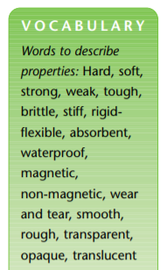
Choose a room in your house, how many objects can you find? What materials are they made of? What properties do those materials have? Why are they made from those materials?
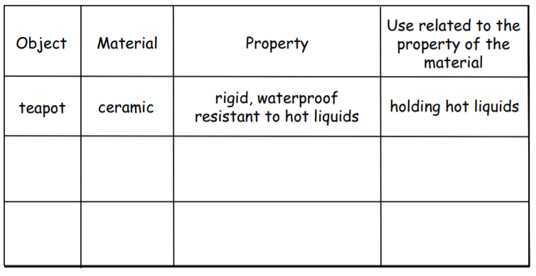
Create a table like the one below for the objects you’ve found:

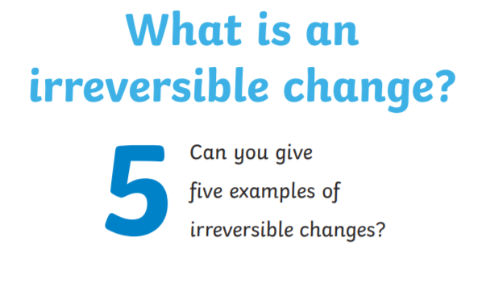
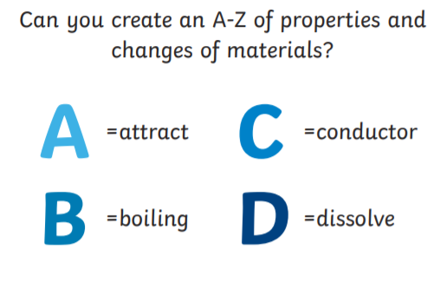
Inventor
Who are some famous inventors and what were their inventions?
- The Wright brothers invented and built the first successful aeroplane, completing the first successful flight on 17 December 1903.
- Stephanie Kwolek was an American chemist. Klowek developed Kevlar - a synthetic fibre so strong that it's used in sails, tyres and even bullet-proof vests.
- James Dyson invented an innovative bagless vacuum cleaner which is popular throughout the world.
- Steve Jobs - co-founder of Apple - designed the iPod, iPhone and several other Apple products.
All inventors need to take great consideration over the materials they use and which will be the most appropriate for the purpose of their invention. If it is to be used in water, it will need to be made of waterproof material. If it is to be used in the air, it will need to be made of light weight material.
Can you design your own invention? It could be a new toy; form of transport; item of furniture or a different type of object. Draw your invention and label the materials it is made from. Explain why you have chosen those materials and why they are suitable for purpose the object will be used for.
Art

- Create a collage portrait using cuttings from magazines.
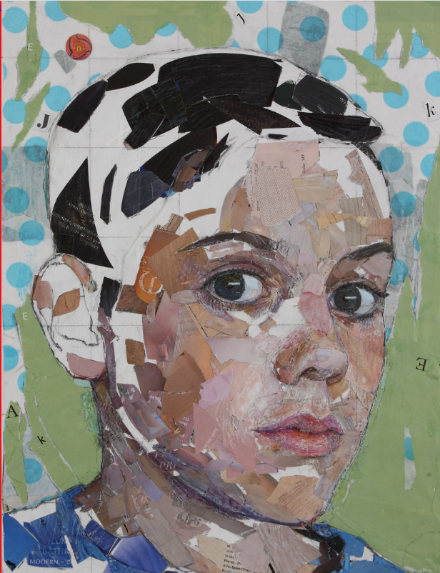
Alternatively, take several photos of the same person or scene from different angles, cut them up and rearrange them to create a collage. Artist David Hockney accidentally discovered this technique (he called these pieces ‘joiners’) when photographing a room for a painting. He felt that a single photograph doesn’t show movement or time, but a collage tells a story.
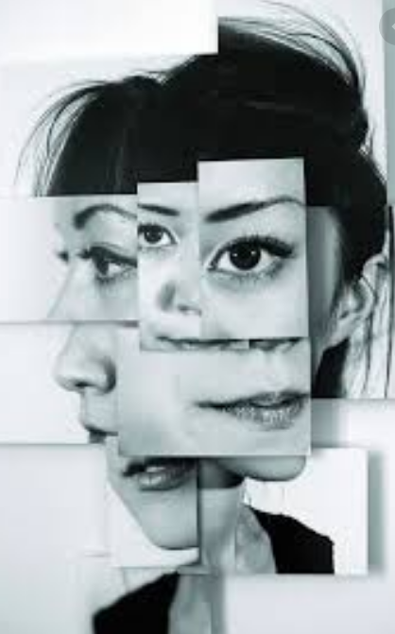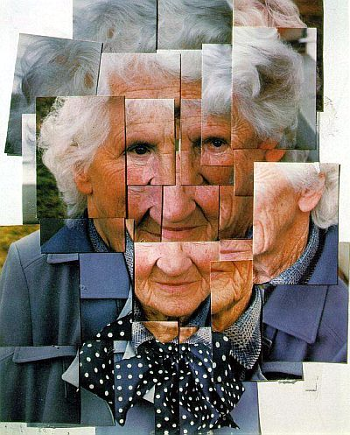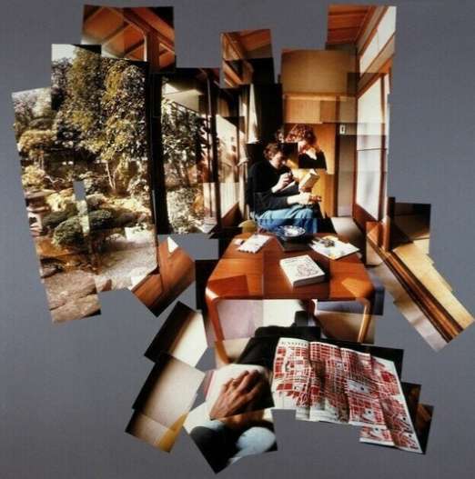

- Create a 3D Picasso face with a box from your recycling
Visit www.teachkidsart.net and search ‘3D Picasso face’
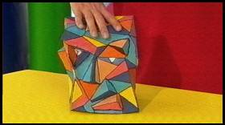
- To find out more about the artist Picasso, visit
https://www.teachkidsart.net/more-about-picasso/

